Project analysis

Introduction
This project will develop a graphical user interface that works as a calculator. It will be capable of both basic and scientific mathematical problems, such as logarithms, trigonometry, and calculus. with the capabilities of any scientific calculator that may be used by an A-level or GCSE student, while providing a minimalistic and easy- to use interface.
It will be modelled after a scientific calculator, which is more advanced and is designed for more complex calculations, with built – in functions for various mathematical operations. It will be accessible via any computer or device that is able to run python and python libraries, and be convenient for those who don’t have access to physical calculators.
While it is primarily designed based on a student’s needs, this program would be well – suited to a wide demographic of people who are looking for a calculator program, used in everyday life for finance, time and data management, and statistical calculations.
By making use of maths libraries using this program can be a great time- saver for anyone who needs to do repetitive calculations in their line of work or study, and needs a free alternative to a physical calculator or calculator emulator.

Is The Problem Computational?

Is the problem computational – can it be solved using only a computer’s logic and arithmetic? This is a poster example of a computational problem. Mathematical problems have definite answers that are solved using straight – forward logic.
Mathematical equations are similar to computer programs and can be directly translated into any language for a computer to follow. Both computer algorithms and mathematical equations are closely linked. The word algorithm, “was a name given to the 9th – century mathematician Abu Ja’far Muhammad ibn Musa, author of widely translated works on algebra and arithmetic.” Meaning it was used to define mathematical equations before computers even existed.
Accodring to Marek Kowalkiewicz, algorithms are merely specific descriptions of step – by step actions that need to happen to achieve a particular outcome. This means the word can be applied not only to computer algorithms, but to any computational or mathematical problem.
A calculator program , using fast computer processing speeds and problems that are difficult for humans but straight – forward to computers, can solve problems in seconds that would take hours to complete manually.
Example : Log tables
In order to find logarithms manually, refer to the Log table. Not only would this table take time to navigate and make sense of, but it only offers solutions to a finite amount of numbers. If someone wanted to find log (3.5) for example, they would be out of luck. As well as this, with so many numbers close together it would be possible to make a mistake and record the wrong answer. Using a calculator or computer program, all the user would have to do is input log(x) and their answer would be outputted in an instant. This not only saves time and reduces the chance of error, but it has no limitations in what numbers can be inputted. 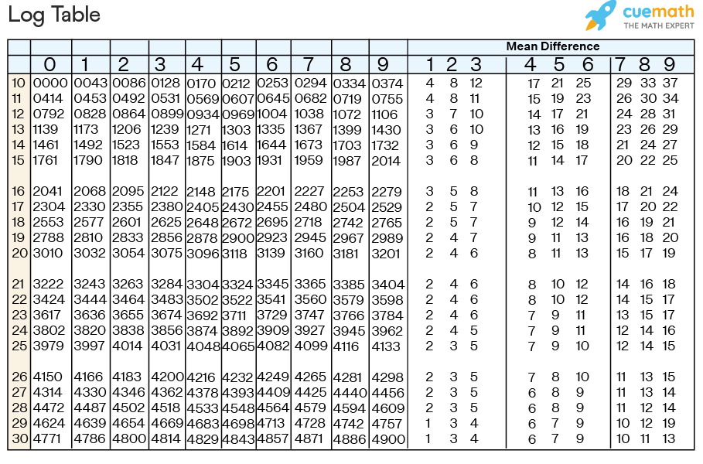
The reason there are no limitations to which number can be inputted is not because the calculator has the answer to every possible equation pre – stored. It is because the calculator knows how to process the input following a number of steps in a function and uses the inputted numbers as its parameters.
The logic behind logarithms and rules of logs can be broken down into simple logic gates.
This is shown in the SymPy documentation.
Logarithms have similar issues as powers. There are two main identities
$$log⁡(xy)=log⁡(x)+log⁡(y)$$
$$log⁡(x^{n})=nlog⁡(x)$$
Neither identity is true for arbitrary complex and , due to the branch cut in the complex plane for the complex logarithm. However, sufficient conditions for the identities to hold are if and are positive and is real.
So logarithms are a type of problem that is very difficult without the use of a computer. But actually, even the simplest calculations can be broken down into computational problems easily, and can be done more quickly and efficiently by the computer.
Example 2: The combination formula
Another example which can be seen on the Casio fx-991ex calculator, is the nCr , or “n choose r”button. This button uses the combination formula, which, given an n- set, finds how many r- subsets there are, or how many ways there are to choose r elements out of n total elements without repetition.
The combination formula is applicable In various situations where combinations of items need to be formed and the order of selection is not important. Here is how it works
- The user has a set of n elements and wants to find the number of ways they can choose r elements from this set without regard to the order.
- Find n! , the product of all positive integers up to n.
- As well as this, find k! and (n-k)! , using the same method.
- Multiply (n-k)! by k!.
- Divide n! by the answer to step four.
The mathematical formula for this is written as nCr = n! / k!(n-k)!
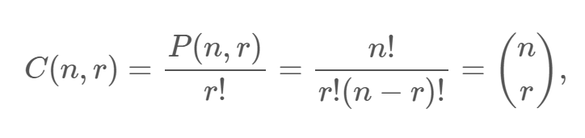
This problem, like any mathematical problem, can easily be converted into a computer function with n and r as parameters. It shows all the characteristics of a computational problem with inputs and outputs as well as a clear algorithm.
Input- the numbers and operations the user types into the calculator.
Processing – following a set of instructions, either pre – stored into the calculator like the combination formula or by executing the operative commands entered by the user, such as +, - , etc. in the order of operations. These instructions are pre – existing and can be found online or in maths textbooks with the intention of being used by a human.
Output- The output is the result of putting the parameters through the formula or executing the operations given to the calculator. For example if the input is 2+2 the output will be 4. This will be returned and displayed on the virtual calculator screen.

On a whole a calculator can only rely on logic and arithmetic, so all problems that it’s possible to give a calculator are strictly computational. While some problems such as predicting weather or success of an app are heuristic and are given to other types of calculator, the one in this project will only focus on numeric and algebraic problems which are straightforward and computational, but difficult for the human brain to execute quickly.

Stakeholders
A calculator is an essential tool that has been an integral part of life for decades. They are indispensable and time saving in making important and error – prone calculations .
Education
Calculators have become a critical part of modern-day education. They simplify complex calculations and allow students to focus on the underlying concepts and improve their understanding of mathematical and scientific principles. – Acko, 2023
Past learning basic arithmetic, having to manually count, add, and divide numbers can take up valuable time and focus when learning maths past a primary school level. This is why scientific calculators can be found in almost any maths or science classroom. Referring back to logarithms as an example, when learning the laws of logs the focus should be on the concept rather than having to meticulously find and work out individual equations in a table. Using a calculator can help a student to better understand and visualise this.
To save money and resources, a calculator app such as this project could be useful, saving time having to fumble with buttons on a physical calculator. It can also help young students become familiar with the functionalities of a calculator. A classroom teacher might choose to use a program such as the one in this project for their students to use. Especially in the modern day when laptops, ipads and phones are accessible to students and many primary schools, secondary schools and colleges have these devices to hand, which could be used to run calculator software- and many children even have access to their own phones which are now being used as a tool in the classroom more frequently. If a student forgets their physical calculator teachers might allow them to use their phones as a replacement. While most phones come with a relatively simple calculator software pre- installed, past a primary level a more advanced software is required and would be an asset for students to have installed on their phones.
This type of stakeholder has the following characteristics:
- Low / Medium educational level
- Male or female, Under 18
- Student level of literacy and numeracy
- Working in a classroom / learning environment
- Likely to be familiar with technology
The software needs of this type of user include:
- Can possibly be run on a personal phone or tablet for portability
- Software is simple and resembles familiar calculator interfaces so that the student doesn’t need to learn to run the program themselves
- Low in cost and can be replicated on many devices, so a teacher can install the program on multiple school tablets or computers for their pupils to use
- Capable of all calculations that might be done by a student up to GCSE level.

A level student
It’s convenience of existing on a computer or phone makes it one less item for a student to worry about remembering. Even in subjects like biology, maths problems will arise and a calculator such as the one in this project will be able to save the student plenty of time and energy.
An A level maths student, Urvi Odedra said “As an A level Maths student I need a calculator every day. It’s always a pain when I forget it and I can’t do my work without it. “
Similarly, Honey Rymell, an electronics student said that “I need to use a calculator almost every day, I have to carry one with me. I mean I have a calculator in my bag every day.” Despite not taking maths as a subject she still uses a calculator almost daily in her own studies, as the use of a calculator is vital for any subject that could involve data.
An A level student , while still in the context of academics, has slightly different software needs compared to a teacher or a student up to gcse level. The A level student has these characteristics:
- Male or female, aged 16-18
- May have some income / resources but will be limited
- Intelligent and likely to be familiar with technology
- Moves around several classrooms during the day and relies on their own supplies

The software needs of this type of user include:
- Portability, being able to run on a laptop , phone or tablet, which most A level students carry and use during classes
- More advanced functions eg. Differentiation
- Quick and accurate processing and output
- Affordable and accessible to install

Business owners
A business owner or entrepreneur is an example of someone who needs to make financial calculations to find profit margins, payroll ,and tax calculations, as well as projecting future expenses and revenues.
While anyone in control of their own finances would make good use of a calculator program , a business owner would have to do so on behalf of their company as well. Calculating how many hours to play employees, how much revenue is made per week, etc. are important and require the use of a calculator to eliminate human error and allow the business owner to focus on other tasks. As well as this the calculator being stored on a PC would be useful as it can easily be kept alongside other important documents and can be pulled up in a separate tab in order to record calculations on spreadsheets and pay slips.
This type of Stakeholder has the Following Characteristics:
- May be working under pressure
- Relies on accuracy
- Male or Female and over the age of 20
- Intelligent and any level of familiarity with technology
- High level of literacy and numeracy
The software needs of this type of user include:
- Happy with a complex interface or software requirements
- Most likely to use analytical and statistical calculations as well as calculating costs
- Unlikely to use any type of algebraic operations or calculus

Existing Solutions

There are a wide range of options to choose from when looking for virtual calculator software.

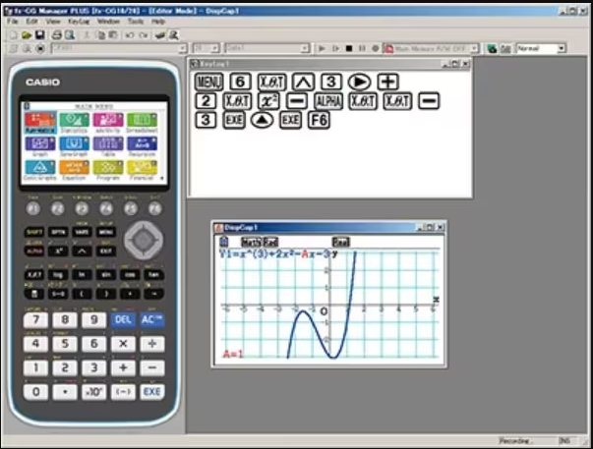
Casio fx-CG manager PLUS

As the leading calculator brand in an academic context, 88% of teachers recommend Casio scientific calculators as they have all the key functions, and up – to – date technology. Casio also offers paid subscriptions of emulator software for various models.
The fx – CG manager PLUS is an emulator which is made for preparing teaching materials and presenting in the classroom. The application projected onto a smart – board can allow students to clearly see what the teacher is doing on the calculator. It also includes a graphing feature which generates graphs that can be copy – pasted into other applications, which is extremely useful for the preparation of teaching materials. This calculator does require a paid subscription to use however, so while it may be accessible to schools and teachers the average student or would most likely choose a free option instead.
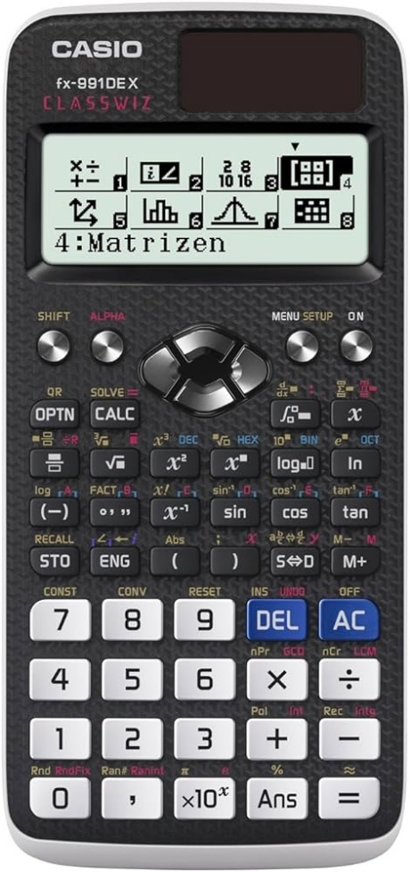

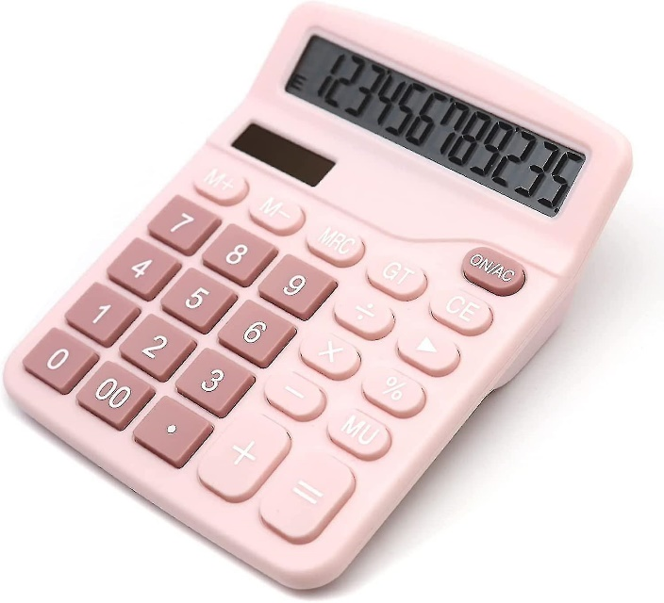

Physical Calculators

Another example from the same brand is the Casio fx-991DEX, from Casio’s Classwiz series. This line of calculators are popular among students. It is pictured above next to a pink desk calculator, one which has more limited functionality but shares the advantage of being an embedded system. This means it combines software and hardware to perform a specific task, rather than having to be run on a general – purpose computer or other device. The project currently being designed could be adapted into an embedded system by creating a hardware similar to the GUI of the virtual version. This would make it much more convenient to people who don’t own a multi – purpose computer. They could have all the functions of a calculator at their disposal at a much cheaper price than it would be if they purchased general – purpose hardware with the sole purpose of running calculations.
However, for an individual who already owns a computer, which is a large sector of the population, a free emulator may be more convenient and accessible as opposed to a physical embedded device.

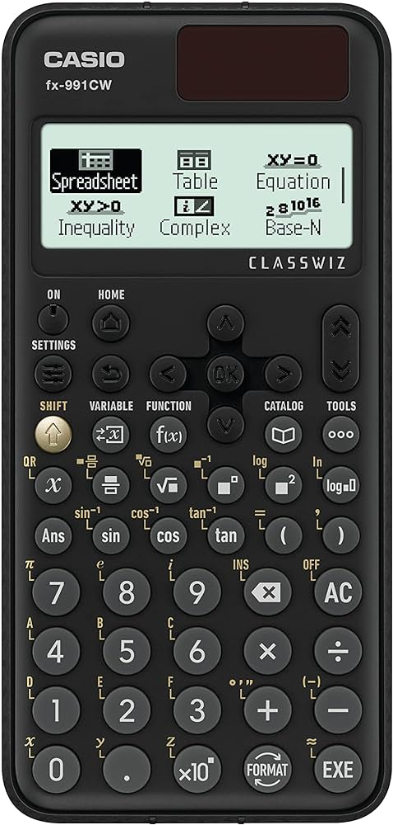the casio fx- 991 CW is another embedded system by the brand of casio. While it was developed years after the fx- 991dex , and is much faster than it’s predecessor, it has received several criticisms from users on it’s layout and interface. One anonymous student said “They’ve buried many functions in menus that they could have exposed on the keys. Much slower to use .. overall downgrade.” Despite it’s faster processer, this calculator is slower to use for some due to the several menus needed to navigate, showing the importance of a user- friendly interface. However, one feature this calculator has which is appealing is 10 variables that numbers can be stored in. The project calculator will therefore ensure it is simple to use without menus, and will offer the storage of variables, avoiding the issues of the 991 CW while including it’s strengths.

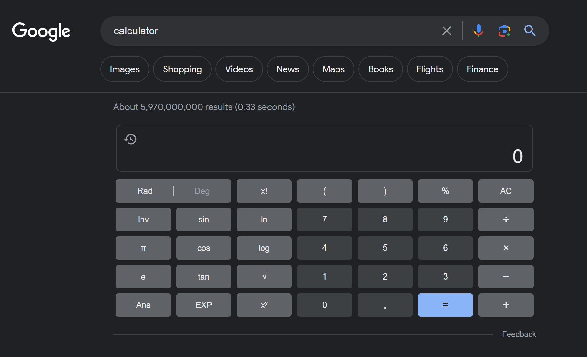
Google Browser Calculator
Another existing solution is a browser calculator or online calculator. In this case, the one provided by google. This solution is free and is also compatible with keyboard input, as the user can choose to either use the buttons of the GUI or type their expression into the search – bar. It is also convenient, as the user is not required to download any program and can access this calculator simply by typing “calculator” into google. For those who own a general – purpose PC this may be the most convenient option. It is made to suit a range of demographics, with the number buttons in a distinct colour so they can be easily differentiated from the rest. This means google can provide more functions without the GUI appearing cluttered or hard to navigate. The only drawback of this solution is that it requires internet access to be used, and is best suited to small and quick calculations.

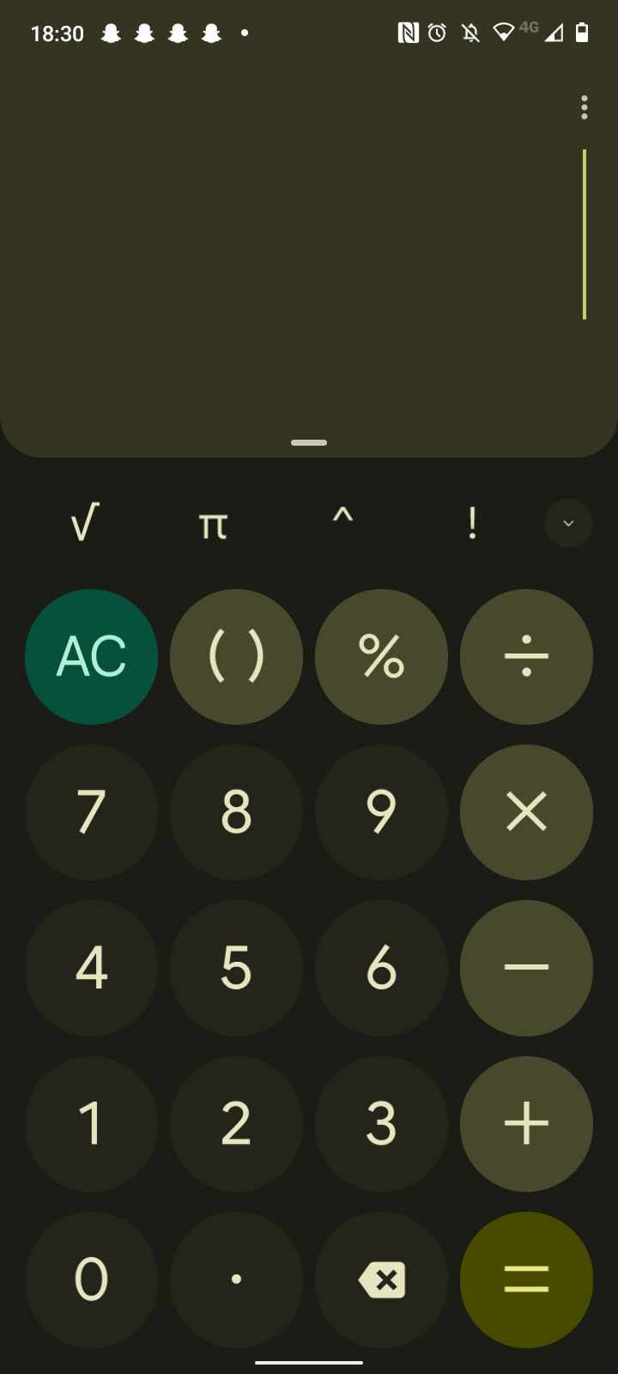
Phone app calculator

This solution is similar to the browser calculator, but it doesn’t require internet access. Most modern phones come with a calculator app installed for convenience. This one is specifically designed to be compatible with the phone’s interface. It is very minimalistic, the numbers appear very large on the screen, therefore long equations would be difficult to type. It’s portability is an advantage, most people carry phones with them and this means they don’t have to carry a physical calculator as well.
This sort of calculator could be used to calculate prices in – store , or be used by a student who forgot to bring their own physical calculator to class. However, it has less functions than the average student’s calculator, so may not be the perfect solution.

Requirements

The calculator software will have the following essential features
- The user can input numbers and symbols using buttons
- The user input will appear on a virtual screen
- The calculator will be able to process any arithmetic expression and return an answer
- When processed the answer will be displayed on the calculator’s virtual screen
- The calculator will have functional DEL and AC buttons
- The answers will not be rounded and they will be displayed in exact form
- The calculator will be able to store answers using the “ANS” button so they can be re- used
- The calculator will be able to function on phones as well as computers

Justification
Feature | Justification
The user can input numbers and symbols using buttons | The user must be able to express what mathematical problem they need the calculator to solve , however to fit in with the traditional interface of a calculator as well as to reduce syntax errors, buttons will be used for input that are confined only to valid symbols and numbers.
The user input will appear on a virtual screen | Many mathematical expressions and calculations can become long and complex so it is important for the user to be able to clearly see what they are typing and spot any logical errors, as well as syntax errors eg. A missing bracket or the incorrect operator.  This also makes the process easier to track and understand for the user.
The answers will not be rounded and will be displayed in exact form | It is vital that the results of the calculation are reliable and accurate, as while for some purposes rounding and truncation are useful, for more small and precise measurements the user may require to see the exact form.
The Calculator will be able to function on phones as well as computers | In order to make the software more accessible and convenient to a wider demographic it must be able to run correctly on most devices including mobile phones. This is to give the program the portability of a physical calculator.
Functional DEL and AC buttons  As well as a Functional ANS button | These buttons are common on popular calculators. They can make use much more quick and efficient which is valued by a user who wants to do a lot of calculations. The DEL button is a necessity while the AC and ANS buttons will speed up different processes.
Multiple variables | When working out a large calculation the user might have to write down long decimal numbers on paper so they can re- type them later. To make this process faster, they can instead use multiple variables to re- use numbers.

Requirements
Software
The program will be written in python with the use of two additional libraries called GuiZero and SymPy.
There are many methods of installing python libraries onto devices other than computers, such as python-for-android, a packaging tool for python apps on android , as well as Pydroid3, which can be found in the google playstore.
Python itself, or just a python interpreter can be downloaded onto windows, Linux, Mac, AIX, IBM I, VMS and Solaris.
For this program, especially since it makes use of libraries that are compatible with more recent versions, an interpreted from Python 3.0 onwards is required to run it.
Because of this, in order to run the software, both a series 3 Python interpreter, as well as GuiZero and SymPy libraries must be installed onto the device along with the program itself.
Hardware
Because the program requires no keyboard typing and relies only on buttons for input, it does not require a keyboard or microphone for input and can be used with any touch- screen device as well as a monitor with a mouse. As long as the device has a display and some form of user input so that the user can interact with the program it can be run.
There are no requirements for Wi-Fi or Bluetooth connections either as the software is self- contained with everything It needs to perform calculations. Being a relatively simple program it also won’t take up much space on the computer. The processing and algorithms executed by the program will have reduced strain on the processor as they are fairly simple and only process a limited amount of data at a time, since the user can only manually type out calculations, large amounts of data can’t be fed through it at once, so there is little to no risk when it comes to the performance and speed of the program on any given device.

Limitations

The software has these limitations.
- Each calculation must be typed out separately – meaning that the calculator can’t be fed hundreds of expressions in bulk to process and then be left to do it over a period of time . It is only intended for personal use and for the user to receive the output themselves.
- It can only store one output at a time, meaning the value stored in the ANS button is replaced every time a new expression is processed.
- The software lacks graphical capabilities, meaning it is unable to generate graphs, which is possible with some modern screen calculators.
- The software is only provided as a python interpretable file and relies on external python libraries in order to run correctly.

Success Criteria

Requirement | Success Criteria
Type number or symbol buttons | When hovered over, the button turns a different shade  The button being pressed causes the character to appear on the virtual screen  DEL and AC buttons also work properly
Enter a valid expression | Output an answer to the expression  Quick output , under 5 seconds  The output is correct  The output is in exact form
Enter an invalid expression | An error message appears  The message specifies which type of error has occured
Algebraic functions | The calculator is able to process simple algebraic expressions  The software is able to use at least 3 algebraic functions such as integration and differentiation
Trigonometric Functions | The calculator can use at least 3 trigonometric functions
Logarithms | The calculator can process expressions using log, ln, and e
Statistical Functions | The software can use at least 3 statistical functions such as the combination formula
Store results | The Software stores the last answer  It can be retrieved using the “ANS” button  This works as a value in expressions with a correct output
Store Variables | A variable can be edited by the user using only the GUI  The values of variables can be retrieved and used in expressions

Project design

Decomposition
The problem can be decomposed into several broad areas which can be developed seperately and using pipelining:

- GUI
The GUI will be a vital feature of the calculator as the program will rely heavily on the user’s interactions with the GUI. Because of this, many other elements of the program will be dependent on it, so it has to be completed to some extent before work on any other part of the project can begin. It will enable usage of all features as well as containing the output so it must be easy to read, use and navigate. It will contain a virtual screen , or display box in which both the input and output will appear just as they do on a traditional calculator design.
Further decomposition:
- Display main window
- Display virtual screen
- Display buttons which are labelled
- Select modes

Input and display
This decomposed problem will allow the calculator to respond when buttons are pressed and display the user’s input on the virtual screen. This is required for the user to be able to keep track of what they are entering, and the display will later be used for outputs as well.

Translate into and out of python language
Once this problem is solved the program will actually be able to read what the user inputs as mathematical expressions rather than a string. To achieve this all symbols and ways of typing expressions have to be read as how they would be written in python.
- “×” = *
- “÷” = /
- “^” = **
As well as this, the mathematical functions which aren’t pre – existing in python need to be Imported. This includes logs, trigonometry and differentiation, so that when these expressions are typed the program can interpret them even without the use of it’s pre- existing operations.
basic operations
combining the use of the Input and Display, GUI and ability to evaluate expressions, the program now needs to be able to complete all of these operations with testing:
- Addition / Subtraction
- Multiplication / Division
- Multiplication with the use of brackets
- Indicies
- Square roots
Shift mode
In order to make room for more buttons and uses on the calculator, this decomposed problem will allow the buttons to each take on different functions and as a result will make more operations possible. For example, the sin() button will become a cosec() button.
- All functions of buttons that are affected will change according to the shift.
- The symbols displayed on the buttons as well as on the virtual screen when typed will change as well, making it visible to the user
- The buttons will be fully functional, give correct outputs and be able to change back and be used alongside each other in expressions.

Trigonometric functions
This will include sin, cosine, and tan. Using a secondary mode on the calculator, cosec, sec, and cot buttons should also be available. This section as well as the logarithms section will be simple to implement and will make the calculator more accessible and useful.
- Sin()
- Cos()
- Tan()
- Cosec()
- Sec()
- Cot()

- Logarithmic functions
This will include ln() and log() and using shift, there will also be an e button in order to reverse the natural log.
- Ln()
- Log() without adding a base, uses base 10
- Log() is able to work with an added base
- e^x
Algebraic operations
All operations which fall into the algebraic or calculus category will be able to be completed. This includes the use of the shift mode. This area is important as it will set the calculator apart from other online / virtual calculators. It also needs to be programmed separately to features such as arithmetic and trigonometry because it will need separate functions to be performed.
- Differentiation (using shift)
- Integration (using shift)
- Indicies
- Square roots
- Expanding / factorising
Output and save Answers and Variables
This area is important as being able to use ANS and variables will make the experience of using the calculator much faster and more efficient.
- Answer is correct, and appears on the virtual screen
- Answer is saved to the ANS variable
- Answer can be recalled using the ANS button
- Variables Can be edited within the program
- Variables can be used in expressions
Here is a flowchart which illustrates how the problem is being broken down using decomposition and pipelining. Some areas rely on previous areas while others can be completed in a more flexible
order.

Algorithms
Each decomposed problem can be solved using algorithms.
Here is each algorithm used:

GUI
Object- oriented programming and the library called GUIzero will be used to make a simple GUI. This area can be further decomposed into separate algorithms:

- Create The window

Main = App(“calculator” , height = 600, width = 350)
Main.display()

- The virtual screen

Screen_box = box(main, border = True , height = 100 , width = 200)
Display_text = Text(screen_box , align = “left”)

- The buttons

def create_button(parent, command, text, grid)
box = Box(parent, layout = “grid”, grid = grid)
button = PushButton(box, command = command, text = text, grid= grid)
button.bg = “white”

box.when_mouse_enters: button. bg = “ blue”
box. When_mouse_leaves: button. bg = “white”

Input + Display
Building on the GUI algorithm, each button will have its own command triggered by input.

- Buttons trigger commands

One = create_button(grid, lambda: display(1) , “1” , [0,0])
There are separate modules for different ways the user can interact with the display and how the app responds.
- Input: type, display: characters typed

Def display(num):
Num = str(num)
Screen_value += num

- Input: DEL , display: delete last char
Def delete():
Screen_value = screen_value[:-1]

- Input: AC , display: clear display
Def clear_all():
Screen_value = “”

- Input: mouse hover, display: button change colour

Def on_enter(button):
Button.bg = “blue”

Def on_leave(button):
Button.bg = “white”

Translate into Python
This area will use a function that the input is passed through so the calculator can read it as an expression.

Def read():
Replacement = [[“^” , “**”],[“div”, “/”]], etc.
For I in range (len(replacement)):
If replacement [i][0] in screen_value:
screen_value = screen_value. Replace (replacement[i][0],replacement[i][1])

Basic Operations
This problem fits together all the previous ones. GUI buttons that have basic operators are used and they can now be inputted and translated into a basic expression. Now, a function can be added that will calculate the result of the expression and display it.
^ example of the operator buttons
Output + Save Answer
Def findanswer():
Replace()
Try:
X = sp.symbols(x)
Expr= sp.sympify(screen_value)
Result = sp.N (expr.subs(x,0))
Screen_value = str(result)
Except:
Screen_value = “Error”

This makes use of predefined modules from the Sympy maths library which is made to evaluate mathematical problems.
Sp.symbols() is used to set the letter x as an algebraic variable in the expression as it is the only letter which is being used on the calculator, while some calculators may include the use of more variables.
Sp.sympify() is going to read and evaluate the expression and return it’s value, passing it with the variable result which will be given as the screen value.

Alternate mode
This makes use of the GUI feature and expands upon it, giving buttons alternative uses.

Shift_pressed = False
Keep track of mode
Alter mode (this function is called by the shift button)
Def toggle_shift
Shift_pressed = not shift_pressed

Function to differentiate between shift and not shift. This will be called by buttons.

Def button_use();
If shift_pressed:
If value == “log”:
screen_value += “10”
Elif value == “ln”
screen_value += “e”
#etc
Else:
Display(value)

Trigonometry , Algebra & logarithms.
Now that an alternative mode is available there will be more space for trigonometric and logarithmic functions. These buttons can be added to the GUI.
Also, the calculate_result() function can be linked with other similar algorithms for expanding, factorising, differentiating and integrating.

Def operation(type):
If len screen_value > 100:
print: “input too big”
Try:
x = sp.symbols(“x”)
expr = sympify(screen_value)
if type == “differentiate”:
result = sp.diff(expr, x)
elif type == “int”:
result = sp.int(expr, x)
#etc.
screen_value = str(result)
Except:
screen_value = “error message”

Save Answer + Variables
The ans variable will be added to the other operations so it is saved.
Variables for buttons correspond with a file. Buttons to use these functions will also be added to GUI
Def toggle_store():
Store_mode = not store_mode

This store mode will determine what the variable buttons do , if they are used for typing in an expression or to be saved to.
Def savel_variables():
Variables = {dictionary}
With open(“filename”, “w”) as file:
For key, value in variables.items():
File. Write(f”{key}:{value}\n”)

Def load_variables():
Variables = {dictionary}
With open (“filename”, “r”) as file:
for line in file:
key, value = split(“:”)

Here is a table to keep track of each module which will be made use of in the program.
Module | Parameter | output | Variables
Create_button() | Parent  Command  Text  grid | Displays an interactive button | none
displaychar() | num | screen_value + num | display_text, screen_value
delete_char() | none | screen_value[:-1] | display_text,  screen_value
clear_all() | none | “ “ | none
On_enter() , on_leave() | button | Change button colour | none
replace_chars() | screen_value | The user’s inputted string with various characters replaced | screen_value
calculate_result() | none | The answer  or  “error” | expr  result  screen_value  display_text
Toggle_shift() | none | none | Shift_pressed (Boolean)
toggle_store() | none | none | Store_mode (Boolean)
Handle_button_press() | value | A string of what to display  Or what function to call | Shift_pressed  Store_mode  Screen_value
Perform_operation() | Operation_type | The answer  Or  Error message | Screen_value  Ans
Save_variables() | none | none | Variables  file
Load_variables() | none | none | File  Key  value

All of the requirements for the program will be met by these modules working together.
Input | - Using the OOP method, a class called Pushbutton() is put to use to create several similar buttons which are used for typing.  - The module shift_mode() will also respond to the user and allow them access to more buttons.  - The modules displaychar(), delete_char() and clear_all() are used for typing and editing. These will take the button’s input as a parameter and concatenate it to a string which will contain the expression that the user types. The expression will also be displayed.
Processing | - The module replace_chars() will translate the expression in order for the computer to more easily interpret it.  - Using pipelining, The module calculate_result() will take the output from the module replace_char() in order to then interptet the expression and come up with an answer, or display an error message if the expression is erroneous.
Output | - Following the result from calculate_result() , it will be displayed on the screen by using the global variable screen_value , and the output will also be stored so that it can be re- used.

Variables
Here is an explanation of some of the most important variables in the program
Variable | Data type | Purpose | Global / local
Screen_value | String | Records the inputs by connecting them together into one string, which will be used to update the display text. | Global
Display_text | String | This corresponds with what text is on the display and instantly updates when this variable is changed. It displays both the input and output. Only one of these can be held in the display at a time, so there is only one display variable. | Global
expr | String | The expression which is evaluated by the calculator. For example, 2(x+3) . It only holds one expression at a time, so there is only one expr variable. | local
Ans | Float or string | Stores the previous answer before it is wiped from the screen, allowing the user to re- use the answers from previous calculations if they need. | local
Shift_pressed | Boolean | If shift is on, it will be true, if not, it will be false. | local
Store_mode | Boolean | If the store mode is on, A, B, C, and D buttons will be used to store values rather than to be used in an expression | local
A  B  C  D | Float | These will read and store the correct variable values. They can also be changed by the user. | Global

Data structures
Stack- the string which is displayed on the virtual screen will be treated as a list of numbers and characters, and string manipulation will be used in order to add more characters to the end, or take away from the end. Because edits can only be made to the “top” of the string, it is similar to a LIFO stack data structure, which uses push and pop commands. In this case the displaychar() and delete_char() functions take the roles of push and pop. In a stack the element which was inserted (typed) last is the first to come out (be deleted) and this applies to the string. This data structure is efficient in using memory space as it leaves no gaps and uses a contiguous block of memory. However, it dosen’t allow for random access, meaning that if the user wants to delete a character in the middle of the expression, they will have to delete all the ones they typed after it as well.
A more complex data structure isn’t required for this, however, the use of the stack can limit the usability of the program, as it means the user is expected to manually type out brackets for functions such as sin(x) , since it is impossible to type between the brackets.
Nested lists – several nested list will contain co- ordinates for the grid that the buttons of the calculator will be arranged on in the [x,y] format. For example, the location of number one can be found as the first element in the numbers_box list, at the co-ordinates [0,0].

Input validation
Because the user will be making use of a virtual keyboard it is possible for them to type invalid expressions, and there are different possibilities for errors caused by user input.
Input | Possible error
2++2) | Syntax
1 ÷ 0 | Runtime
Length 100+ | Crash Program, Can’t see whole expression

Input validation can’t account for logical errors, which don’t crash the program, however it can help to prevent the program crashing due to any other type of error. For this particular program the code blocks try: and except: have been used in order to combat errors. As well as conditional if statements to prevent inputs that are too long.
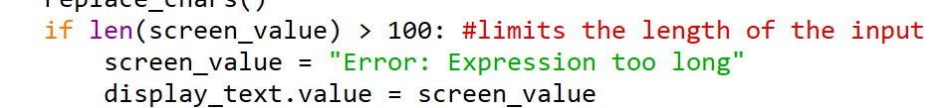
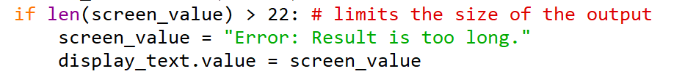

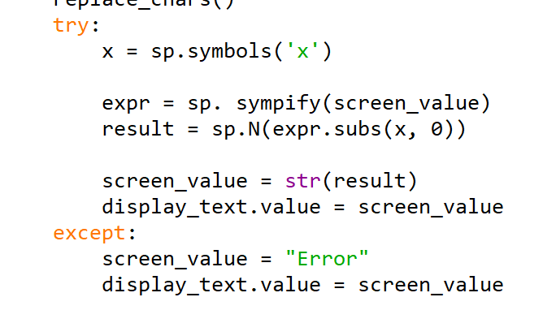
The try block tests a block of code for errors. In this case, it will attempt to run the five lines of code contained within the try block.
These are the lines where errors could occur due to user input, as the program is going to attempt to evaluate the expression stored in screen_value using the sp.sympify() module from the sympy library. It is then going to use the line sp.N(expr.subs(x,0)) , which will substitute the letter x with zero, solving the inputted equation for f(x) if required.
The first step could face a syntax error , or a runtime error, and the second step could also cause a runtime error. The following two lines can only be executed if a result is achieved from the first three lines, which is why they are also included in the try block.
If an error occurs, instead of crashing the program will abandon these lines of code and display an “Error” message on the virtual calculator screen , letting the user know that what they typed either had an invalid syntax or led to a math / runtime error.

interface design and usability

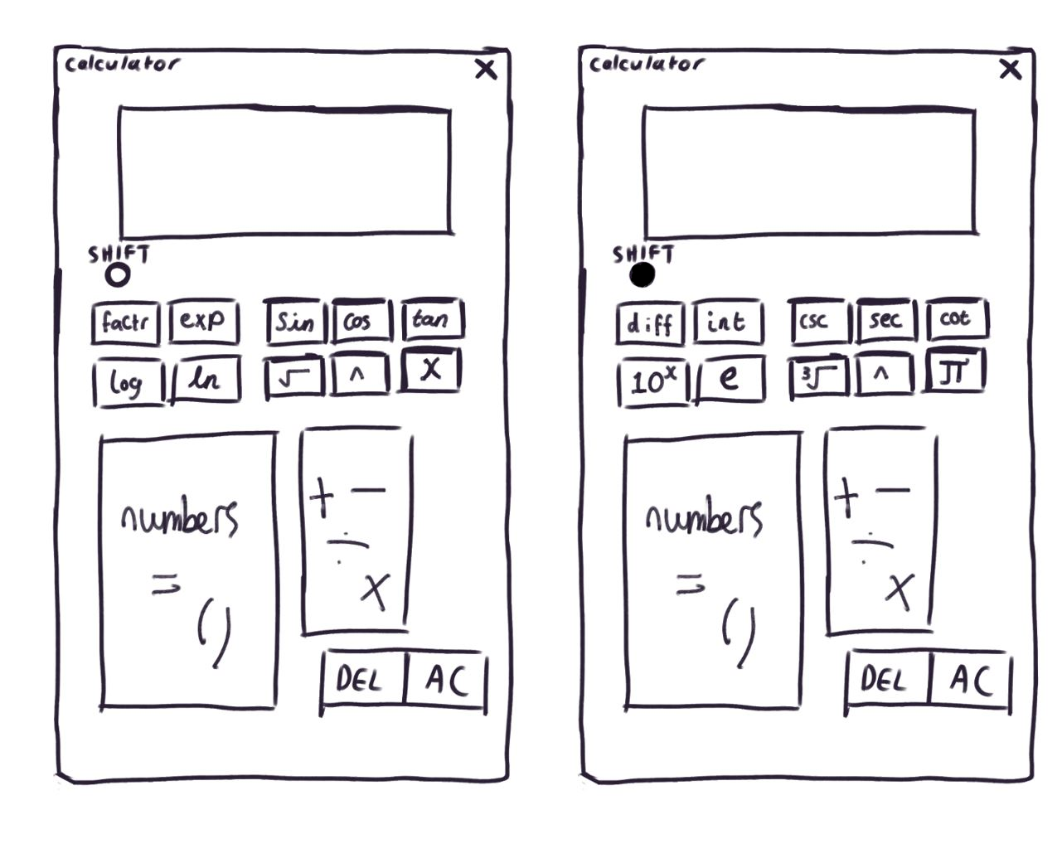
Here is a visualisation of how the calculator will be laid out, using a simple arrangement of buttons. It also illustrates which buttons will change when the shift mode is used, allowing for a wider range of functionality.
To improve usability, the interface makes use of a simple, minimalistic layout with large labelled buttons, which use commonly recognised mathematical symbols. The display screen allows the user to keep track of what they are inputting and will display all answers in their exact form, making them suitable for any purpose. The interface is extremely simple and accessible through a mouse, trackpad, touch screen or stylus. The only downside of the usability of this program is that it is possible for the user to make mistakes as they are expected to manually type out the closing brackets following the name of a function such as sin.
This program will be tested thoroughly against it’s success criteria as well as any other possible issues using iterative testing.

Test Plan

Before It is completed this app will be thoroughly tested with iterative tests, user tests and a final test comparing it to it’s success criteria.
Iterative tests will take place at the end of each prototype stage. Different features will also be shown with screenshots through development.
Normal testing: Using the program as intended. This will include inputting various calculations and actions that would be expected in normal use.
- Entering calculations
- Using the different functions
- Saving and editing variables
Extreme testing:
- This means testing the boundaries of valid normal use to know the limitations of the software and what it is able to handle. This will include entering extremely long values, as well as calculations that will put an extreme amount of strain on the software.
Errenous Testing: This will include logical and syntax errors. This is best tested through inputting invalid expressions. Such as 3)4 and 2 divided by 0.

This program will be tested thoroughly against it’s 9 success criteria as well as any other possible issues using iterative testing. With 16 main tests to be checked iteratively and finally at the end of the development:

Test No. | Justification | Test Type | Data | Expected result
1a | Button Hovered over | Normal | Mouse hover over, then leave button | Button changes colour
1b | Button Pressed | Normal | 1  + | appears on virtual screen
2a | Expression : Valid | Normal | 2 + 2 | Return Correct Answer
3a | Expression : Invalid Syntax | Erroneous | 3 ( 4 | Error
3b | Expression : Invalid Logic | Erroneous | 1 / 0 | Error
3c | Expression : Extremely large number | Boundary | 300 ^ 10000000 | Return Correct answer or Error message
3d | Expression : Blank | Abnormal | Enter | Nothing or Error message
4a | Factorise expression | Normal | x^2 + x | x(x + 1)
4b | Expand expression | Normal | x(x + 1) | x^2 + x
4c | Differentiate expression | Normal | x^2 | 2x
4d | Integrate expression | Normal | 2x | x^2
5a | Expression: trigonometric | Normal | sin(90) +1 | 2
6b | Expression: logarithmic | Normal | Log(10) | 1
7a | Statistical function | Normal | nCr (9c2) | 36
8a | Expression Using Ans Button | Normal | - Set ANS to 3  - ANS + 2 | 5
9a | Set Variables  And use Variables in an expression | Normal | - Set A to 4  - A + 4 | 8

User testing
At least 10 individuals who fit the stakeholder descriptions will be asked to test the calculator. They will be given no instructions and this will allow me to gauge how easy the software is to interpret. They can also give feedback and suggestions for things they would change about the software and things they like about it.

Code Development

Prototype 1
For this project I have chosen to create a graphical user interface that works as a calculator. By making use of the libraries GUIzero and SymPy, The first prototype can complete all non- algebraic calculations including a square root, sin, cos, tan and indices. It has an error pop- up when required as well as working DEL and AC buttons. It works as the user enters an expression, such as “5 ÷ 3 “ , by pressing the buttons, and an answer will appear on the calculator screen.
It uses symbols which are more recognisable than the operations used in python code, making it more accessible to the user.
The shift and mode, factorise and expand buttons which aren’t currently functional are intended to add more options as well as to set the calculator to different modes such as Boolean or algebraic operations.

Input | Output
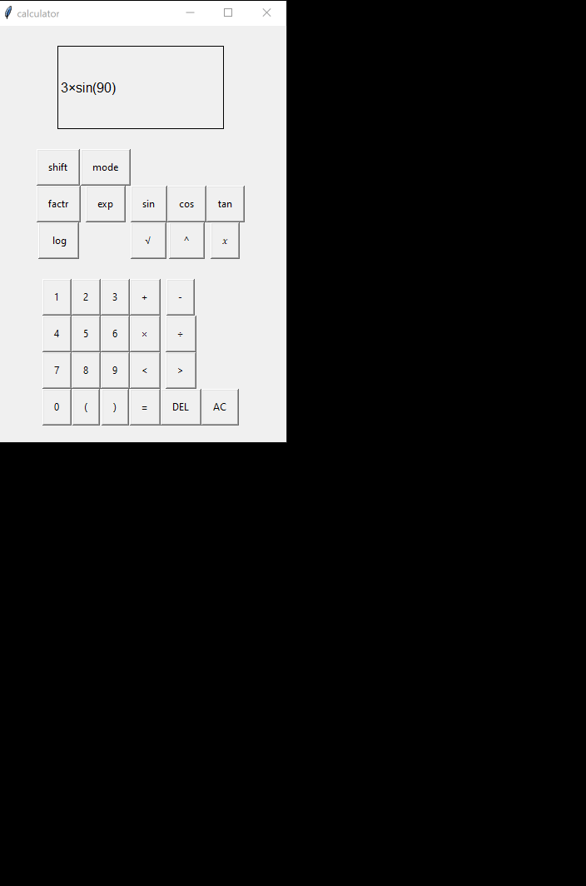 | 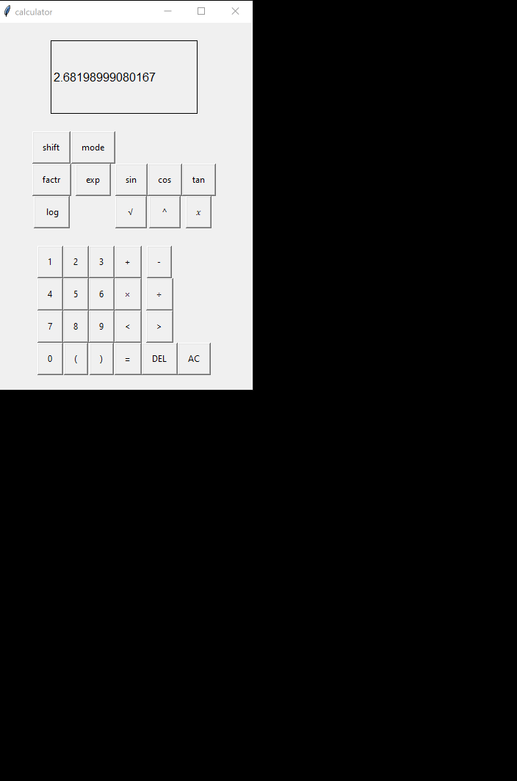

Here is the code for the first draft of the calculator, which can do basic calculations:
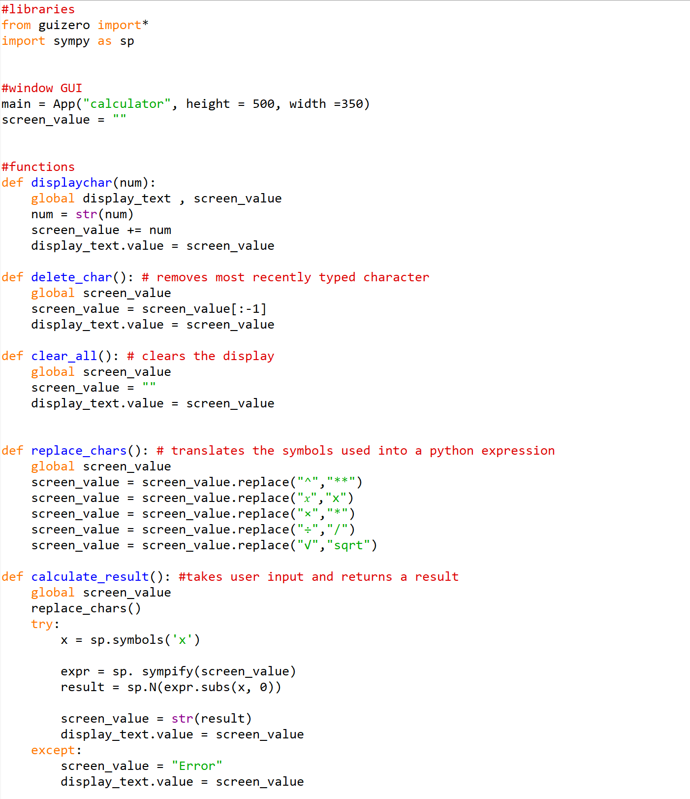

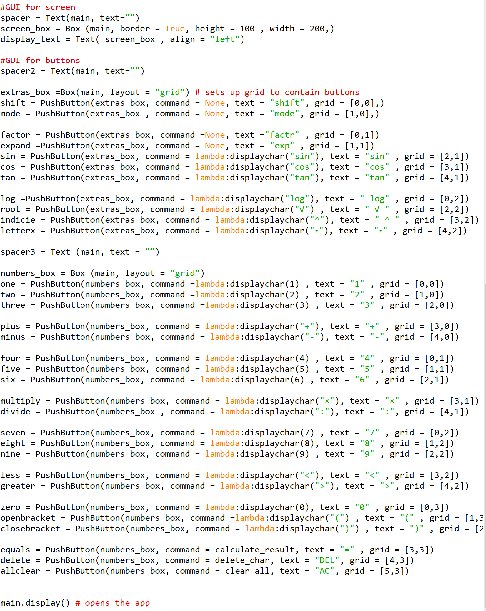

Opens the app

Libraries

The two libraries used in this application are SymPy and GUIzero.
GUIzero is a beginner – friendly library for creating UIs, working with the standard Tkinter library. It uses abstraction to simplify aspects of it’s code, making it easier to understand and use. However, as a result of this it is slightly more limited than other libraries such as PyQt. Because the calculator can be represented with a relatively simple UI, I have chosen to use GUIzero.
SymPy Is a symbolic library for python which can be used for all kinds of mathematic equations including algebraic functions such as integration.
There is a pre- existing function in python called eval() which could be used to evaluate a string (the input) as a python expression. However, using eval() can come with security risks as it can execute arbitrary code. Because of this, the library “Sympy” would be better to use for this purpose. As well as this sympy is more suited to complex maths including algebra.
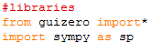

Both libraries can be easily installed to any computer using pip in the command prompt.
The use of the * means that I am importing all functions in the GUIzero library.
I import sympy as sp to make it easier to type. Both libraries are imported before anything else is written, with functions following after it before the main code.

GUI

Since the calculator is going to work based on pressing buttons for input, I went straight to setting up a GUI for the first prototype.
App() is a function from the GUIzero library which defines a window for a GUI to be set up in. Using object – oriented programming, There are several classes provided in the GUIzero library, and ones which I have used instances of in this GUI include ‘App’, ‘Box’, ‘Text’, and ‘PushButton’ .
The variable screen_value is going to contain the string that will be displayed on the GUI “screen”.
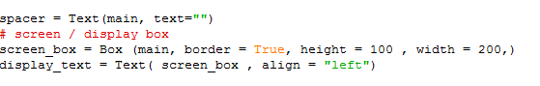
Here the screen has been added to the window called main. The screen is actually a text box, which will display both the user’s input as well as the program’s output. It is made from two components, calling the ‘Box’ and ‘Text’ classes.
There is evidence that inheritance has been used to create the different classes used to make the UI, since it includes similar attributes such as height and width in both the ‘App’ class and the ‘Box’ class.
I have used a grid method in order to display the buttons. 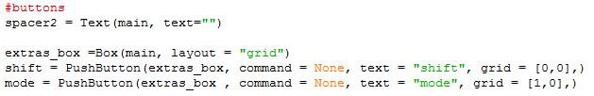
To do this, I have used another instance of the “Box” class, except this time instead of using it as a text box I have used it to create a grid which my buttons appear on. In order to space out the buttons I created two boxes, extras_box, and numbers_ box. (numbers_box actually contains plenty of symbols as well, but it is the section that has numbers in it.) On either side of the screen as well as between the two button grids, I have used Text to create spacers in order to make the GUI appear less cramped. spacer2 is one example of this.
App “main”

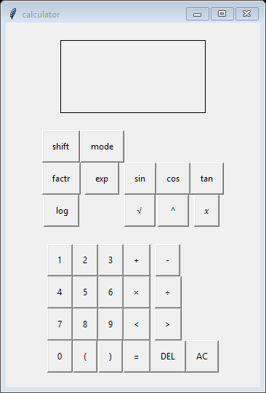
Text “spacer3”
Box “numbers_box”
Pushbutton “tan”
Box “extras_box”
Text “display_text”
Box “screen_box”

Buttons

Admittedly the section of code containing the buttons could be more organized (eg. Grouping the numbers and operators separately) and less repetitive, but this is how it appears now.

Each of the buttons containing a number or symbol to be typed work relatively the same way, so here is an example:
The number 3 is stored in the easily – identifiable variable ‘three’.
It is created as an instance of the PushButton class, and inside a pair of brackets are a list of it’s relevant attributes:
- numbers_box,
It is contained inside the ‘Box’ object called ‘numbers_box’, which is a grid.

- command = lambda:displaychar(3),
When pressed, it calls the function displaychar(3) . The function displaychar() is what will allow numbers and symbols to appear on the calculator’s “screen “ when the buttons are pressed. In this case, it will trigger the number 3 to appear.
The keyword “lambda “ is used in the functions to display the symbols. This is because lambda is used for small, single – expression functions, such as triggering a symbol to appear. It means that the function will not be called when the button is created , either.

- text = “3”
this text is the actual label on the button.

- grid = [2,0]
this is the position that the button appears on the ‘numbers_box’ grid, being the third button along the first row.

In other display buttons, such as for operative symbols, there is a difference.

Because these symbols aren’t integers, and not all of them match the operators used in python, they are displayed as string instead.

The 𝑥 button ,

Functions
In order to be able to execute more complex operations and commands in response to user input, the buttons are connected to several functions, which are defined at the start of the code, after the imported libraries.

- displaychar()
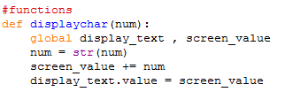

There are also two global variables in this function. While I am aware of the risks in errors and security that come with global variables I have assessed the risk of using them in my code, and since I am the only person working on this code and I Intend to keep a small number of variables which are easily distinguished, I have decided there is no harm in using them this time.

By making the variables display_text and screen_value, which control what appears on the calculator display, global, It means that each of my functions can make changes and have an effect on what appears on the calculator screen.

This function is called when any character button is pressed – numbers and other symbols – so that when the user types “2+2” it is displayed on the screen.

The parameter “num” is a place holder for whatever piece of string is going to be displayed. For example if the user were to press the 2 button:

(2) would be passed to the function as a parameter.

The number or symbol is then converted into a string. This is because the text on the calculator screen needs to be able to be manipulated like a string, being able to concatenate and remove items from it is important.

- delete_char()

This function is called whenever the DEL button is pressed, it’s purpose is to delete the most recently typed character. This is where we can see the stack structure that is being used to store the characters, and the delete_char() takes the role of a pop() command, popping the last value off of the screen_value string.
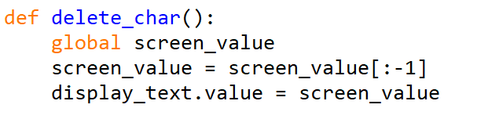
In line 3, The slicing notation [:-1] removes the last element in the string and replaces the string with this new value.
Then, it is sent to the display_text variable, meaning that the amended string is now displayed on the virtual screen.

- clear_all()
this function is called whenever the AC button is pressed, it’s purpose being to wipe the screen entirely of any values.
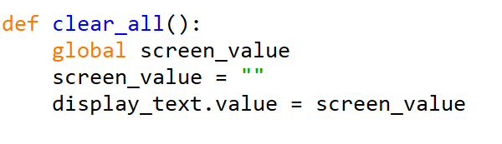
All it does is set the screen_value to “”, which will appear as a blank space on the screen. Then, it sends this value to be displayed on the screen using display_text.value.

- replace_chars()
this function is called by the calculate_result() function when the equals button is pressed. The program quickly translates the screen value into code that is readable by python. For example, the ^ symbol for an indices is replaced by ** , which is the python operator for indices.

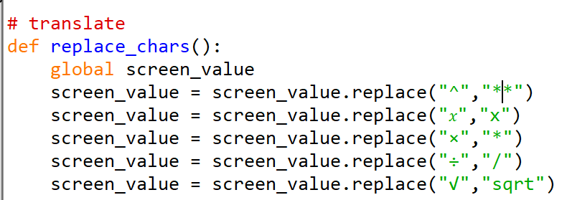

- calculate_result()
this function is called when the equals button is pressed. It’s purpose is to interpret the expression given by the user and return the correct answer.
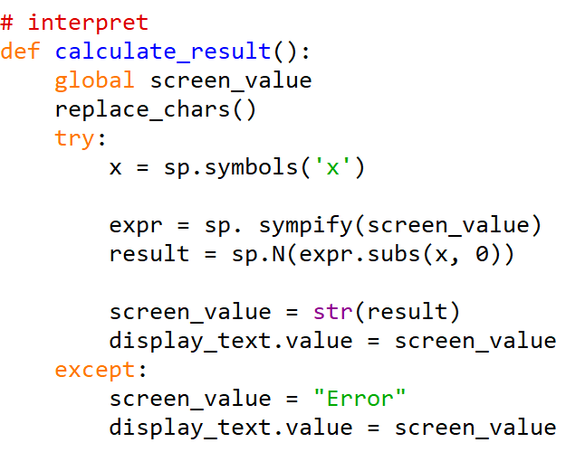
At the start of the function, the replace_chars() function is called, which returns the screen_value in a format which can be interpreted using the SymPy library. This function makes use of several features in the sympy library in order to be able to interpret a variety of expressions.


This line creates a symbolic variable ‘x’ using the ‘symbols’ function from the SymPy library. This means that when the x letter button is used it will be interpreted as a variable.

Here sympify() is used to convert the screen_value string into a SymPy expression.

Here, expr.subs(x,0) means that the “x” symbol is substituted with the value 0, then it can be evaluated as a numerical value using sp.N. The result is then stored in the variable “result”. This will work whether or not any symbols are included in the expression.
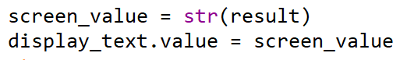
Then , the numerical result is converted back into a string, and displayed on the virtual screen of the GUI.

All of this section of code is wrapped in a “try” block, so that if an exception occurs during the execution (eg. The input is invalid) , it catches the exception and sets the screen_value to “Error”. The error message is then assigned to the value attribute of the display text. This helps to take care of cases where the input is not valid or encounters other issues during evaluation.
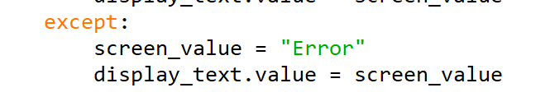

Testing
A series of tests were done to inform development. These tests are based on the success criteria to record my progress.

 | Justification | Test Type | Data | Expected result | Actual result
1a | Button Hovered over | Normal | Mouse hover over, then leave button | Button changes colour | Nothing happens
1b | Button pressed | Normal | 1  + | 1 appears | 1 appears
2a | Expression : Valid | Normal | 2 + 2 | Return Correct Answer (4) | 4
3a | Expression : Invalid Syntax | Erroneous | 3 ( 4 | Error message | Error
3b | Expression : Invalid Logic | Erroneous | 2 ÷ 0 | Zero error message | Zoo
3c | Expression : Extremely large number | Boundary | 300 ^ 10000000 | Return Correct answer or Error message | Program Crashed
3d | Expression : Blank | Abnormal | Enter | Nothing or Error message | Error message
4a | Factorise expression | Normal | x^2 + x | x(x + 1)
4b | Expand expression | Normal | x(x + 1) | x^2 + x
4c | Differentiate expression | Normal | x^2 | 2x | N/A
4d | Integrate expression | Normal | 2x | x^2 | N/A
5a | Expression: trigonometric | Normal | sin(90) +1 | 2 | 2
6a | Expression: logarithmic | Normal | Log(10) | 1 | N/A
7a | Statistical function | Normal | nCr (9c2) | 36 | N/A
8a | Ans Button | Normal | (Set ANS to 3)  ANS + 2 | 5 | N/A
9a | Variables  Set + use | Normal | Set A to 4  A + 4 | 8 | N/A

Screenshots
 | Input | Output | Analysis if needed
1a | Hover over button | Nothing happens | Not added yet
1b | 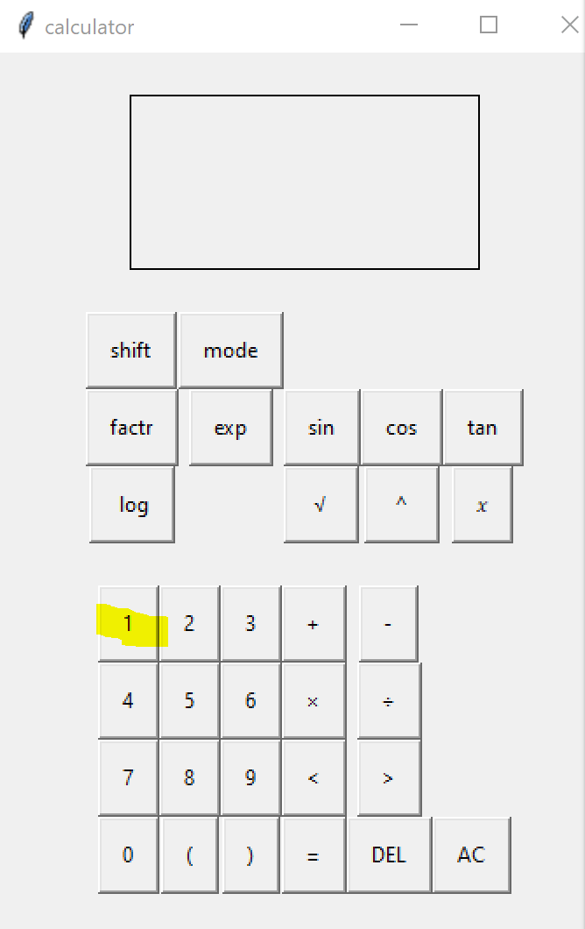 | 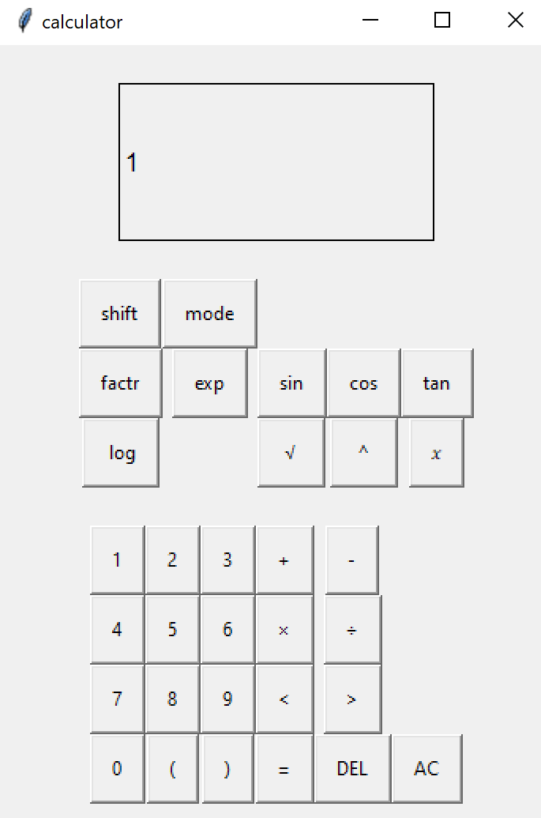
2a | 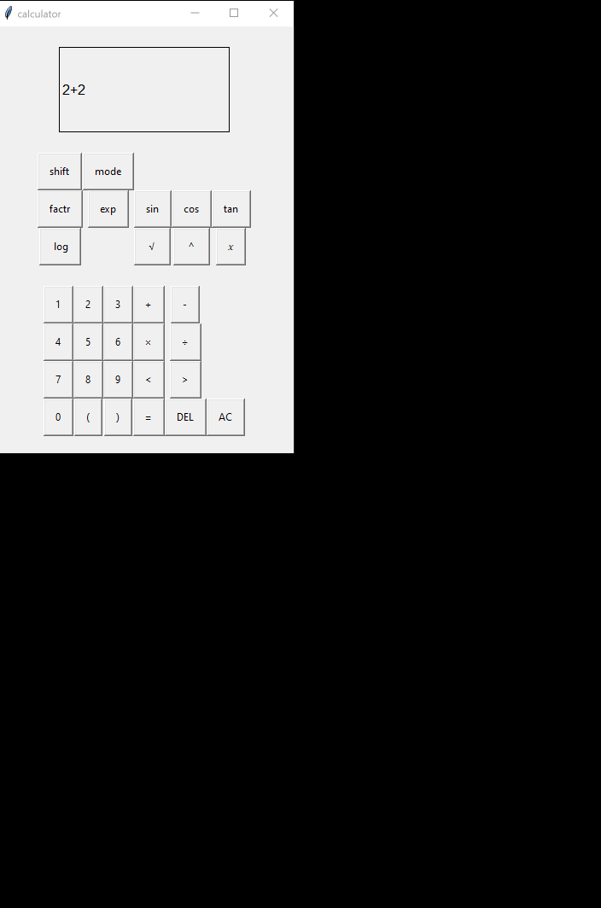 | 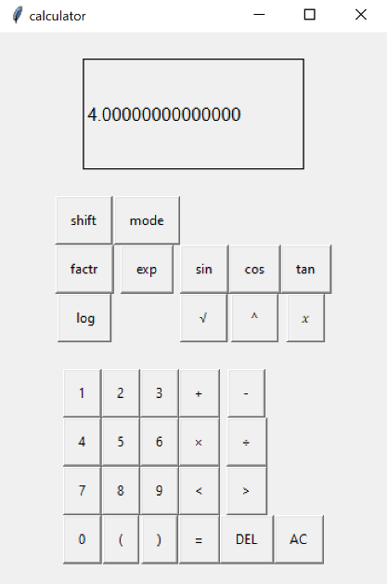
3a | 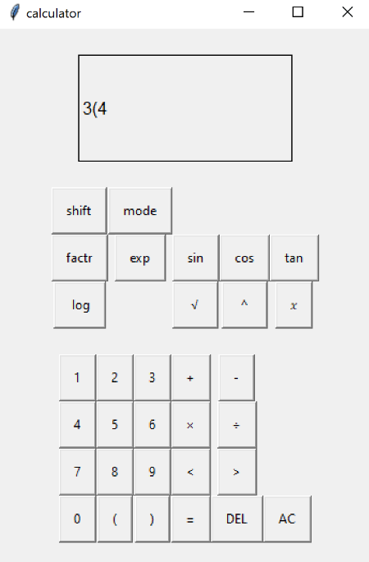 | 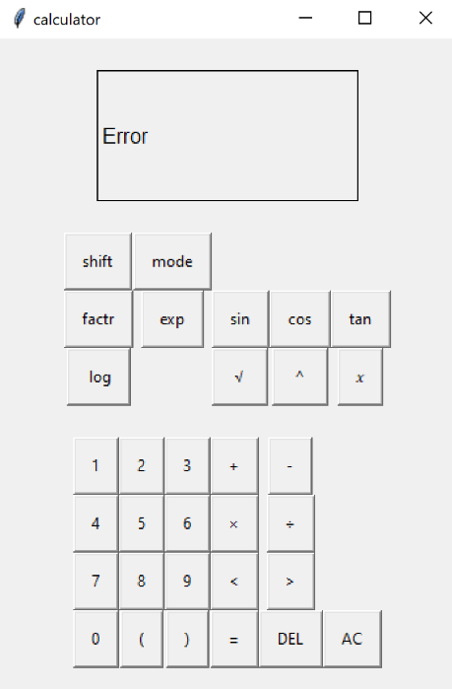
3b | 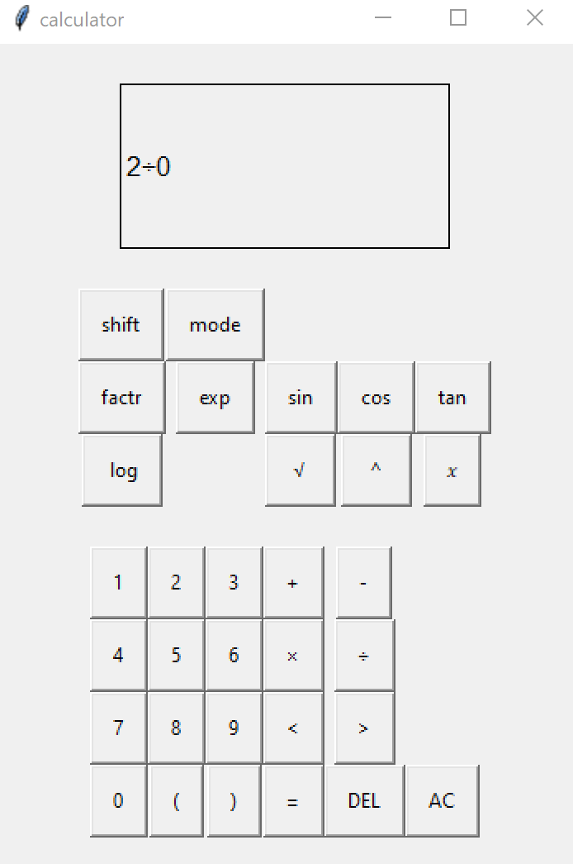 | 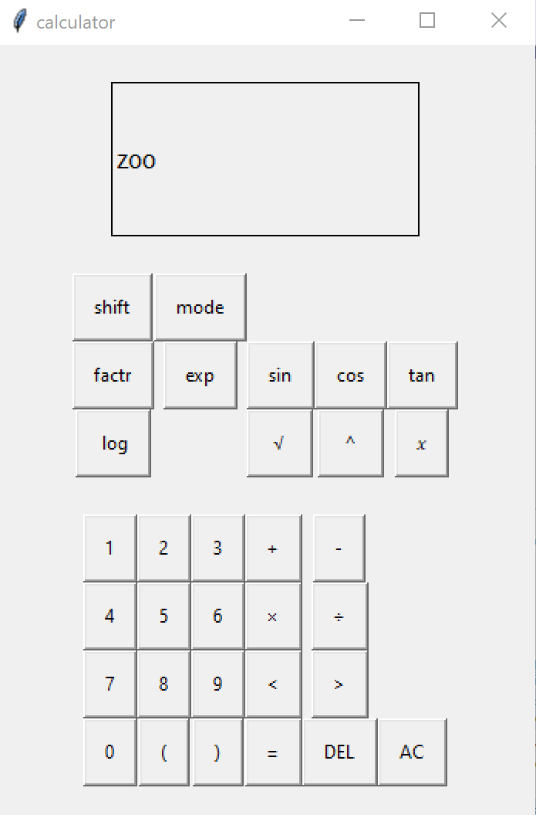 | There is a zero error message, however it needs to be rewritten so it’s easier to understand for all users of the program.
3c | 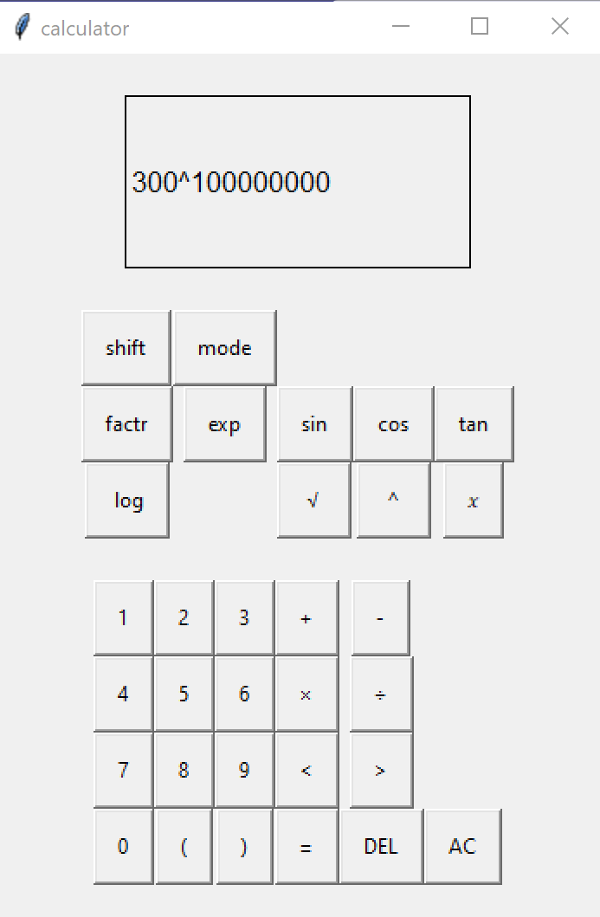 | 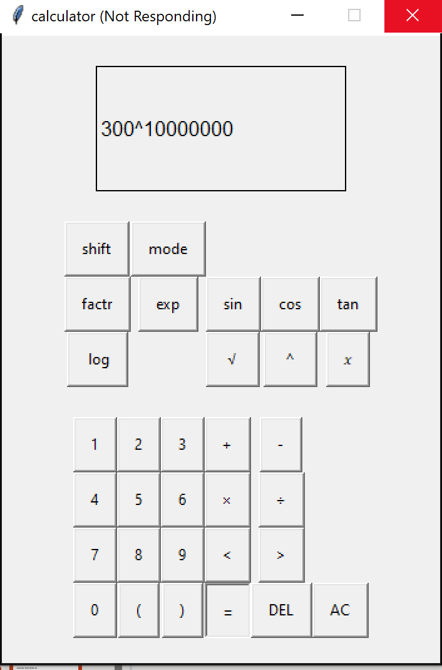 | The program crashed because the answer is too big. To solve this, a maximum limit must be set for the program.
3d | 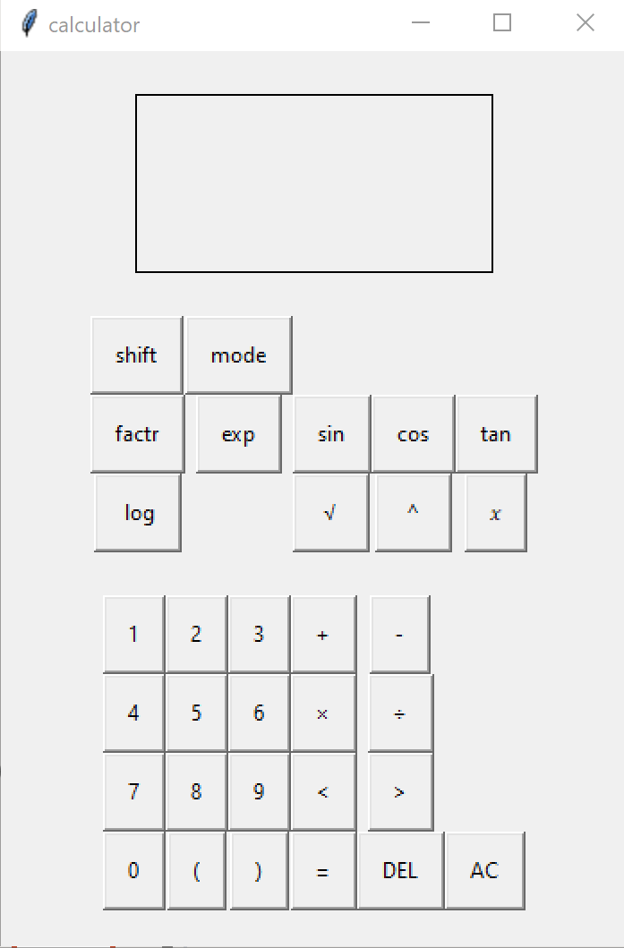 | 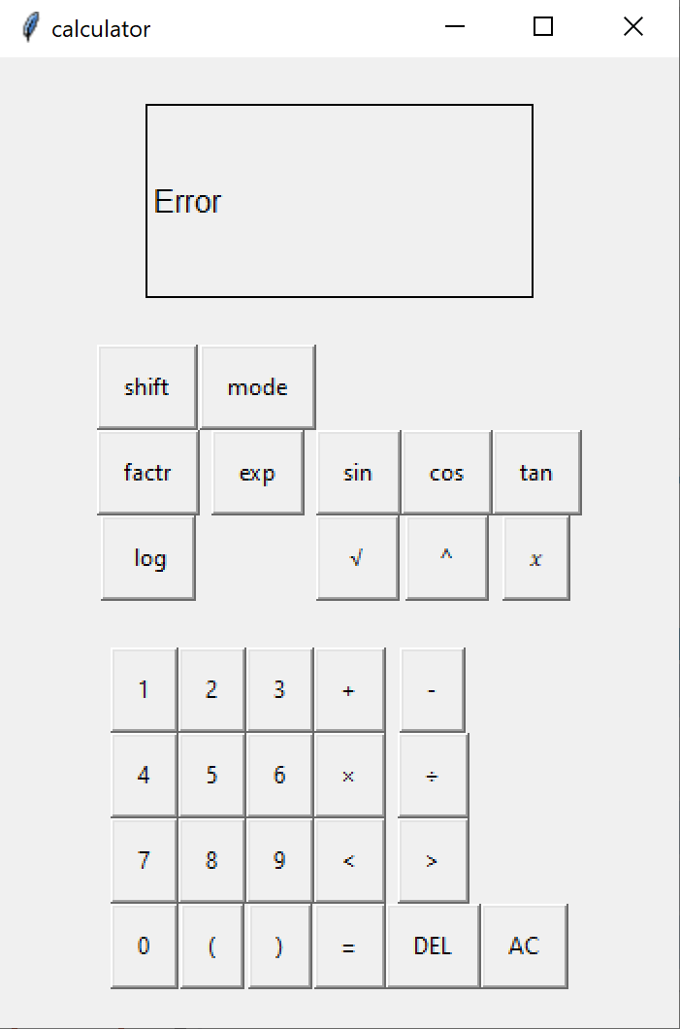 | This is OK , but it could do with not responding at all , as this would be more convenient for the user who might have just accidentally pressed equals.
4a | 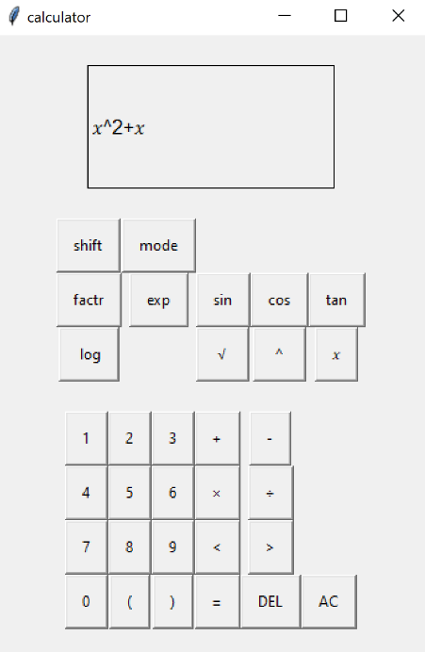 | Nothing happened | Not added function to factr yet
4b | 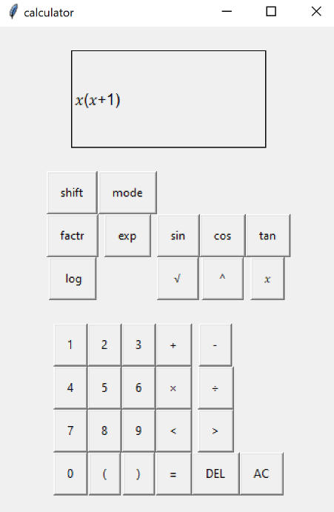 | Nothing happened | Not added function to Exp yet
4c | Differentiate |  | Not added yet
4d | Integrate |  | Not added yet
5a | 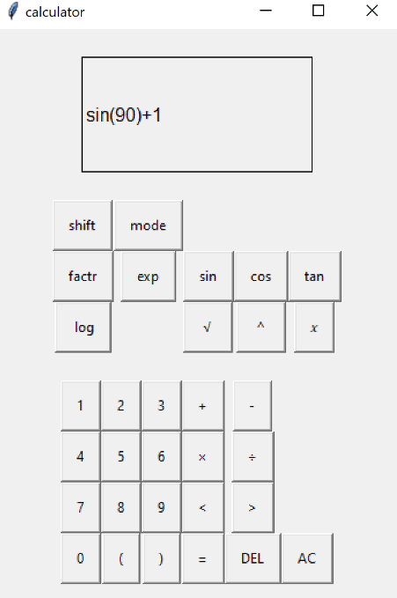 | 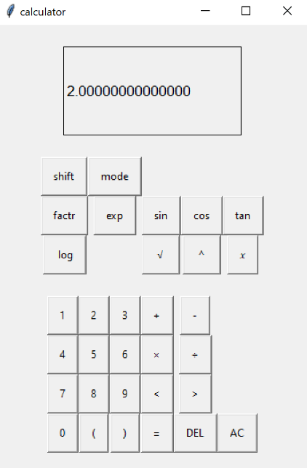
6a | Log |  | Not added yet
7a | nCr |  | Not added yet
8a | Ans |  | Not added yet
9a | Variables |  | Not added yet

Prototype 2
For the second prototype, I have decided to switch to object- oriented programming for buttons to reduce the number of lines needed. The second prototype includes all of the extra features of the calculator, while making use of the foundation which the first prototype provided. Here is an outline of the new features based on testing:
- object – oriented programming
- Buttons change colour when hovered over
- ANS button is functional
- Shift Button Is now Functional
- New Buttons added (natural log, differentiate, integrate, cosec, sec, cot, 10^ , e , cube root, pi)
- Algebraic features now work
- Preventative measures for program crashing
- Ignores empty inputs
- Specific error messages

Code

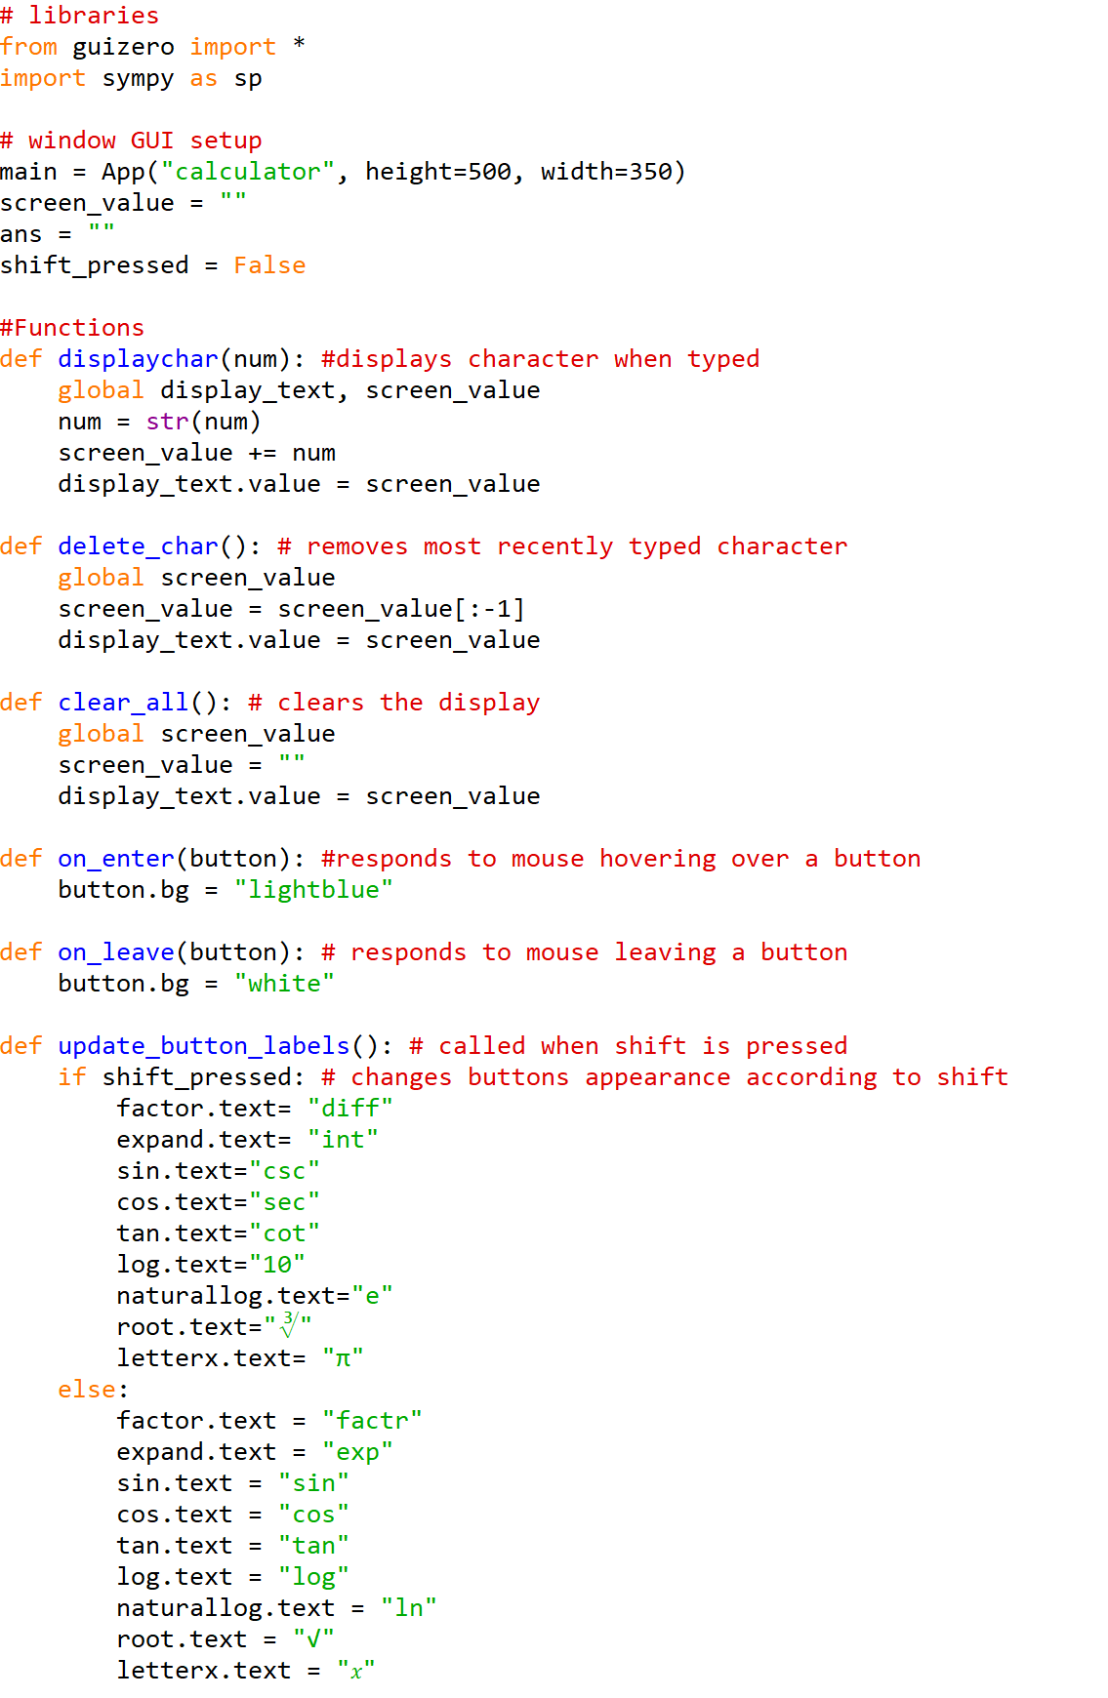

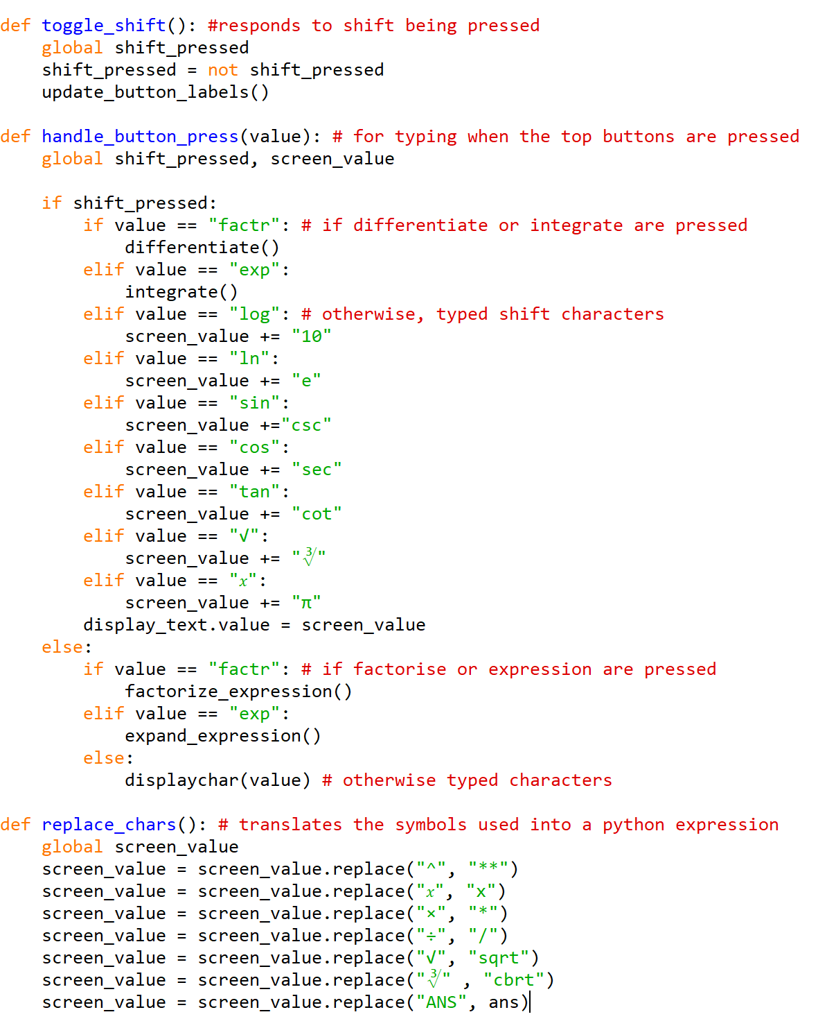

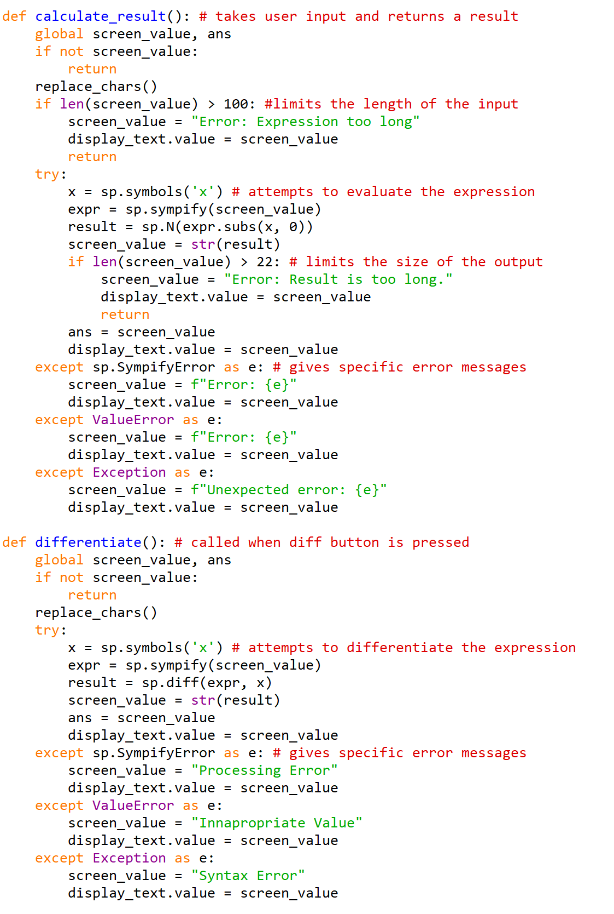

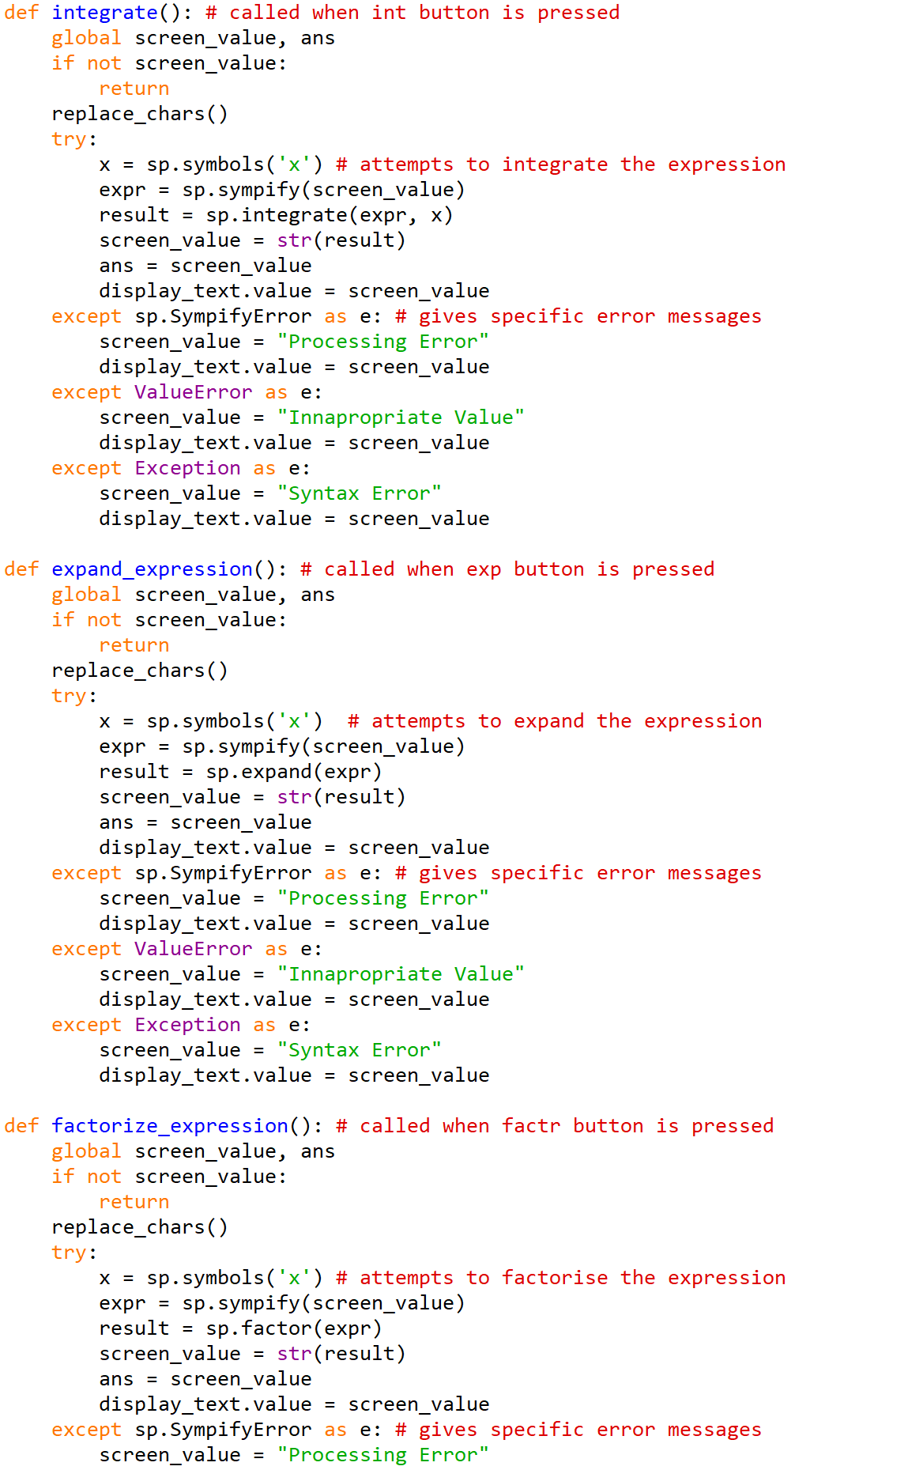

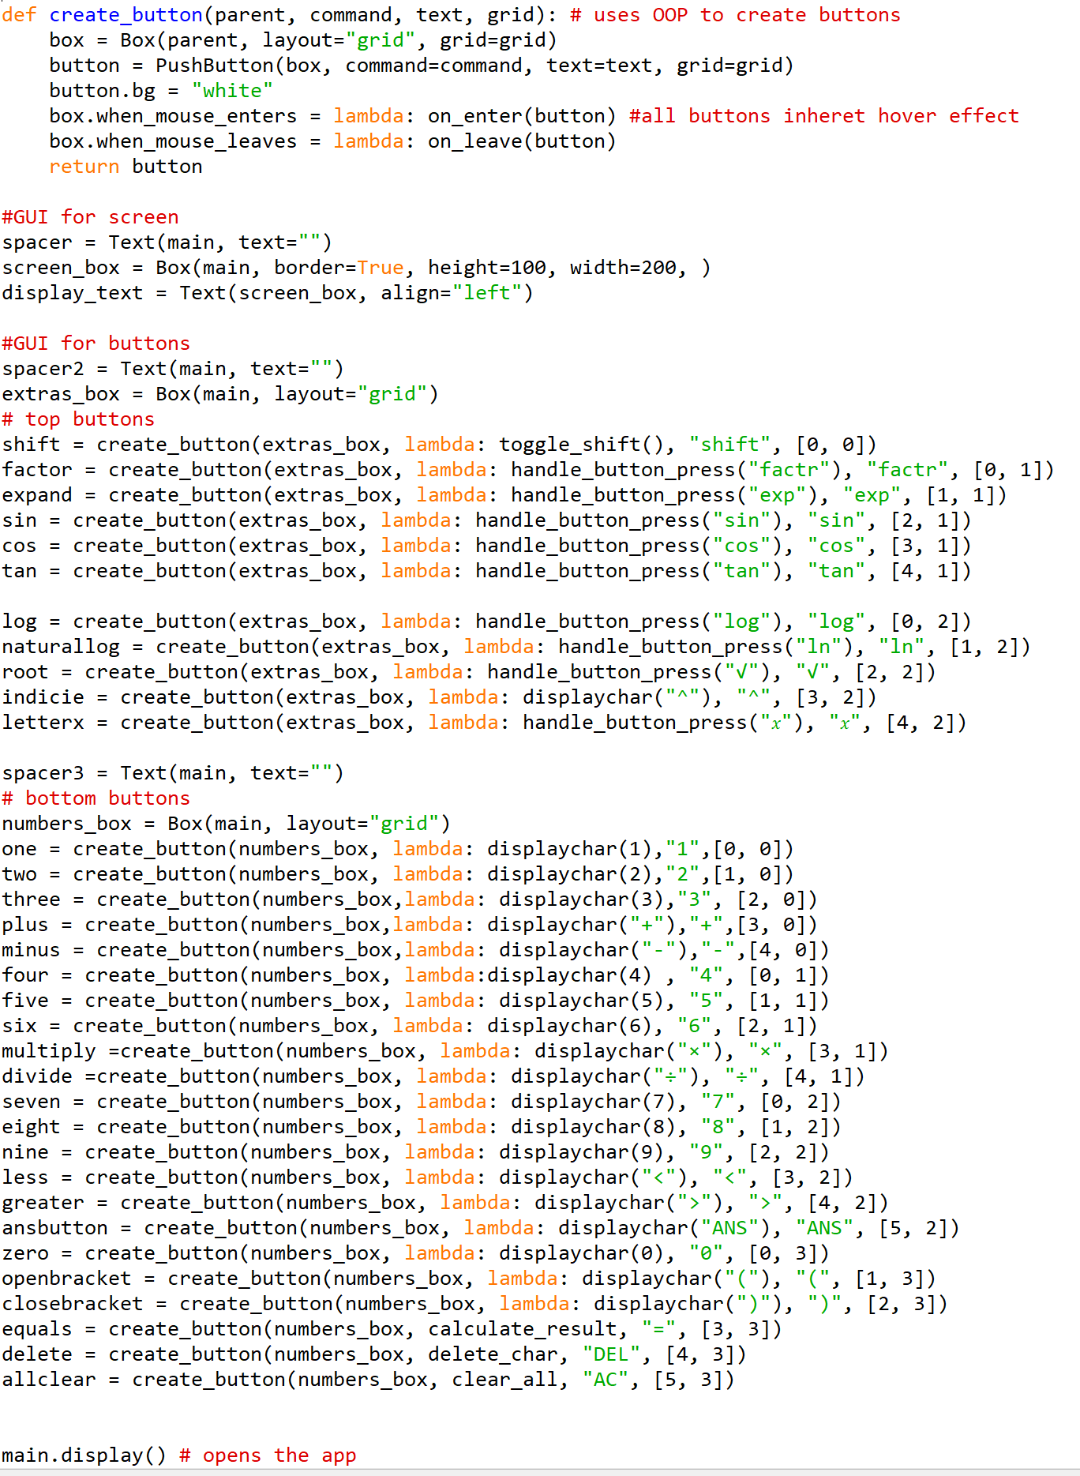

Object – oriented programming

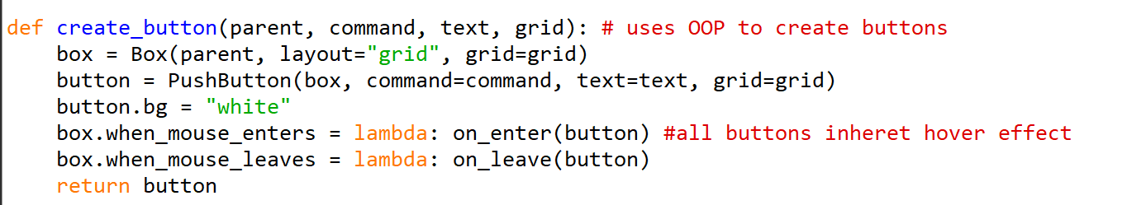
Button Creation Function

This function encapsulates the creation of buttons, making the code more modular and readable. It makes use of the pre- existing classes “box” and “pushbutton” from the guizero library I am using.
It sets the attribute “bg” of all buttons to “white”. Other attributes for buttons include their box, the command they are linked to , the text displayed on them, and their position in the grid.
The penultimate two lines in the function ensures that all buttons inherit the hover effect, meaning all buttons change colour to light blue when the mouse enters them and back to white when it leaves.
Button instances
Buttons are now made using the create_button function as opposed to the PushButton function. This decision was made, because I wanted to give all buttons the attribute of the hover effect, and found it was taking too many lines to assign this attribute to every button. As well as this, the attributes of the button are now much shorter to type out, as the third line of the create_button() function eliminated the parts of the class creation that are repetitive.

Buttons Change Colour When Hovered

These lines in the create_button() function mean that when the mouse enters any button, it will call on_enter(button) , and when it leaves, it will call on_leave(button) .
here are the new Functions which are referenced: 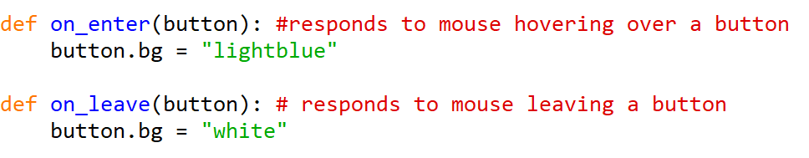
on_enter changes the background attribute of the button to light blue, and on_leave() changes it back to white.

Ans Button Is now functional

A new variable has been created at the start of the program called ans.
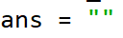

In the calculate_result() function, this variable is now added as a global variable and the result is stored inside the variable.
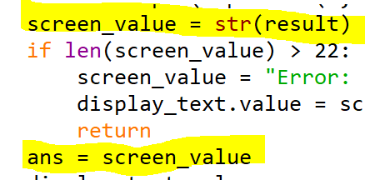

The ANS button has also been added using the create_button() function.
This button’s command attribute is to displaychar(“ANS”) , which means that the screen_value variable and then the GUI’s display are updated to add “ANS” to the end.
When the expression is evaluated by calling calculate_result() , differentiate() , integrate() , expand_expression() , or factorize_expression() , the second line of all of these functions calls the replace_chars() function.
In the replace_chars() function, ans has been added to the list of replaced characters.

You can see it in the last line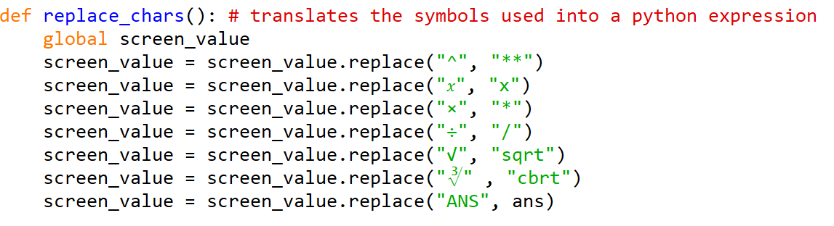

Now the string “ANS” is replaced with whatever value is stored in the variable ans. So it can be used to insert the result from the last calculation.

Shift button is now functional + new buttons added

The shift button is intended so that a wider range of use can be given to the calculator without having to clutter the GUI with too many buttons. This function means the top row of buttons can switch between different uses.

Here is the updated GUI appearance:
Unshift | Shift
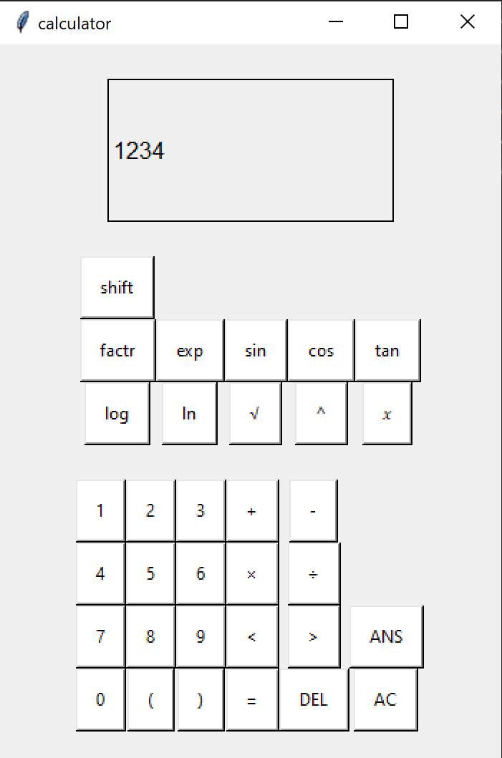 | 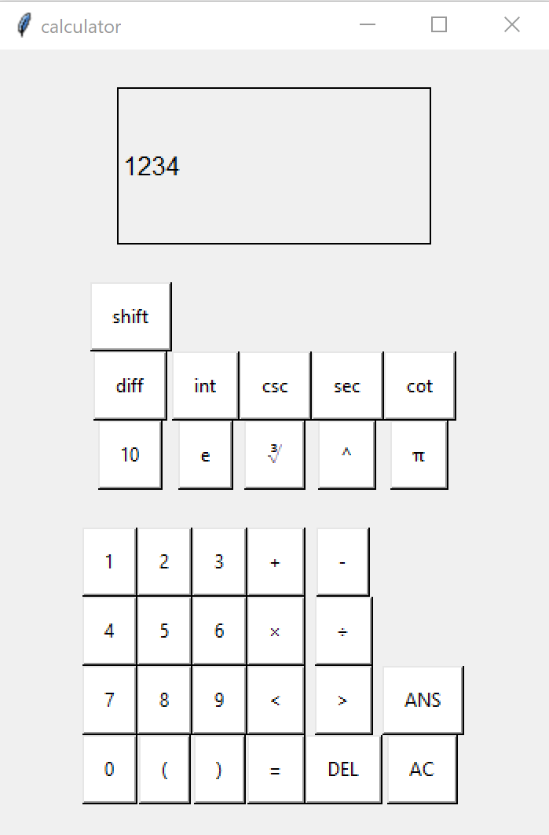

The top two rows of buttons all have an alternate use now, making the calculator more versatile.
A new variable has been added at the beginning of the code.
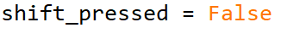
This is a Boolean variable to keep track of whether the shift button is activated or not.

toggle_shift() function
The shift button, which previously had it’s command attribute set to None, now calls the function toggle_shift().

This function changes the shift_pressed variable to the opposite of whatever it was before. It then calls another new function which takes care of updating all labels of buttons accordingly.
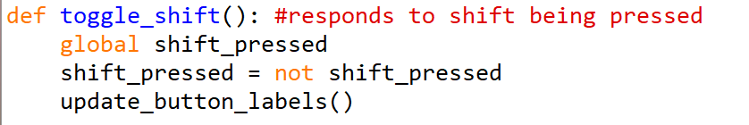

the update_button_labels() function changes the text attribute of all relevant buttons to their alternate. If the shift_pressed variable is true, then shift is on, so it changes all of their labels to their shifted version. If it’s false, then shift has been turned off, so it changes all of their labels back to their original version.

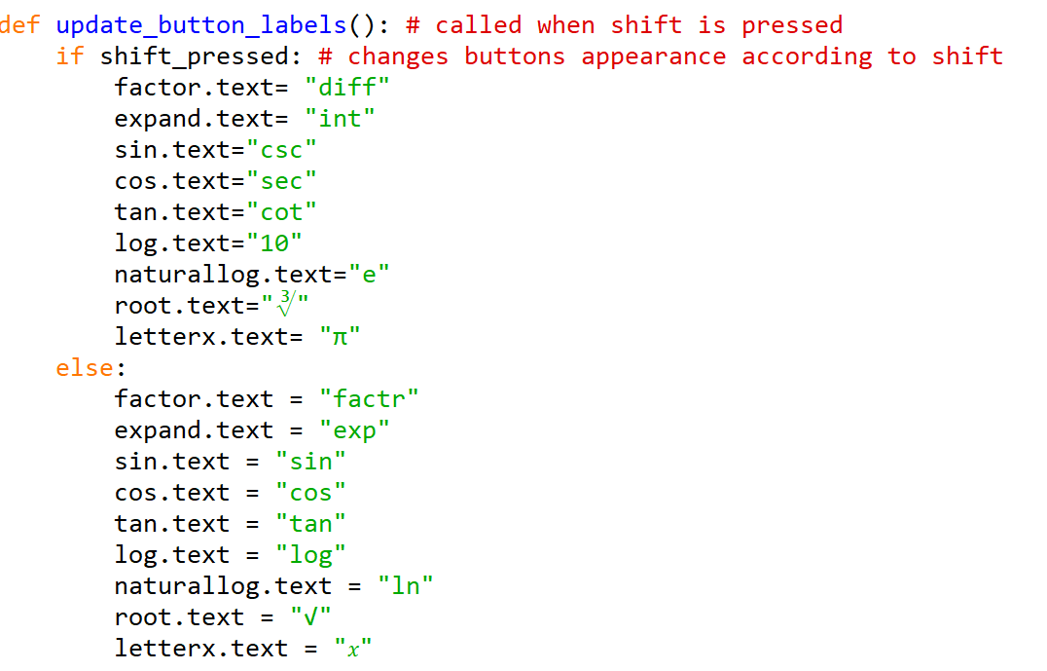
The commands given to each of the buttons in the top row has changed as well. Instead of going straight to displaychar() , It goes through a function called handle_button_press() now. This function checks to see if the shift is activated, and if it is , it performs the relevant command. If not, it performs the original command.
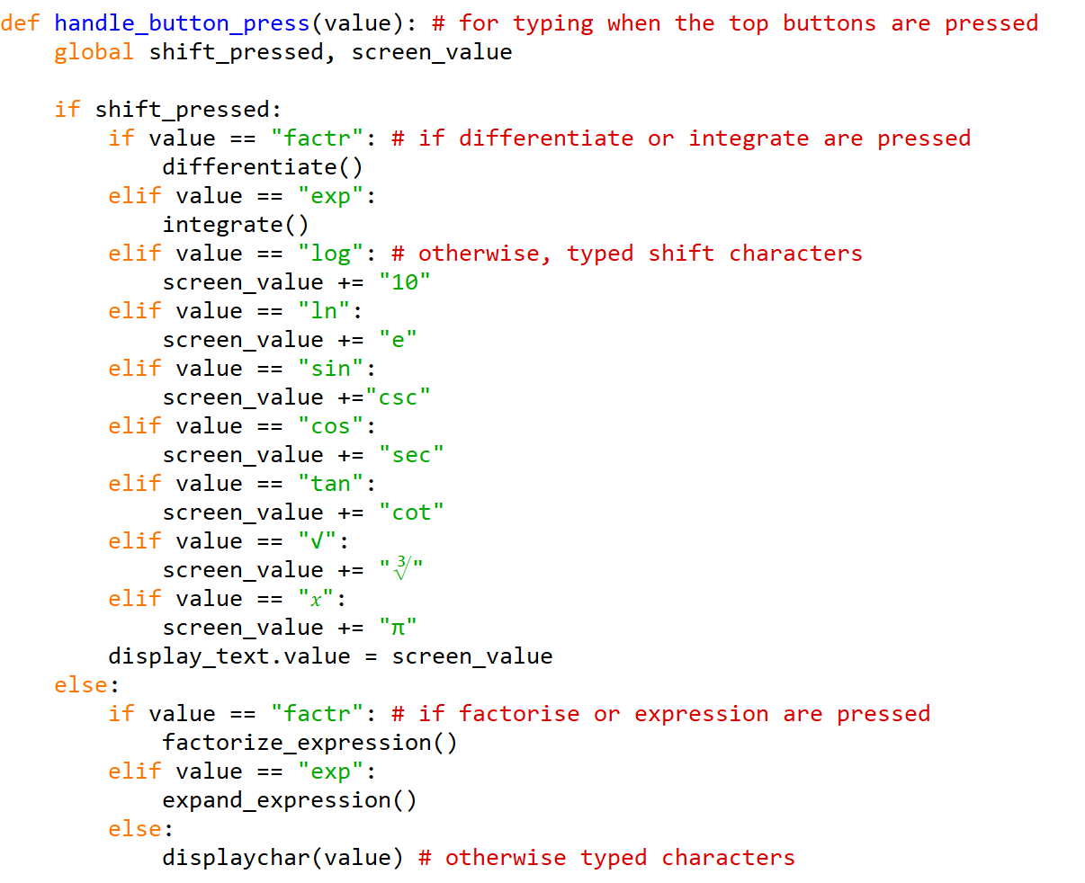
for example , if the button in the [2,1] coordinate of the extras_box is pressed, it calls the function handle_button_press() with “sin” as the parameter.

if shift_pressed = False | If shift_pressed = True
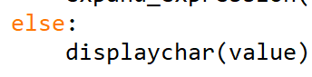  The function displaychar() is called, passing the parameter “sin” onto this function instead. The displaychar() function is the one used by all other buttons that are used for typing. | 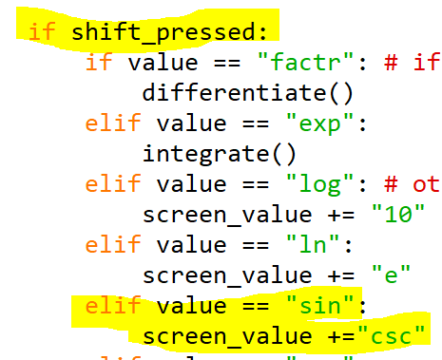  Instead of appending “sin” to the screen value, “csc” is appended to the screen value.
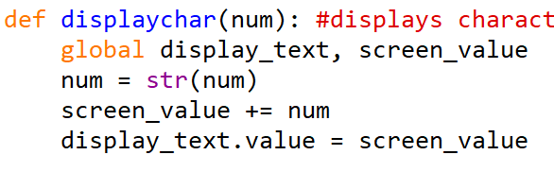  “sin” now appears on the screen. | Then , the display_text part of the GUI has it’s value set to the new screen value, meaning “csc” appears on the screen.

Algebraic features now work

These features include differentiation and integration as well as expanding or factorising the expression. The int and diff buttons are the shifted version of the expand and factorise buttons.
Therefore, the factor and expand instances now have handle_button_press() set to their command attribute.
Unlike all other buttons in the top row, these buttons are not for typing and instead work similarly to the equals button because they return a result. While the equals button leads to the calculate_result() function , four new functions have been added for the purpose of these four algebraic features.
Here is how they have been added to the handle_button_press() function:
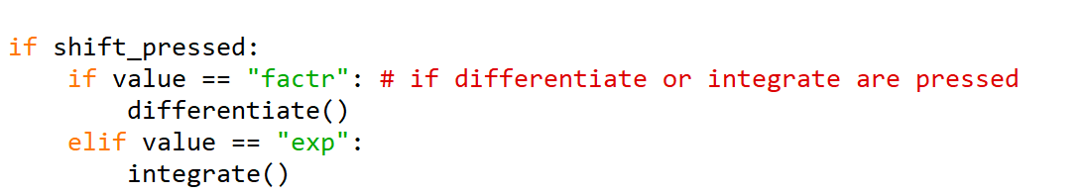
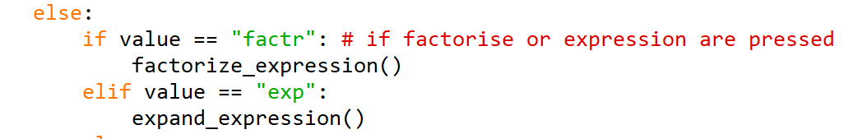
After checking the shift_pressed variable, the appropriate function is called. These are all similar to the calculate_result function.
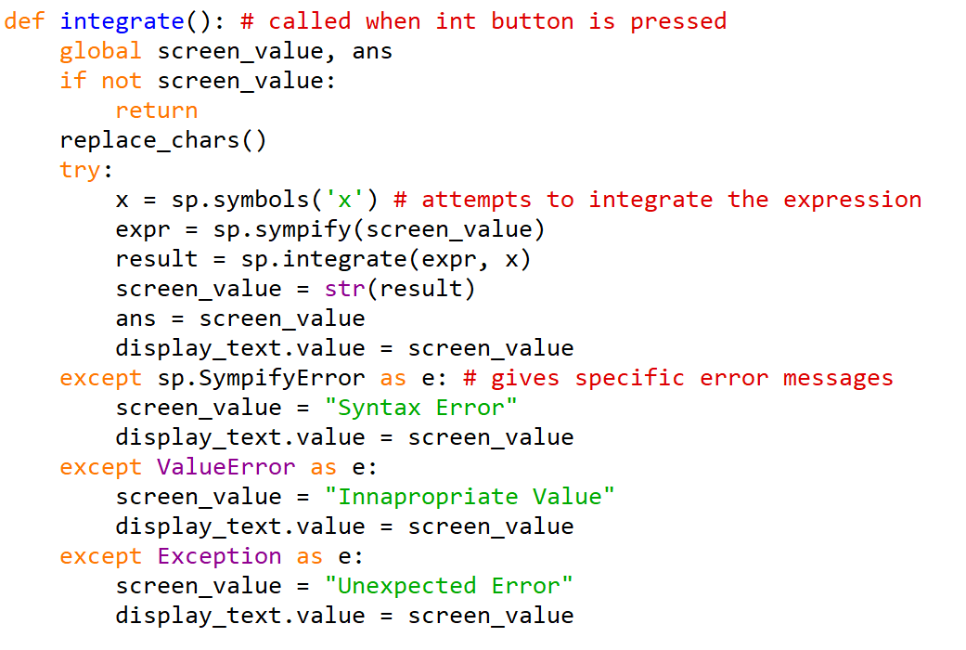
- The screen_value is set to global so that it can be edited throughout the function. The ans variable is also global , so it can be processed if it is part of the expression.
- Replace_chars() is called.
- The variable expr is used to store the expression
- the X button is set as a mathematical symbol
- the integrate() function from the SymPy library is used, passing the parameters of the expression and the symbol.
- The result is stored in the ans variable and is displayed on the screen, replacing the previous expression and is able to be added onto.
The other three functions follow a similar pattern, but the factorise and expand functions don’t need x to be passed as a parameter.
Now the user is able to manipulate expressions as well as differentiate and integrate if they wish to. This makes the calculator more useful to older students perhaps checking their answers on practice maths questions. Being able to quickly and accurately manipulate expressions also saves a lot of time in calculations, which is why it is provided as a feature in this one.

Here is an example of the differentiate() function in use
Input | Output (pressed diff button)
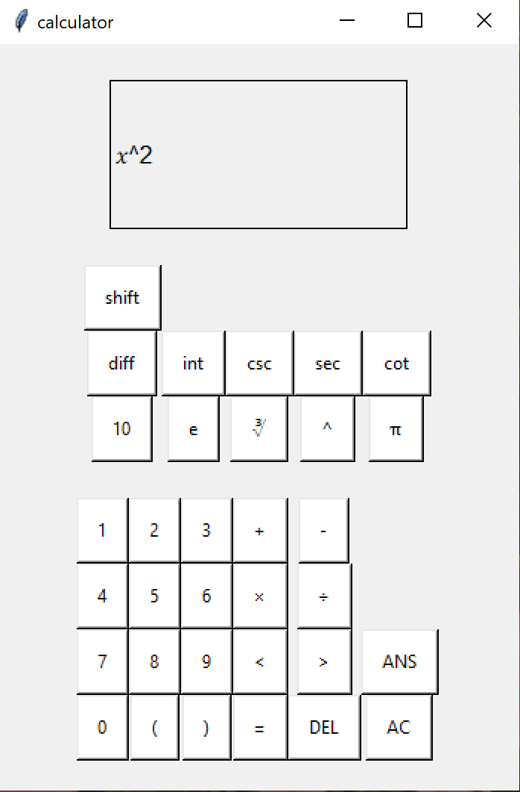 | 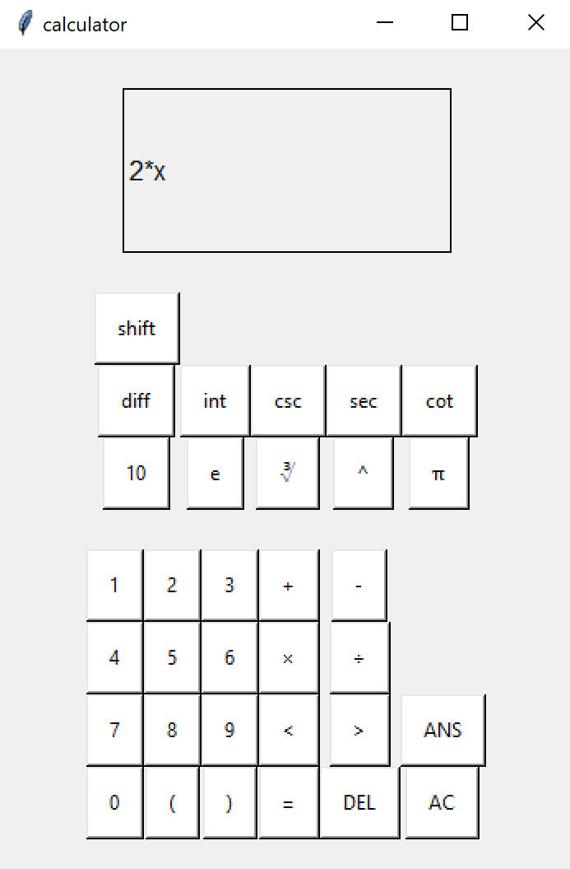

Preventative measures for crashing

During the testing of prototype one, there was an issue where the program would crash if it had to process too big a number. It also had a generic error message which may have been unhelpful to the user. Now a more extensive error check as well as a limit to expression length and answer length have been added to all functions that manipulate expressions.
Limiting the length of the input
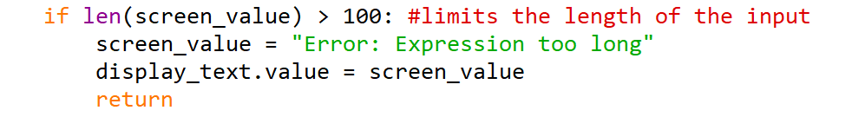
This block of code has been inserted at the start of the calculate_result() function. It checks the length of the inputted expression (screen_value). If it is over 100 characters long it won’t evaluate the expression. Instead it ends the procedure and an Error message appears on the screen.
Limiting the size of the output
The screen of the calculator can only contain around 22 characters. As well as this, a number that is too big has previously caused the calculator to crash. This will catch any too – huge answers and return an error message instead of trying to display the answer.
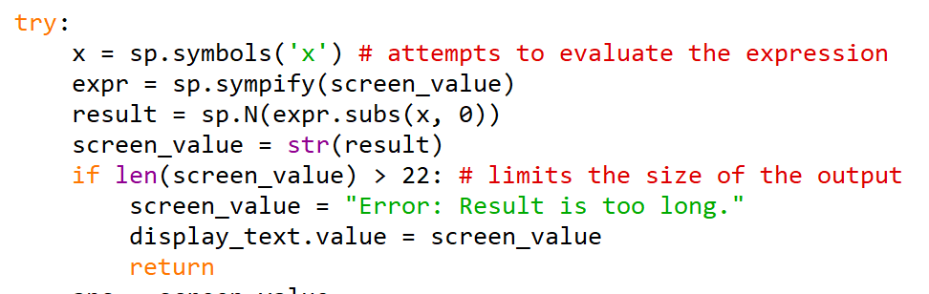
Giving specific error messages
If both of these validation checks are passed and an error occurs when attempting to evaluate, now more specific error messages will be given. The old except: part of the try: except: block has been replaced and now has 3 different ways an error can occur.
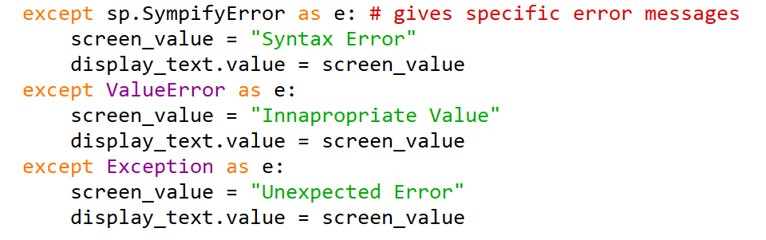
- SympifyError
This exception is raised when there is an error in the process of converting a string to a SymPy expression using the sympify() function. This is a result of the input being in the incorrect syntax. So the error message is “Syntax Error”
- ValueError
When a function receives an argument of the correct type but an innapropriate value. This re-inforces the preventative measures for if a value is outside the range the calculator is able to process. So, the error message is “Innapropriate Value”
- Exception
The base class for all built- In exceptions in python. As the two types of input error have been eliminated, this one returns “Unexpected Error”

At first, returning e for the error was considered. However, those error messages were too long so I wrote some simpler ones.

Ignores Empty Inputs

This has been added to the start of integrate() differentiate() factorize_expression() expand_expression() and calculate_result() functions. Before any error checks are made, the screen_value variable is checked to see if it is empty. If it is empty, the program now returns from the function and makes no calculations.
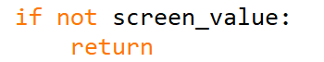
now, when the “equals” button is pressed and “screen_value” is empty, the function will simply return without displaying an error message. So nothing will happen as far as the user is concerned.

Testing
These tests based on the success criteria show my progression towards meeting them and help me find any errors in new features to fix in the final iteration.

 | Justification | Test Type | Data | Expected result | Actual result
1a | Button Hovered over | Normal | Mouse hover over, then leave button | Button changes colour | Button Changes colour
1b | Button pressed | Normal | 1  + | 1 appears | 1 appears
2a | Expression : Valid | Normal | 2 + 2 | Return Correct Answer (4) | 4
3a | Expression : Invalid Syntax | Erroneous | 3 ( 4 | Error message | Syntax Error
3b | Expression : Invalid Logic | Erroneous | 2 ÷ 0 | Zero error message | Zoo
3c | Expression : Extremely large number | Boundary | 300 ^ 10000000 | Return Correct answer or Error message | Error: result is too long
3d | Expression : Blank | Abnormal | Enter | Nothing or Error message | Nothing
4a | Factorise expression | Normal | x^2 + x | x(x + 1) | x(x + 1)
4b | Expand expression | Normal | x(x + 1) | x^2 + x
4c | Differentiate expression | Normal | x^2 | 2x
4d | Integrate expression | Normal | 2x | x^2
5a | Expression: trigonometric | Normal | sin(90) +1 | 2 | 2
6a | Expression: logarithmic | Normal | Log(10) | 1 | 1
7a | Statistical function | Normal | nCr (9c2) | 36 | N/A
8a | Ans Button | Normal | (Set ANS to 3)  ANS + 2 | 5 | 5
9a | Variables  Set + use | Normal | Set A to 4  A + 4 | 8 | N/A

Screenshots
 | Input | Output | Analysis if needed
1a | Hover mouse over 2 button | 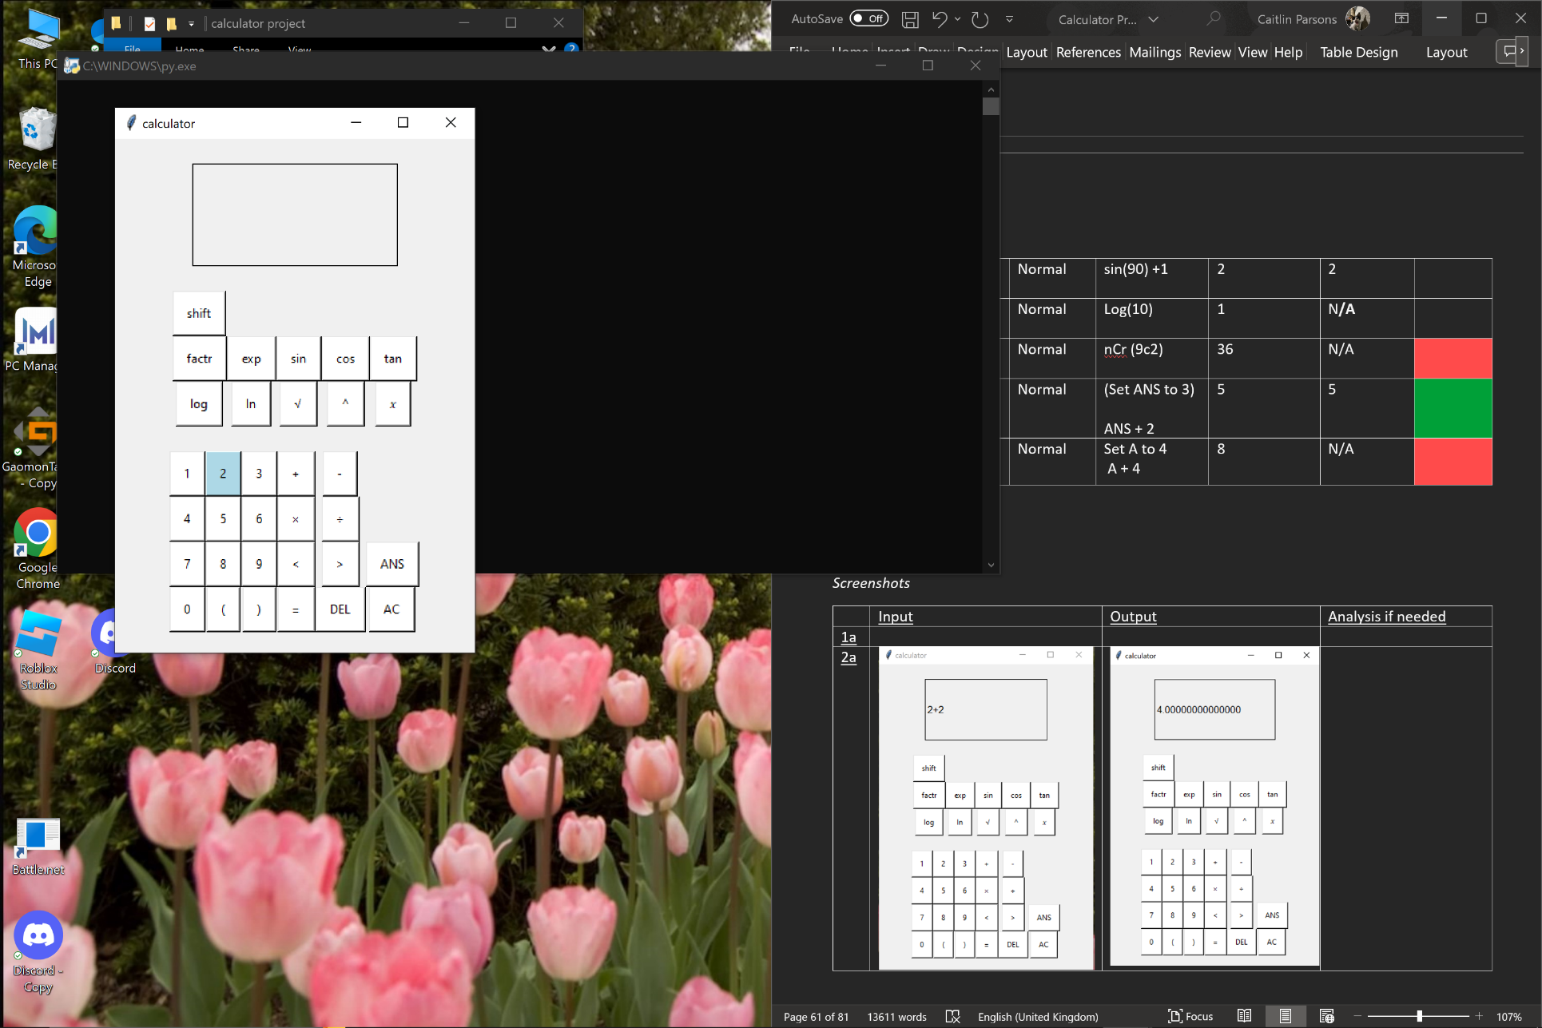
1b | 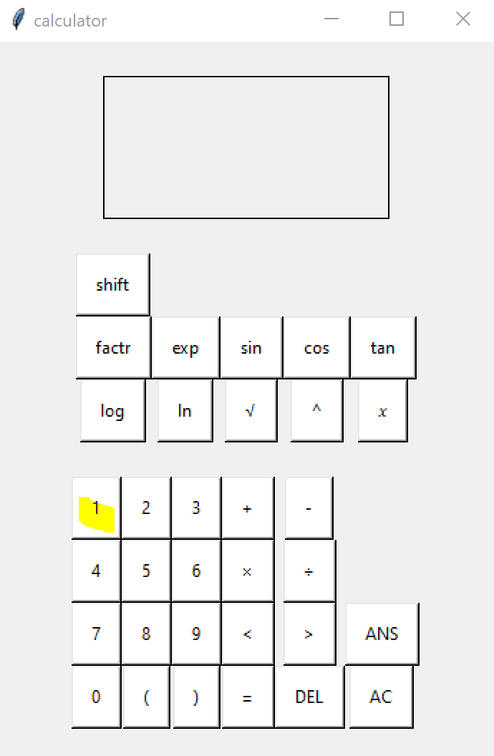 | 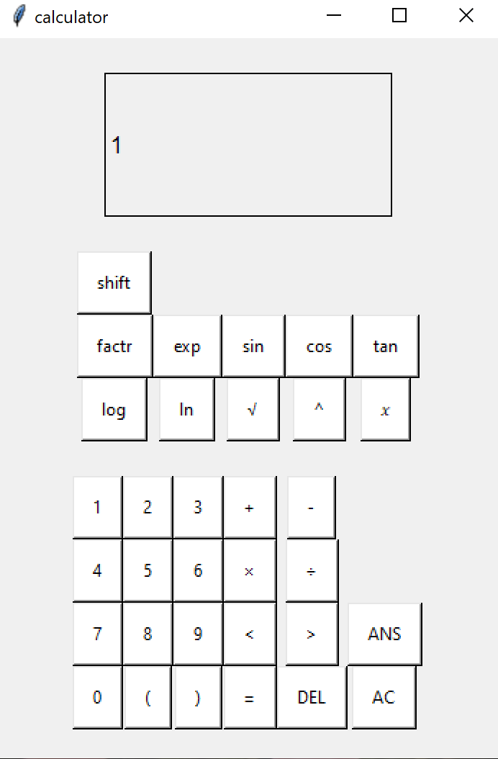
2a | 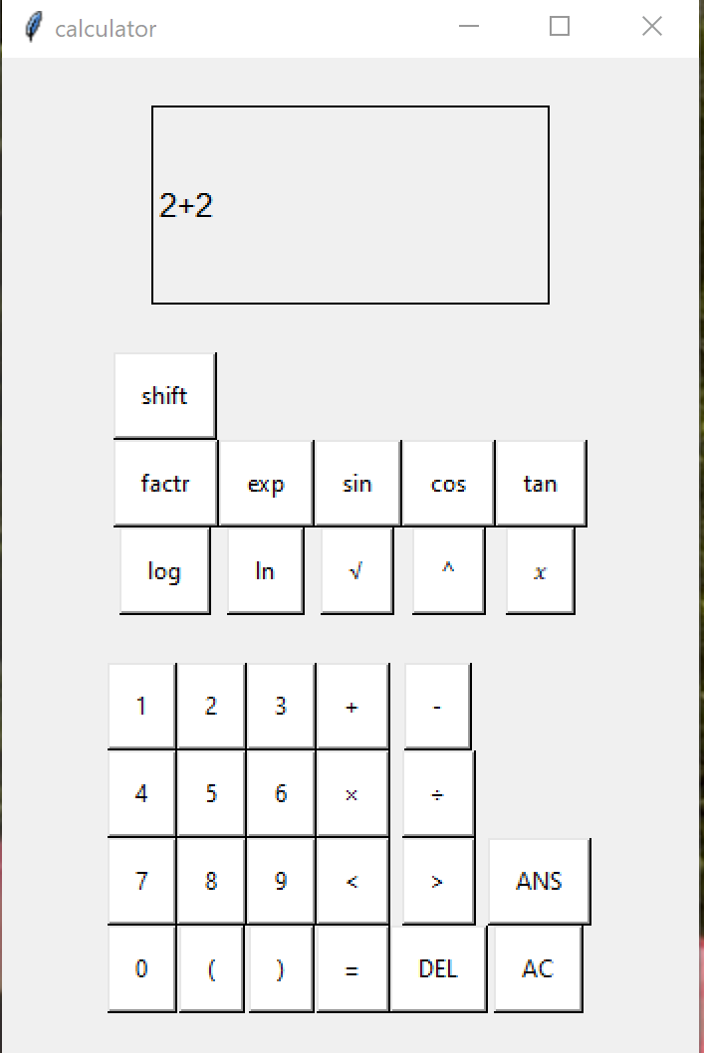 | 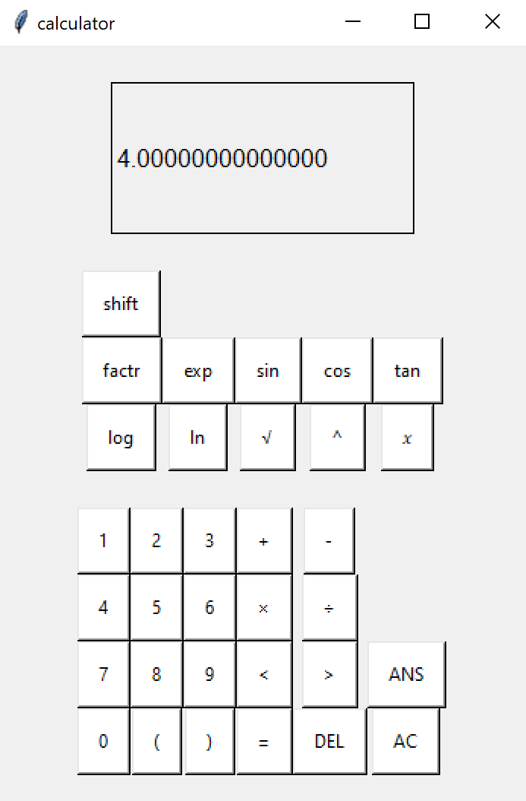
3a | 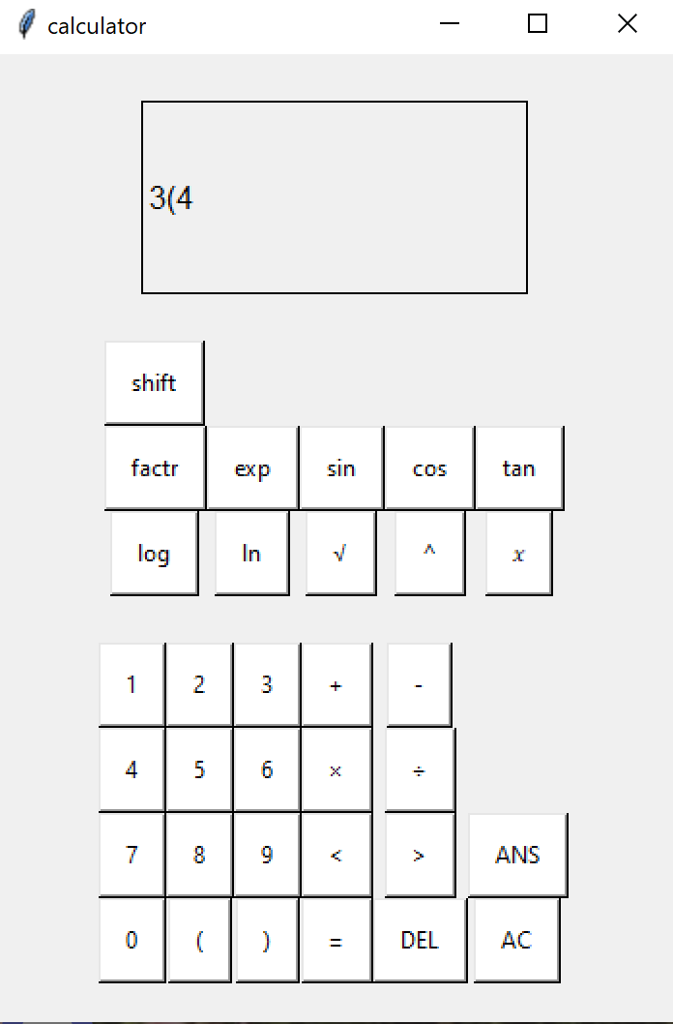 | 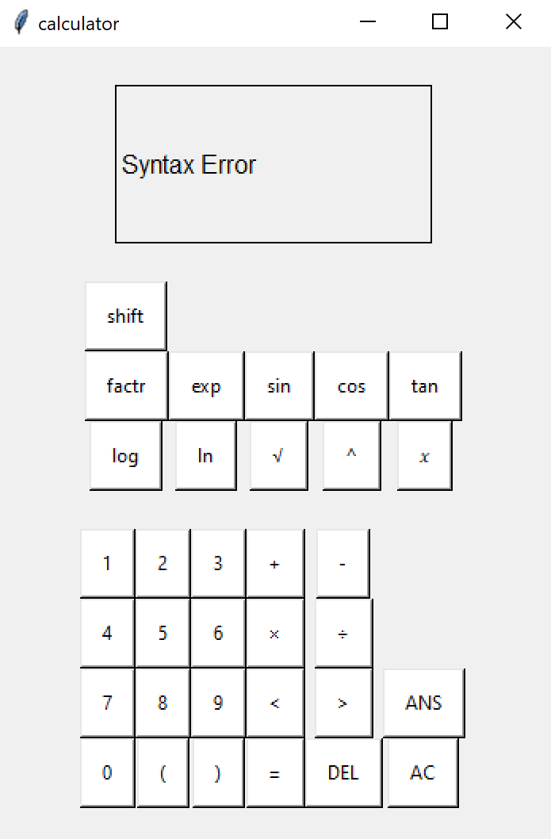
3b | 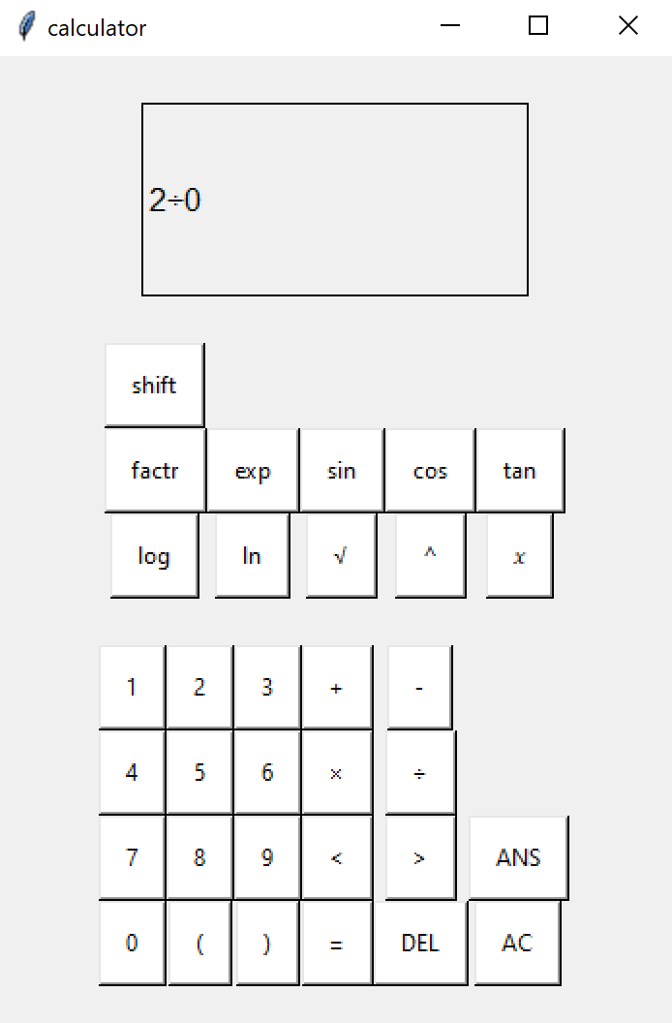 | 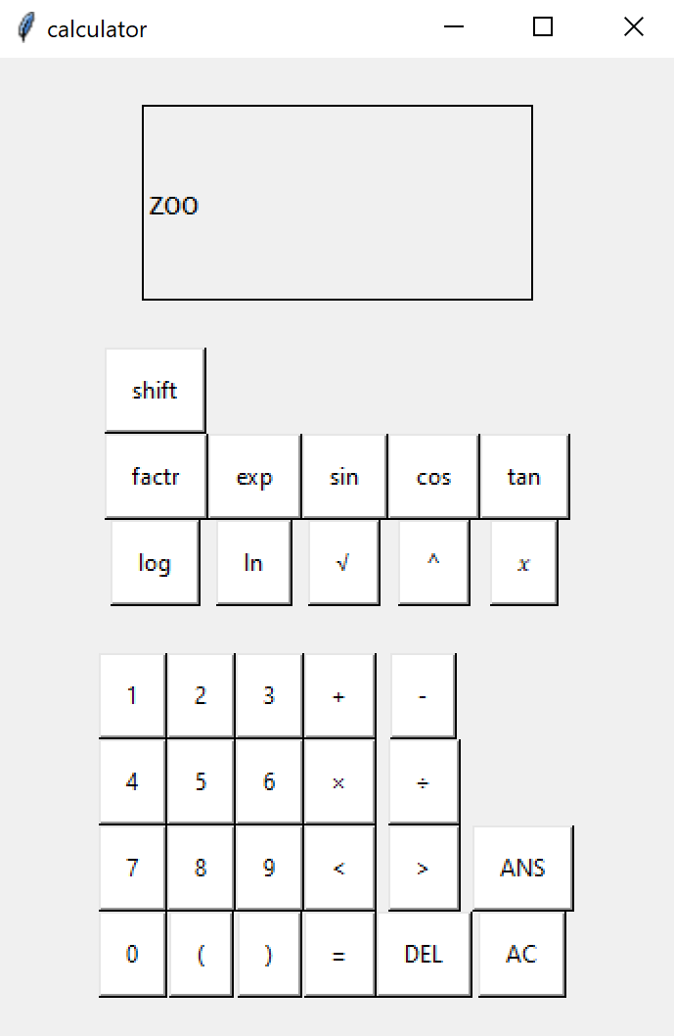 | There is a zero error message, however it needs to be rewritten so it’s easier to understand for all users of the program.
3c | 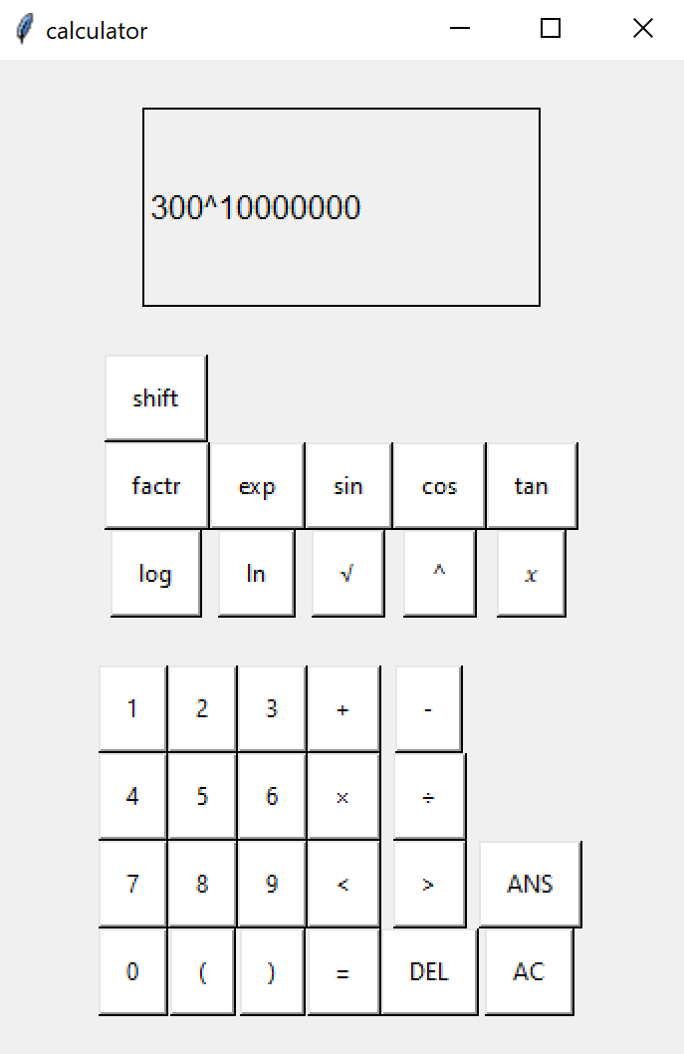 | 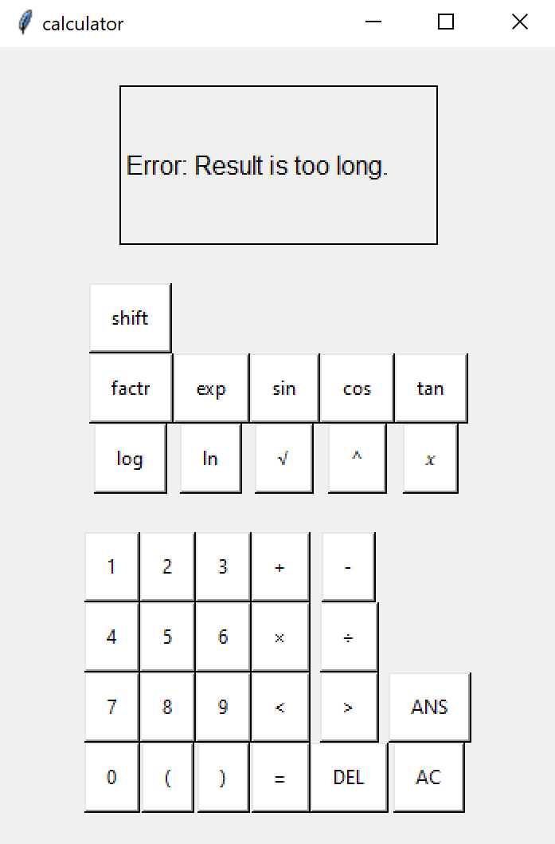
3d | 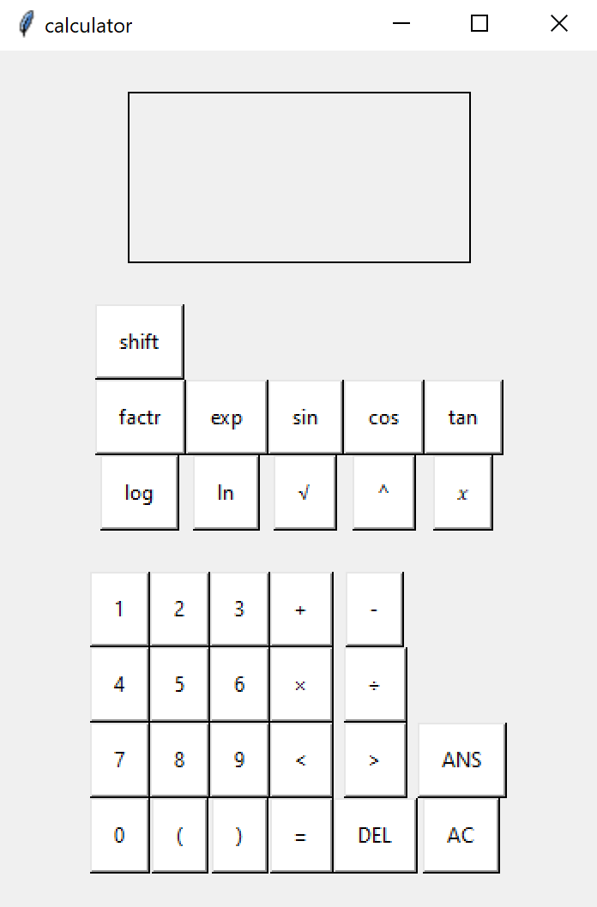 | 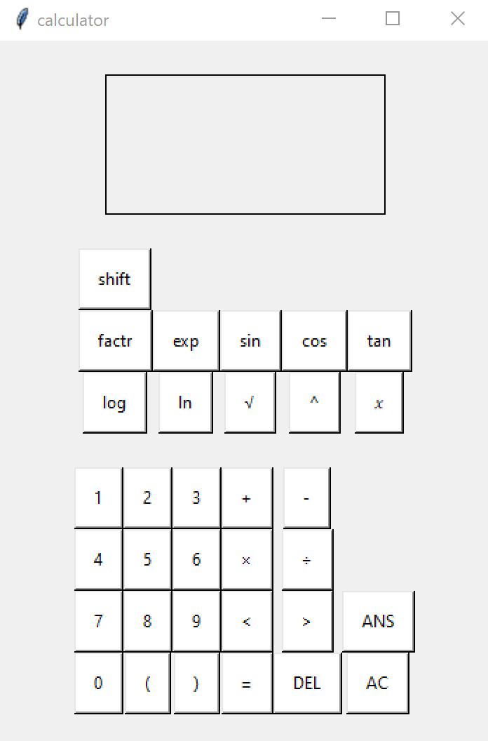
4a | 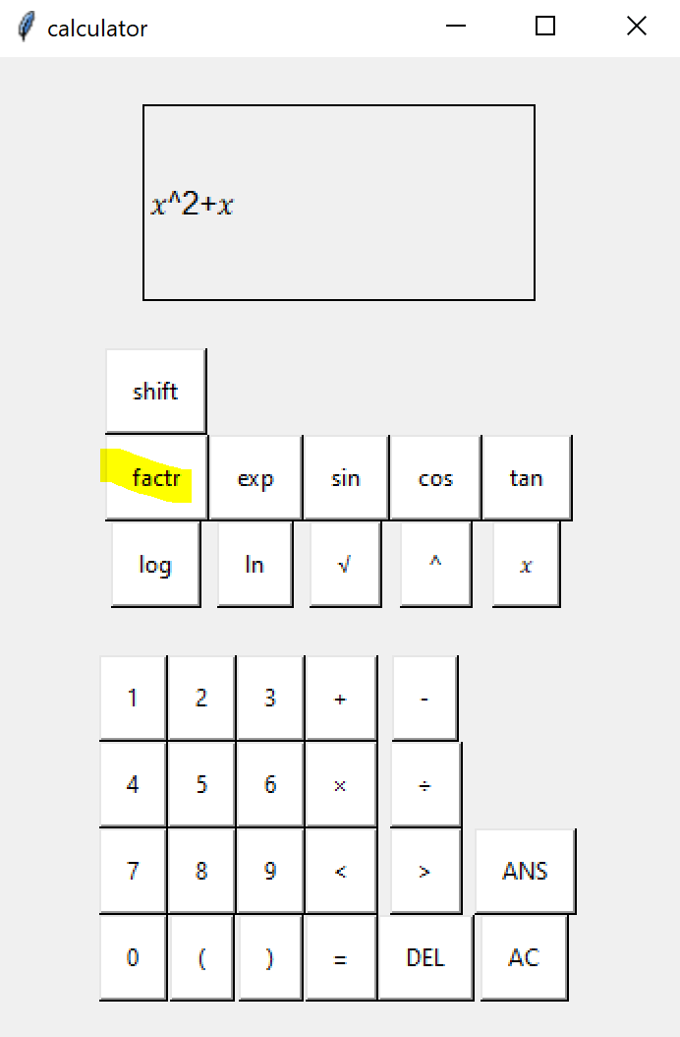 | 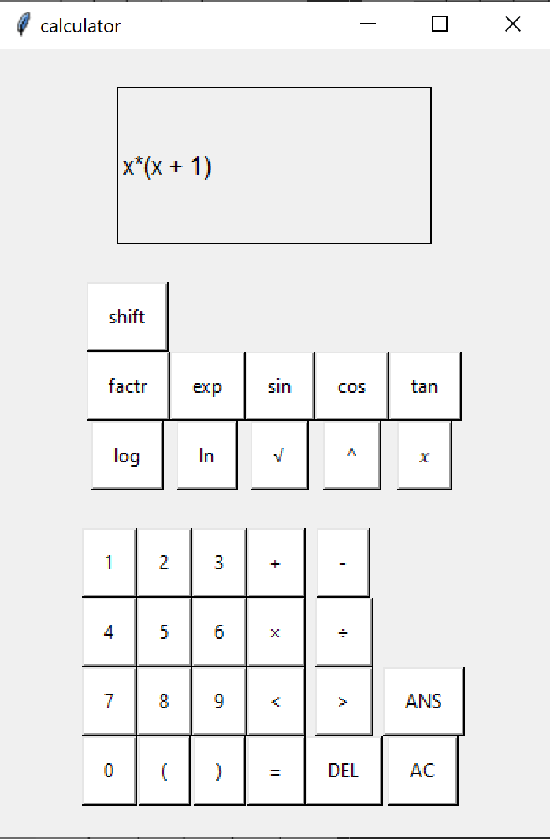
4b | 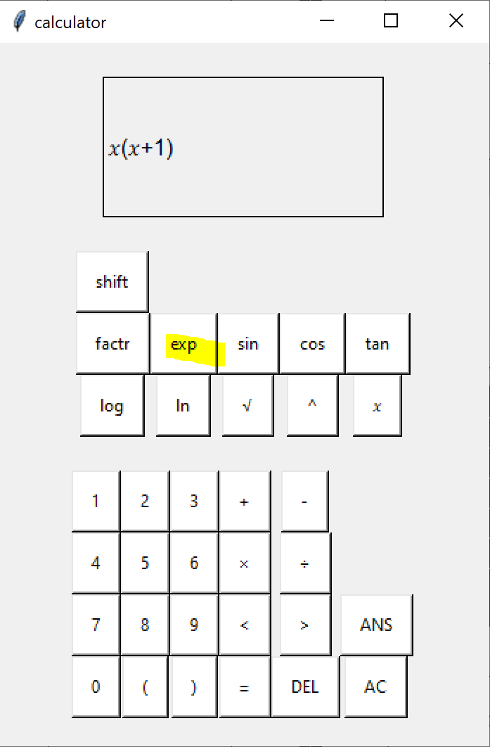 | 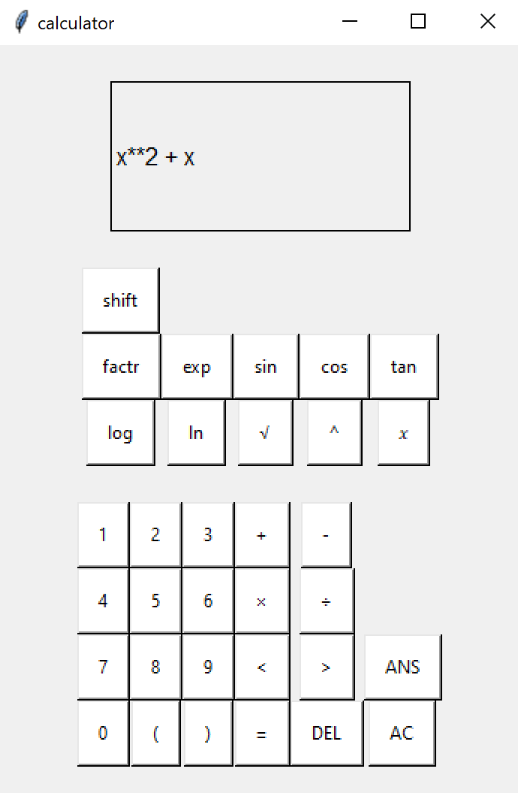
4c | 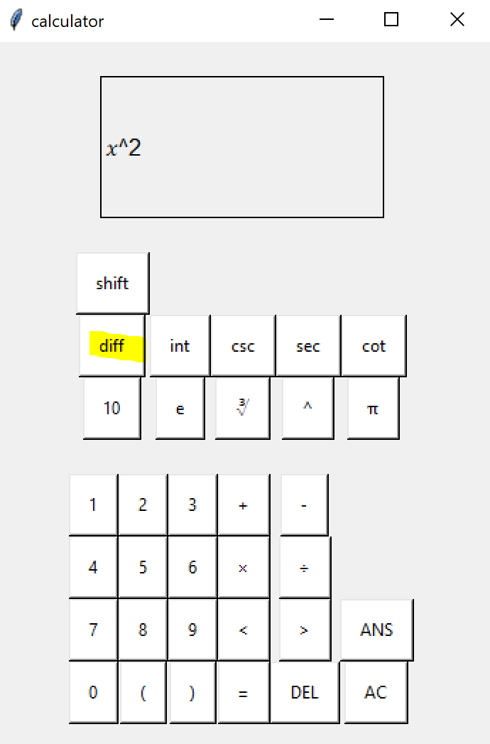 | 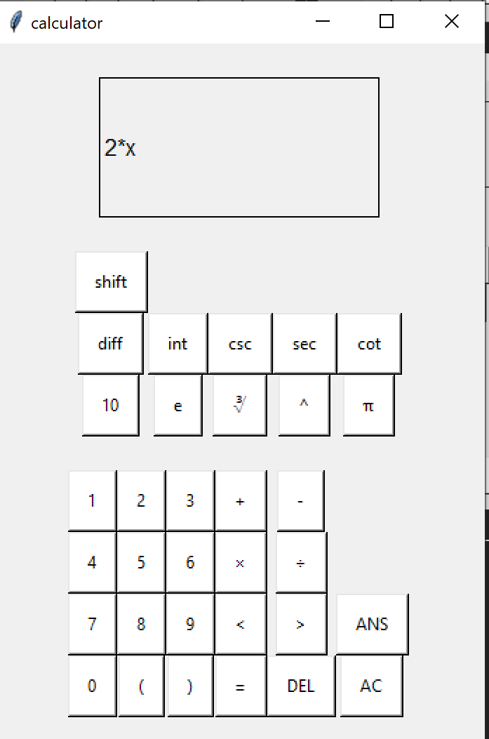
5a | 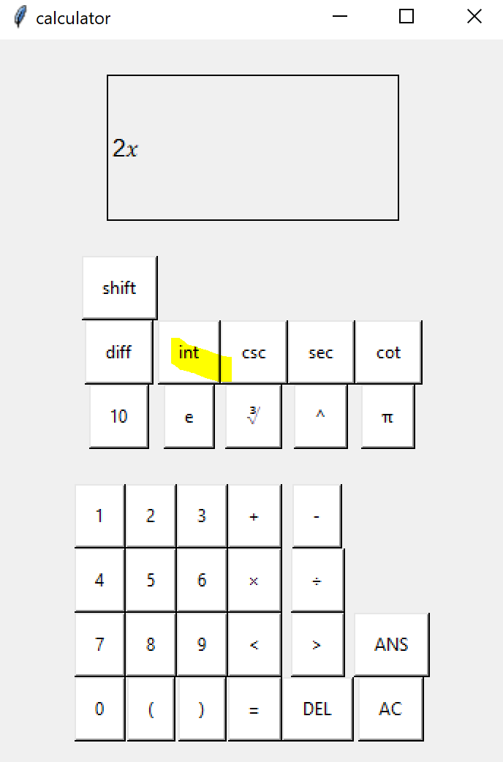 | 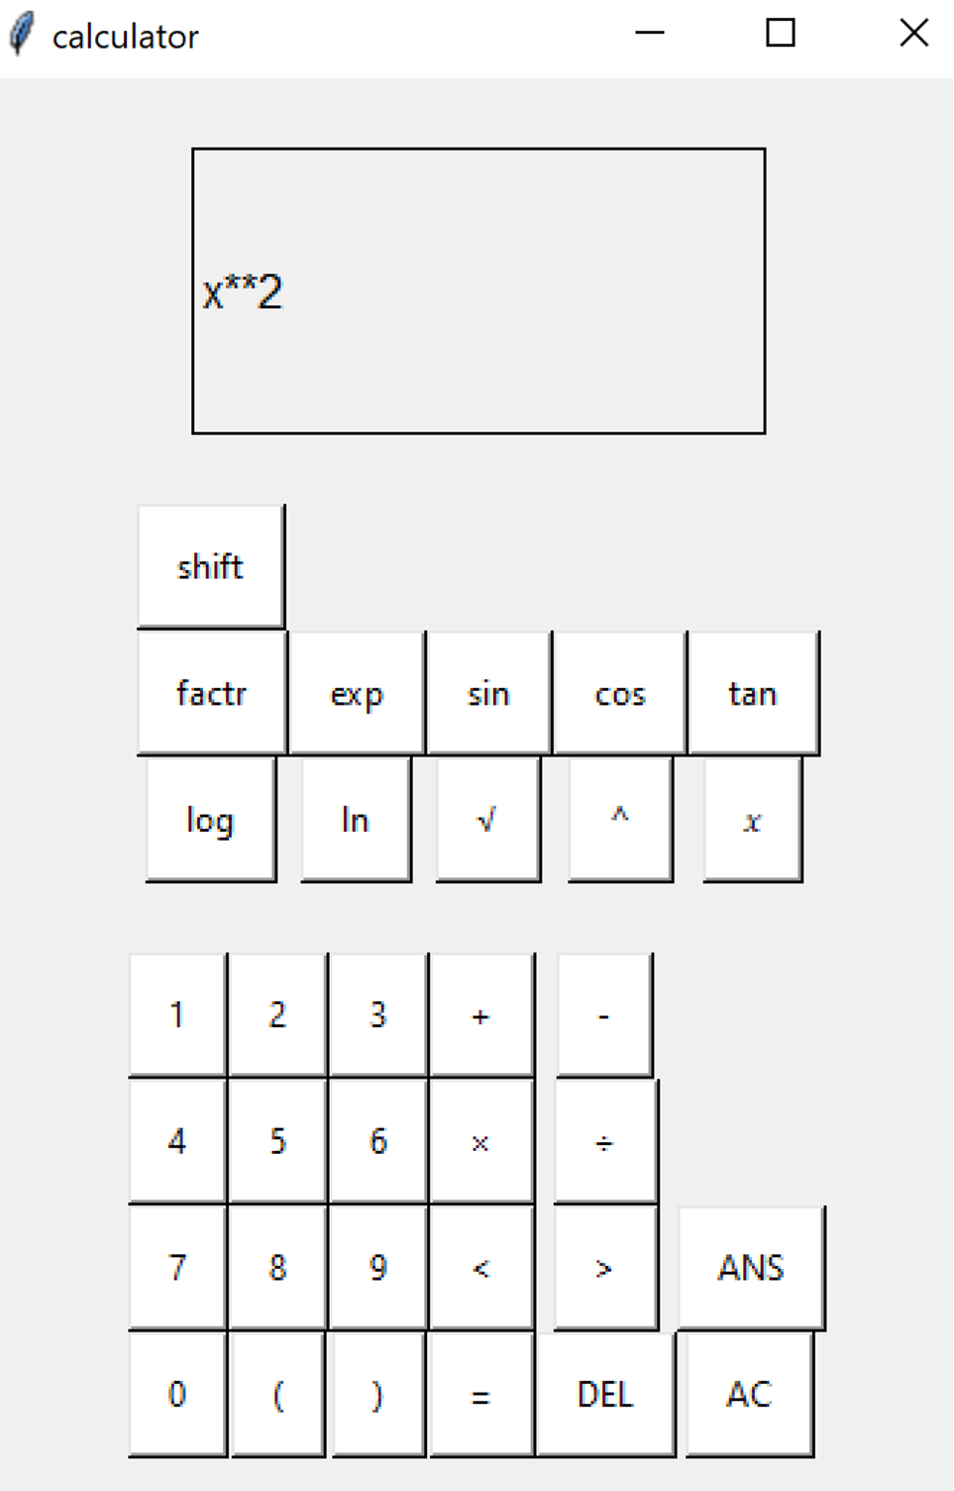
6b | 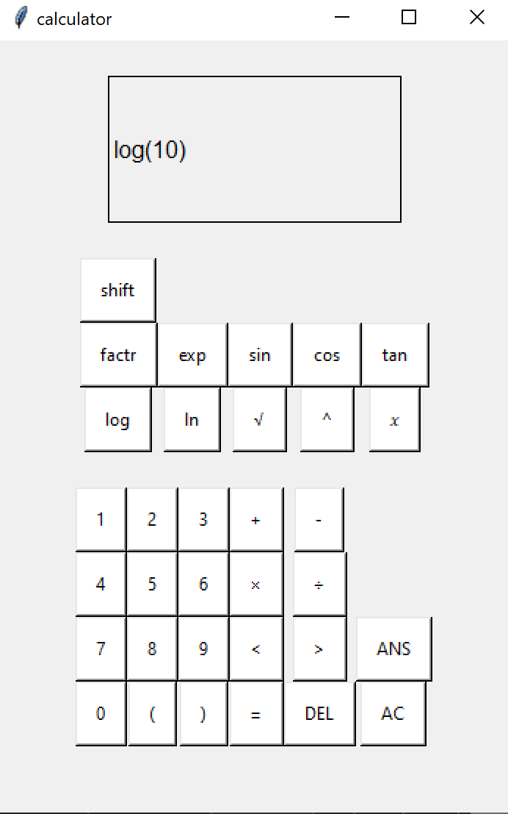 | 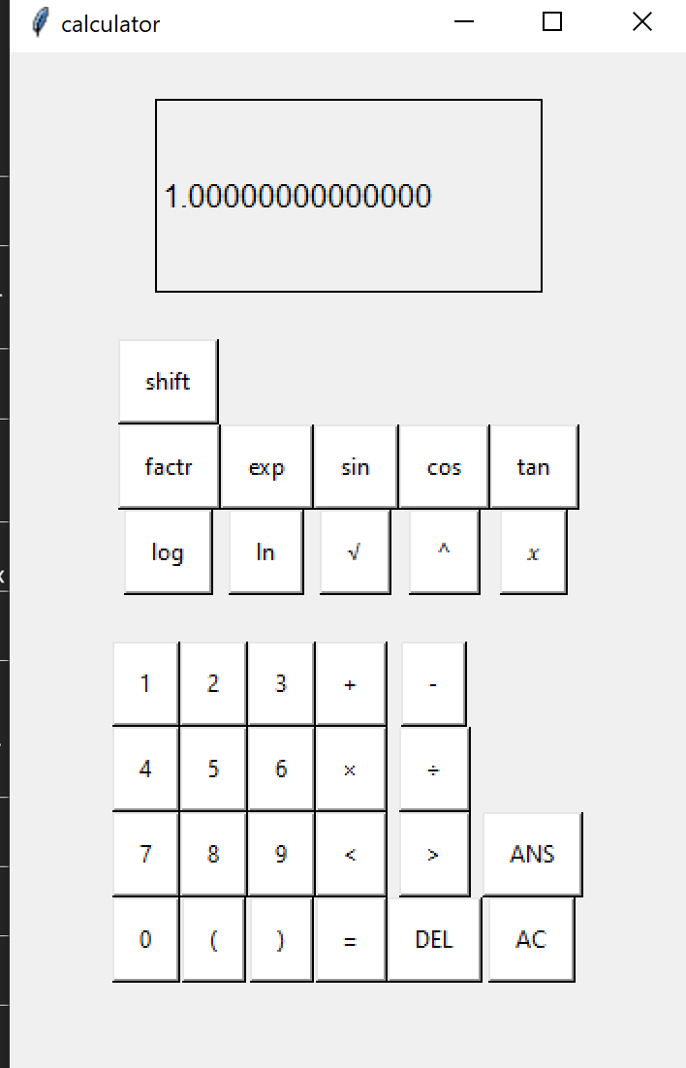
7a |  |  | A statistical function has not been added yet
8a | 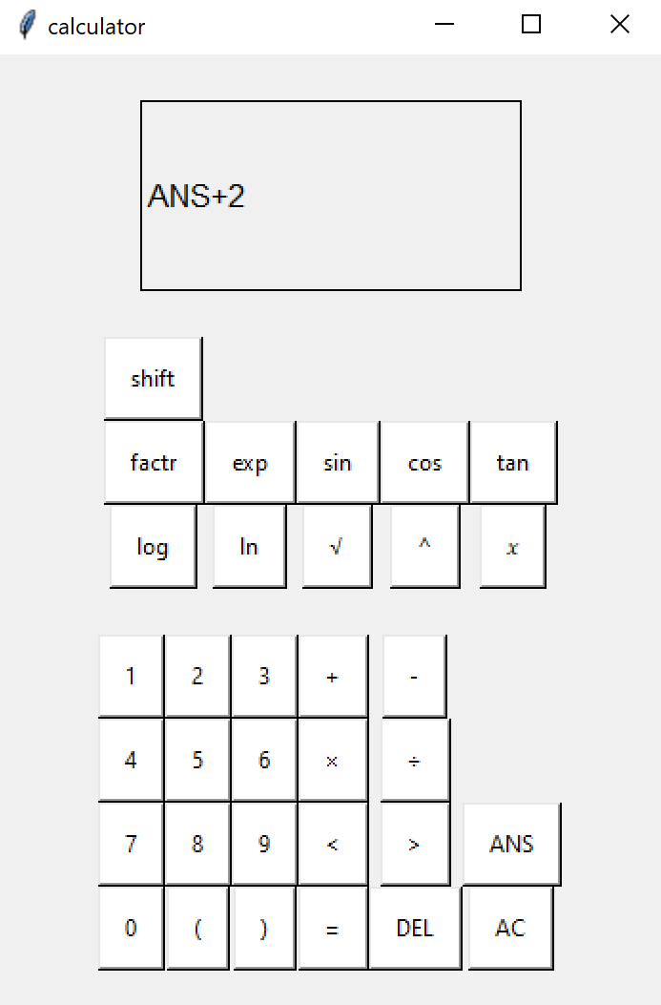 | 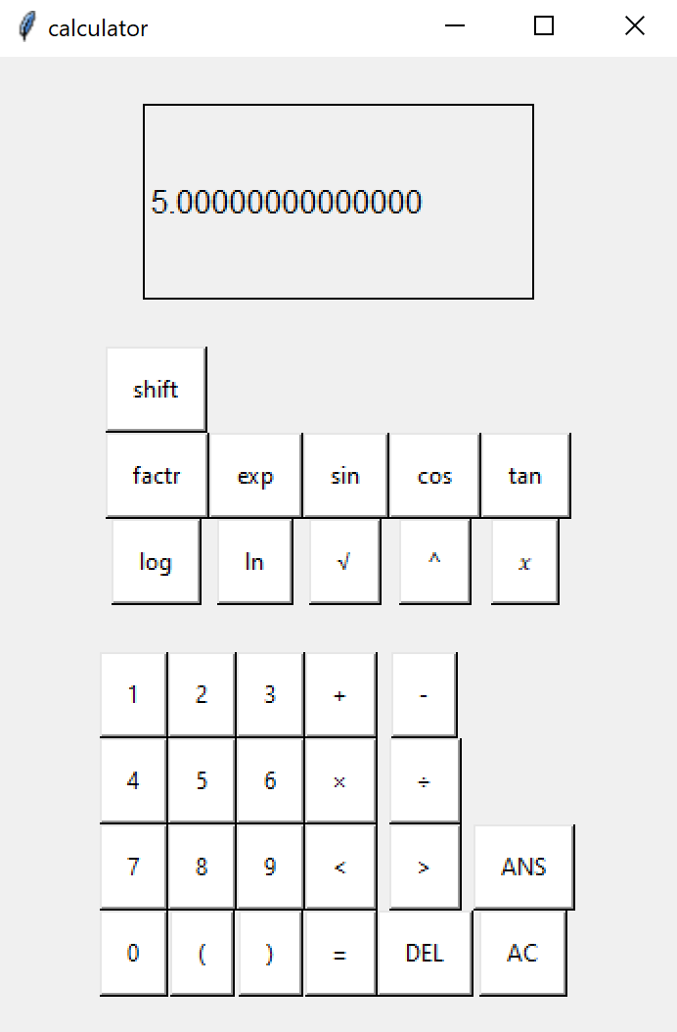
9a |  |  | Stored variables have not been added yet.

At this stage I also had a few users test it and this is when I realised there was no decimal point button.

Final Version
Having tested prototype two, I realised the following amendments were needed:
- A decimal point button.
- Amended error messages
- Stored Variables

I also decided to use a file for these stored variables so that they would be saved when the calculator is turned off.
The different maths functions will also be combined along with their input validation for less repetitive code.
Similarly, the replace_chars function will now have a 2D list and for loop to reduce the length and repetitive code.
I will also remove the need to manually type brackets for things such as sin() to make the function more obvious to a user.

Action | Justification
Added decimal point button | Forgot to add this button, it is an important feature to use in calculations for float numbers.
Added txt file to record variable values | Using a file, variables can be recorded in storage instead of volatile memory
load_variables() function | Called each time program starts to fetch variables from storage
Store_mode Boolean variable and toggle_store() procedure. | To differentiate between when variable buttons are used as part of an expression vs. when they are used to store a value.
(most) actions are now passed through the handle_button_press() function | Prevents logical errors if users have accidentally pressed a button  The function will automatically pass to the displaychar() function if no special circumstances apply to the action
2D list structure used for replacechars() function | Now the function is shorter and as many characters as required can be added to it without it increasing in size.
Combined maths functions into one | These functions are long and almost exact copies of each other. They also all use the same error handling which does not need to be written out multiple times.
Add a bracket to the end of sin( cos( tan( , etc. when typed | Removes the need for users to manually type brackets in for these functions  This makes the calculator easier to use

In order to make the variables and the new functions accessible, a new row of buttons has been added. Here is what the GUI now looks like:

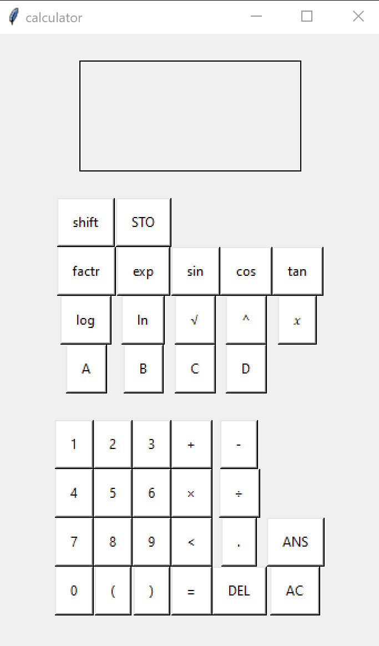

Variables saved in Storage
As it is common in scientific calculators for the user to save several variables, I am adding this feature to my calculator by saving them in a .txt file in the program folder. This differs to the ANS button , who’s contents is only stored in volatile memory and will be lost when the calculator is closed. These variables can store any number and can be re- used in calculations. For example, if “2” is stored in the variable A , and “4” is stored in the variable B, the input A x B will give the output 8.

Here is how the Txt File looks:
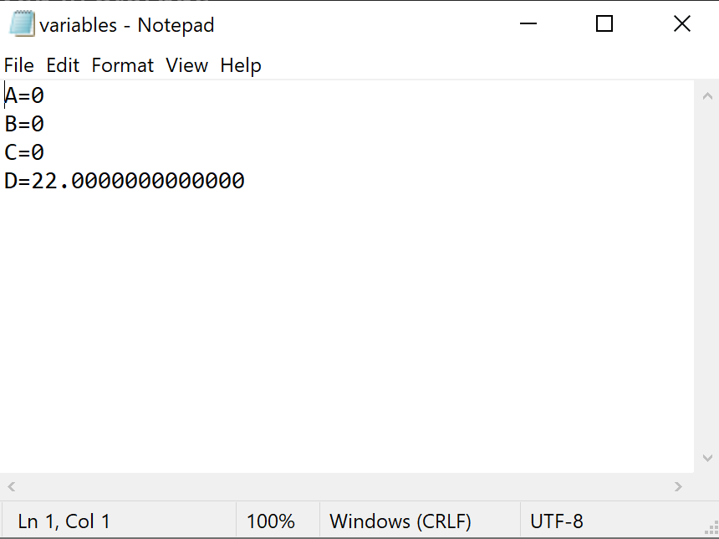
As you can see, the variable D was changed the last time someone used it. Despite them closing the calculator this information was retained. This file is accessed in both read and write mode by the user using the procedures save_variables() and load_variables() . This file is formatted the way it is so it is easier to read and understand .

Firstly , some new key variables were added at the top of the program.
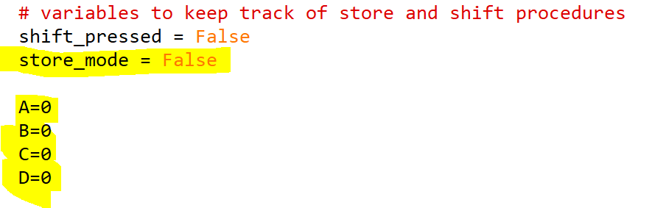
The reason for the store_mode variable is to differentiate between when the variable buttons are used for typing versus storing something in them.
The A, B , C, D variables act as buffers between the program and the file and only hold one piece of data, making them similar to registers in a CPU.
When the program first opens, these variables are updated based on what is in the txt file. This is done with the load_variables() function which is called immediately after opening the app.
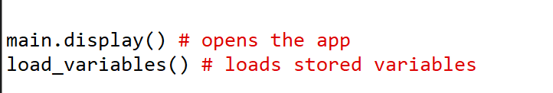

load_variables() function
this function is responsible for loading variable values from the file when the program starts. It reads from the variables.txt folder and assigns them to the corresponding global variables A, B, C , and D.

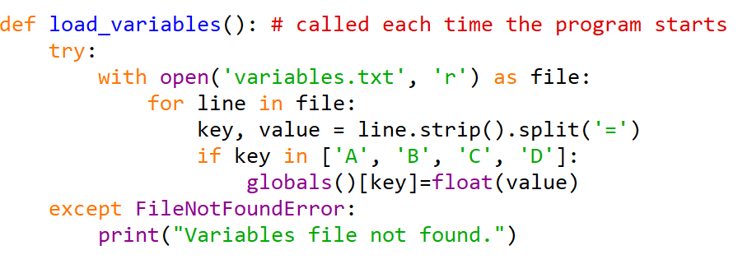

- Try block
The use of the try block prevents the program from completely crashing if the file is not accessible. This could be because the user has deleted the file or python dosen’t have permissions to access the file. If this happens, the app should still work but the variables will all be set to 0 and the user will not be able to change them.

- With open(“variables.txt” , “r”) as file:
The use of a “with” block ensures that the file is properly closed after the block ends, even if an exception occurs. It could also be opened in the form file = , but then there is a higher risk of the file being left open accidentally. “r” indicated that the file is open in read mode.

- For line in file : this for loop iterates over each line in the opened file .
It will traverse over each value with the following commands

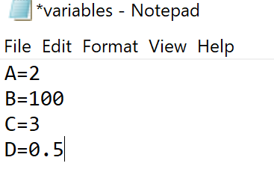
- Key,value = line.strip().split(“=”) : strip() deleted white spaces at the beginning or end of the line. Split(“=”) then splits the current line into elements of a list. The items on the left side of the “=”, A, B , C and D, become the key while the numbers that are after the “=” become the values.

Using the first line as an example: A becomes the key and 2 becomes the corresponding value.

- if key in [“A”, “B”, “C”, “D”]:
Checks if the “key” is one of the predicted variables A B C or D. This might not be true if someone goes and deletes or types in the text file.
In this case it will check this list against the key which is “A”, so it will pass. If the key did not match it would do nothing.

- globals()[key] = float(value)
globals() refers to a table of global variables in the program, which includes the variables called A, B , C , and D. Any variable that corresponds to the [key] part of the file which was read, is changed so it is now equal to float(value)

In this case, globals()[A] = float(2)
Meaning the variable called A will be changed to the value 2.

This is then repeated for every line of the file until each variable is up- to date.

Variable Buttons
So that these stored variables can be used and typed, some new buttons were added to the GUI to represent them, along with a store button which has similar properties to the shift button as it toggles a different use for the variable buttons.
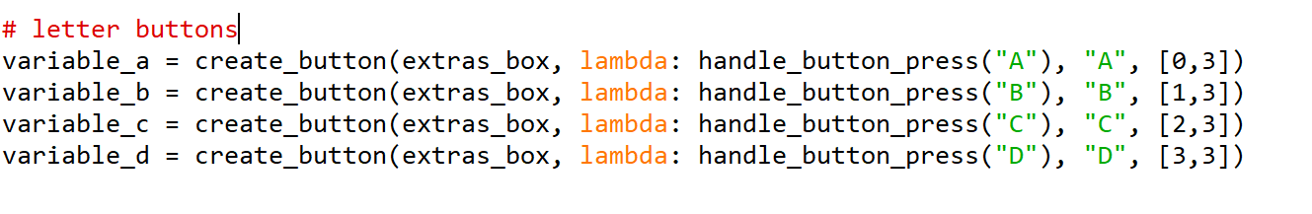
The reason why these four buttons use handle_button_press, which I originally created for the shift buttons, is because they also have two possible uses. The first use is when they are typed normally, this will use the displaychar() command. However, if they are typed after the store button is pressed, it will instead lead to the savel_variables() command. How they have been added to the handle_button_press() value will be explained along with the method for storing.

toggle_store()
This command is called when the Store button is pressed. All it does is alter the previously defined store_mode variable. This variable will affect how the buttons A, B , C, and D act when they are pressed.
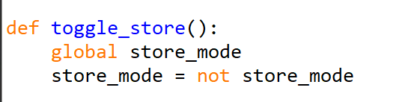

In the case that these buttons will be used for storing, the method of typing is the same one that most calculatrs use.

Changes to handle_button_press()
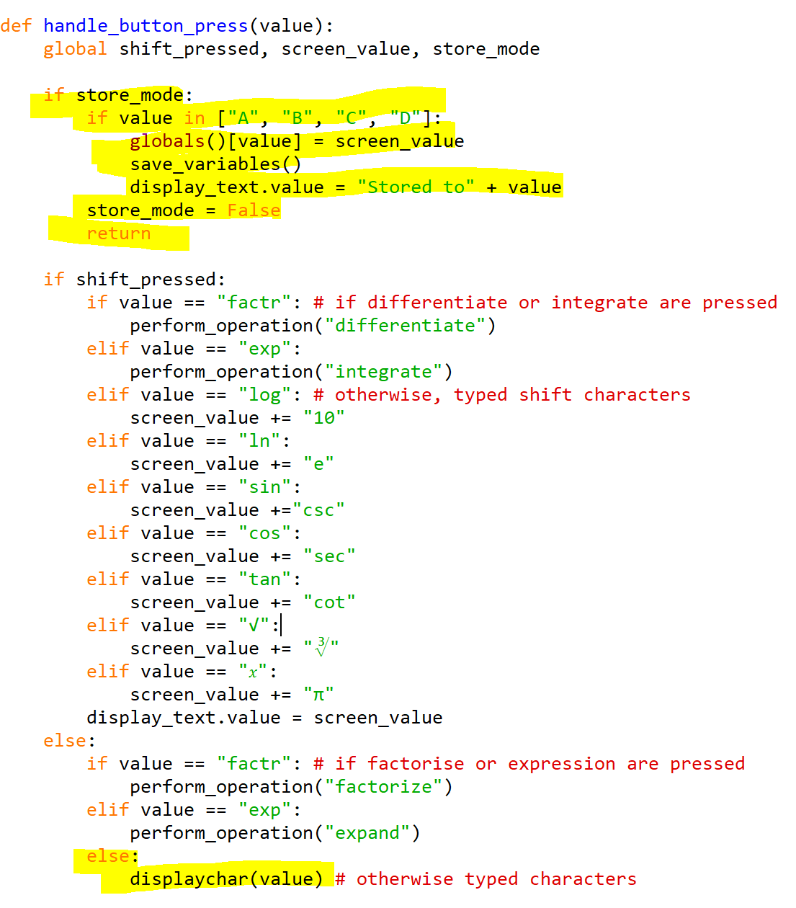

The highlighted parts of the screenshot shows which part of the function will apply to the A, B , C and D buttons. The first section is what has been added to the function since prototype 2.
The first section handles the case in which the buttons are being used to store a value rather than as part of an expression.

- if store_mode:
the first conditional “if” block checks if the store_mode variable is set to True, which means it is checking if the store button was pressed before pressing this button.
- value in ["A", "B", "C", "D"]:
a second “if” block checks if the button that was pressed was one of the letter buttons. If it was not, the store_mode variable reverts to false. This is also part of the reason why all buttons now pass through the handle_button_press() variable, as It prevents the store_mode from accidentally being left true when it is not meant to be.
- globals()value[] = screen_value
By accessing a table of variables, the variable who’s name corresponds to the last pressed button , which is going to be A, B, C and D, has it’s value changed to the expression or number that is on the screen.
- save_variables()
a separate function is then called which will also update the text file with this information.
- display_text.value = "Stored to" + value
a message is displayed on the calculator screen to confirm the action.

Here is a visual example of how this new feature is used. It works the same as it does in most calculators and is therefore easy for users to pick up.

- The user types in an equation or a value  Screen_value is now equal to the desired value to be stored. | 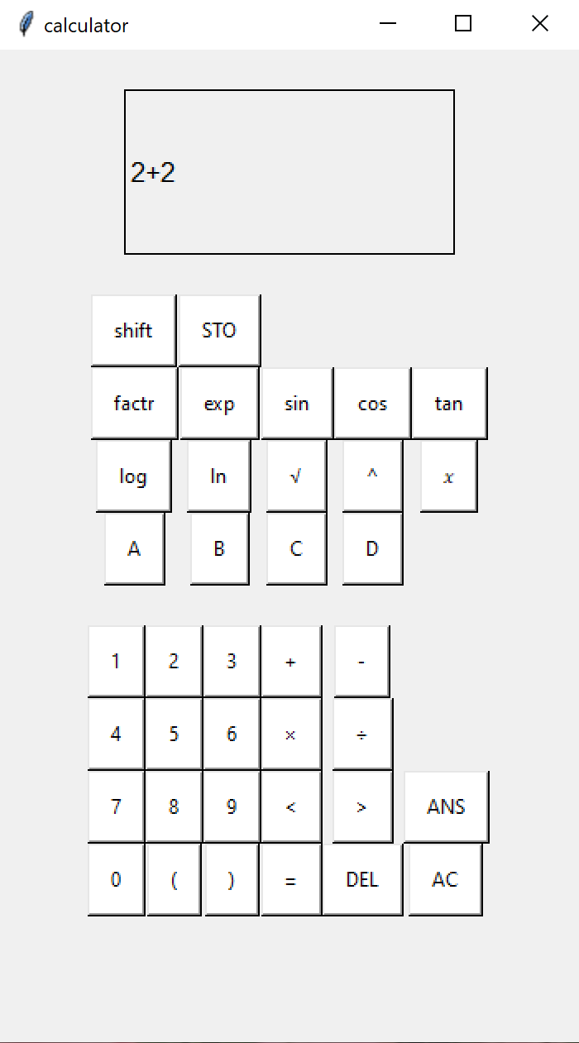
- With the desired value or expression on the screen, the user presses the STO button  This toggles the store_mode variable to true | 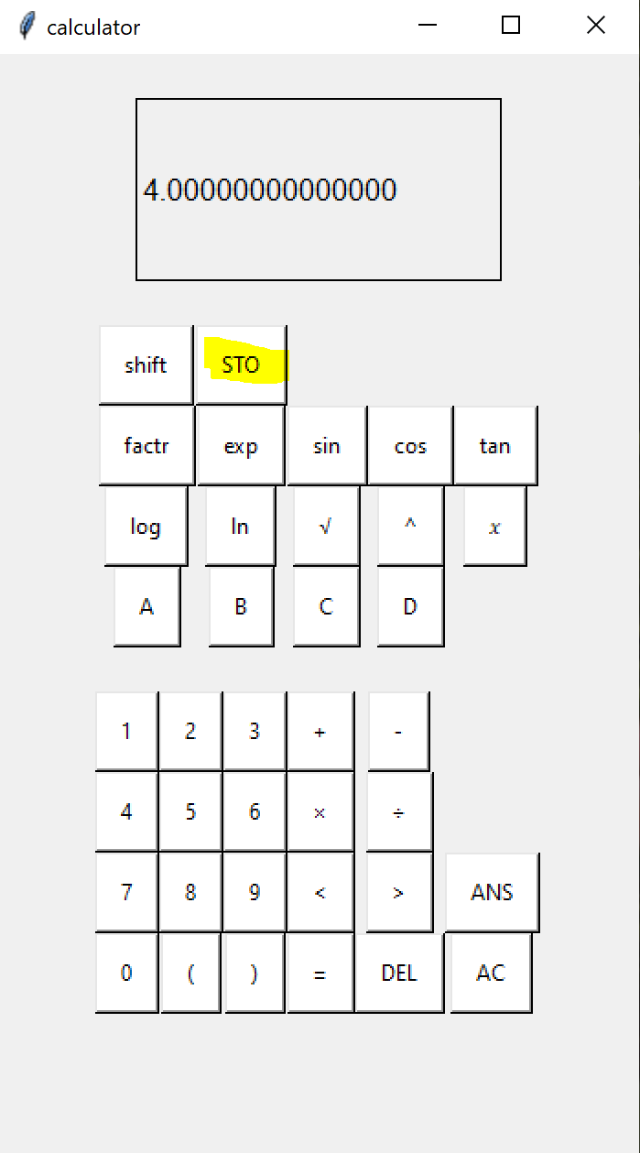
- The user then presses the button they wish to save the value to. | 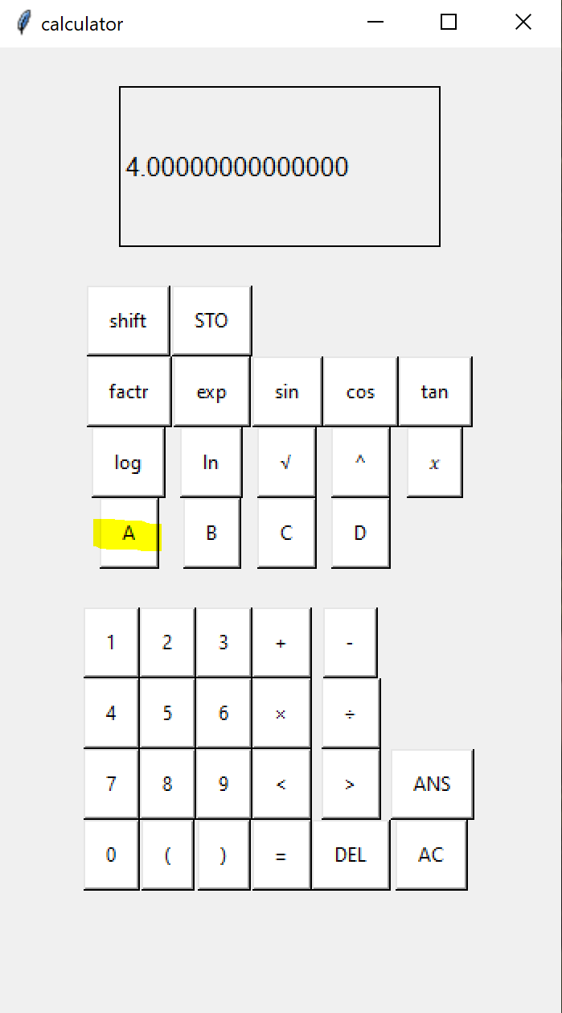
Handle_button_press() is called and the store_mode value is checked. Because it is now true, the save_variables() function is called.  The variable is saved into the txt file as well as in the program and a message appears to confirm this. | 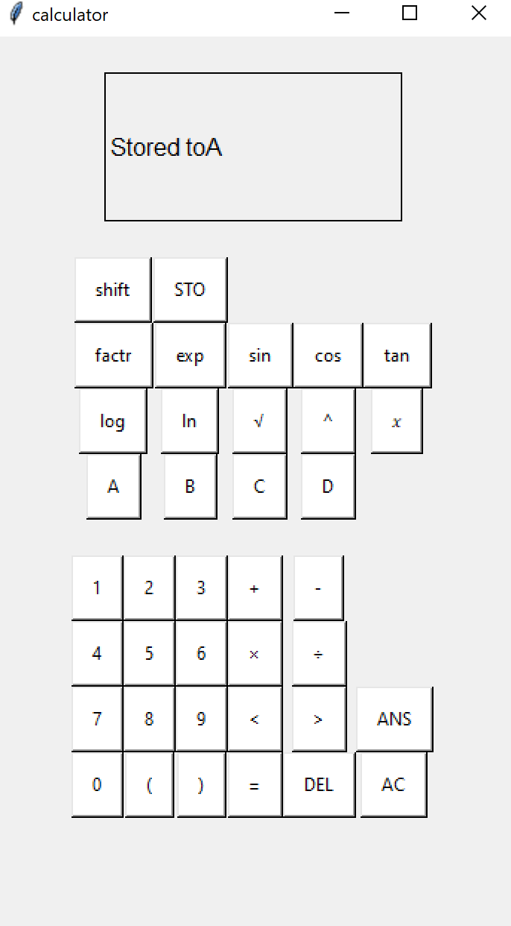
Now if the user uses that variable in an expression it will act like that value. For example if the user types in A + 2 after saving A as 4, then presses equals: | 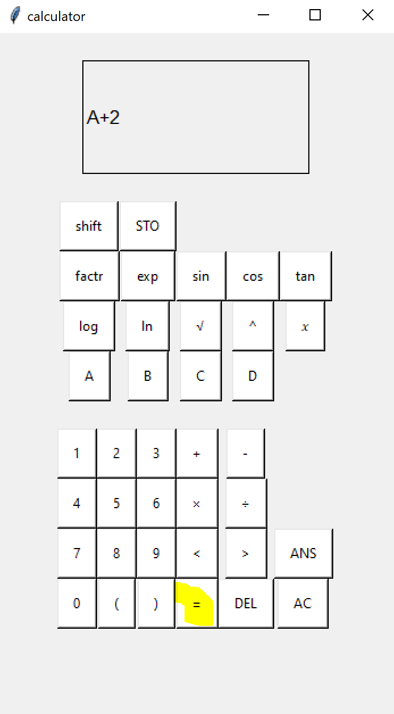
The result is 6 | 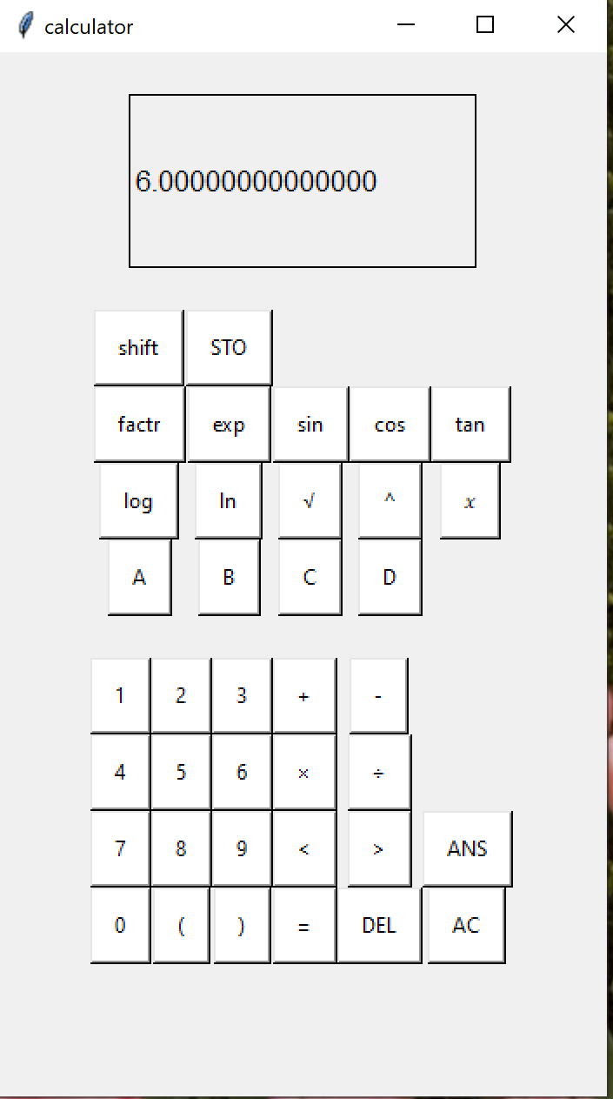

save_variables()
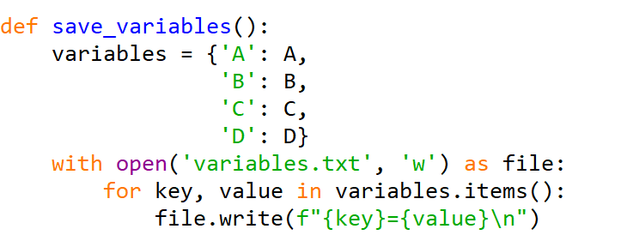
This function is responsible for saving the current values of variables A, B, C, and D to the file.

- First the function creates a dictionary called variables containing the key- value pairs of the variable names and their corresponding values. For example if the user had saved 4 to A what the dictionary will actually look like is {“A”: 4, etc.
- The function opens the variables.txt file in the write mode “w”. This feature also means that if the file dosent exist it will create a new file. Otherwise it simply over-writes the existing file.
- For key, value in variables.items():
File.write(f”{key} = {value} \n”)
The function iterates over each key- value pair in the dictionary using a foor loop. For each pair it writes a line to the file in the format “key = value\n” where “key” is the variable name and “value” Is the corresponding value. For example if A is saved as 4 the first line it writes will be “A=4”
The file will close automatically when this function has run it’s course.

Combine maths functions into one
As the functions calculate_result(), integrate() , differentiate() , expand_expression() , and factorize_expression() are all very similar, they have been combined into one shared function which takes a parameter explaining which function to use. Each function previously had the same validation and error checking code written repeatedly.
Before: this function was written 5 times | After: This function is written once
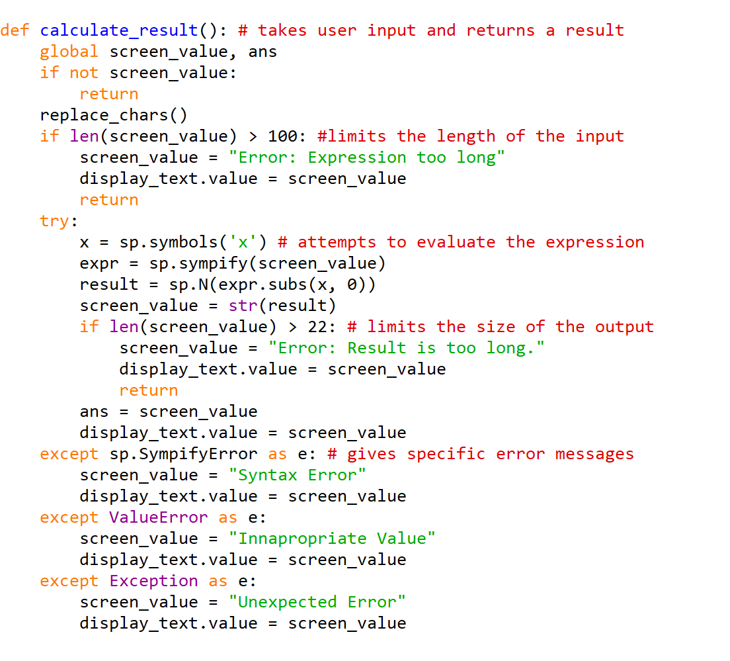 | 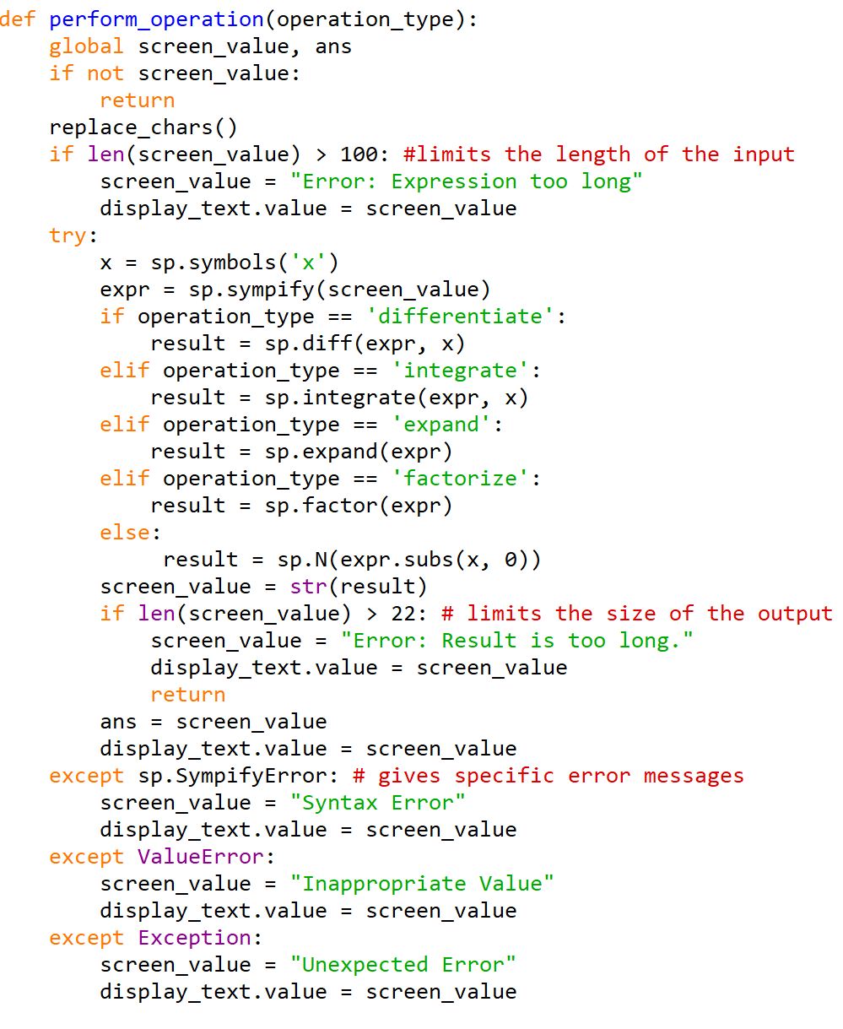
This took up a total of 145 lines | This takes up 37 lines

This way if future changes are to be made they only need to be made to one function instead of 5 identical ones. Since only one or two lines differed, I implemented a branching “if” statement which took the name of the mathematical method as a parameter and took the appropriate action based on that.

2D list used for replace_chars
Here is what the replace_chars() function looked like in prototype 2:
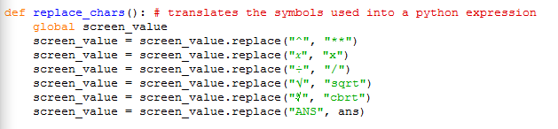
If more buttons were to be added in the future this function could become too long. It is currently linear and goes through the replace method for each value even if that value is not found in the string.
Here is the improved version:
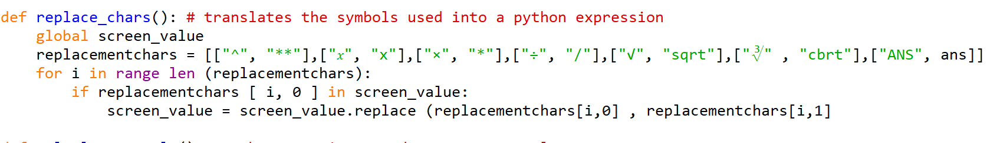
Now the function is 2 lines shorter and as many characters as required can be added to it without it increasing in size. Instead they just need to be added to the 2D list replacementchars
Now, the replace_chars function traverses the 2D list, checking for each calculator element which is in the element index [i,0] and if it is found in the screen_value string, then it will be replaced with the python version, which is found at the element index [i,1].

Remove the need for manually typed brackets
This was an easy fix from a usability issue. Previously the user had to manually type out brackets for sin, cos, and tan. Now, the user no longer has to do this as an open bracket has been added to the string that will be appended to the screen value for each of them.
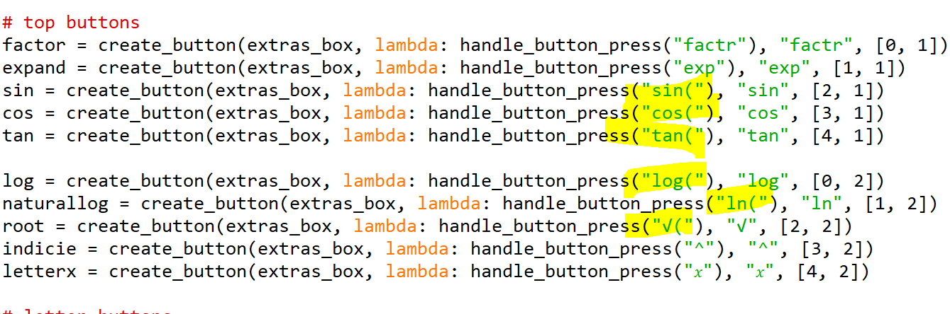

It has been tested that the appearance of this open bracket not only saves the user from having to type it but also prompts the user to type a closed bracket as well.
These changes were also made to apply to the “shift” functions in the handle_button_press() function:
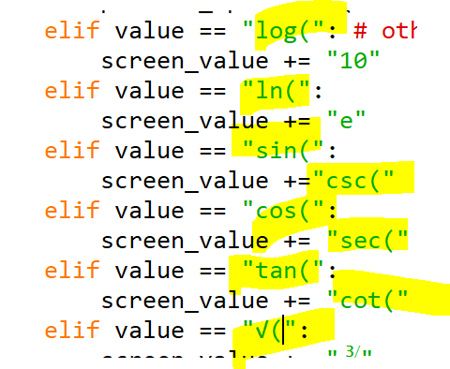

Final Testing
The final testing will include:
- Success criteria testing: Check it matches the requirements set out in the original specification.
- Robustness testing: checking program doesn’t crash or react unpredictably.
- User testing: At least 10 users who fit the stakeholder descriptions will test the app to evaluate the user experience (included in evaluation section)
As well as the original plan, some extra tests have been added to ensure all criteria are met in full. As well as to test any extra features I decided to add.

 | Justification | Test Type | Data | Expected result | Actual result
1a | Button Hovered over | Normal | Mouse hover over, then leave button | Button changes colour | Button Changes colour
1b | Button pressed | Normal | 1  + | 1 appears | 1 appears
1c | Use Delete | Normal | 12  And press DEL | 1 | 1
1d | Use AC | Normal | 12  And press AC | Screen goes blank | Screen goes blank
2a | Expression : Valid | Normal | 2 + 2 | Return Correct Answer (4) | 4
3a | Expression : Invalid Syntax | Erroneous | 3 ( 4 | Error message | Syntax Error
3b | Expression : Invalid Logic | Erroneous | 2 ÷ 0 | Zero error message | Zoo
3c | Expression : Extremely large number | Boundary | 300 ^ 10000000 | Return Correct answer or Error message | Error: result is too long
3d | Expression : Blank | Abnormal | Enter | Nothing or Error message | Nothing
4a | Factorise expression | Normal | x^2 + x | x(x + 1) | x(x + 1)
4b | Expand expression | Normal | x(x + 1) | x^2 + x
4c | Differentiate expression | Normal | x^2 | 2x
4d | Integrate expression | Normal | 2x | x^2
5a | Expression: trigonometric | Normal | sin(90) +1 | 2 | 2
6a | Expression: logarithmic | Normal | Log(10) | 1 | 1
7a | Statistical function | Normal | nCr (9c2) | 36 | N/A
8a | Ans Button | Normal | (Set ANS to 3)  ANS + 2 | 5 | 5
9a | Variables  Set + use | Normal | Set A to 3  A + 4 | 7 | 7
9b | Variables in storage | Normal | Set A to 3  Restart program  A | 3 | 3

 | Input | Output | Analysis if needed
1a | Hover mouse over 2 button | 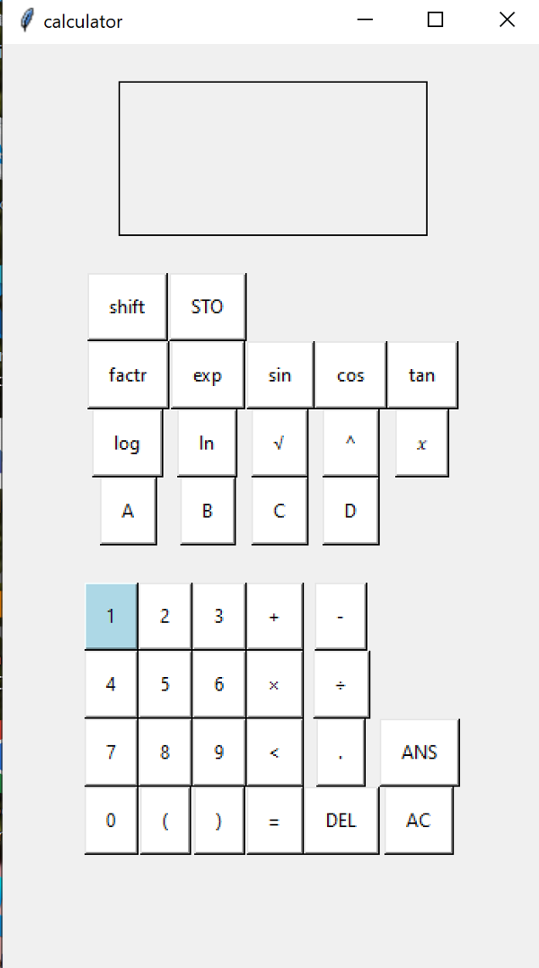
1b | 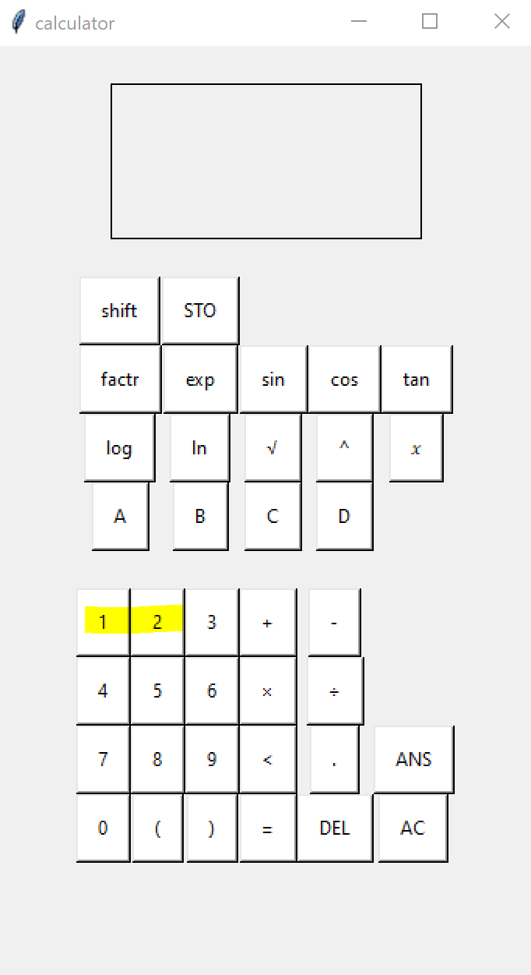 | 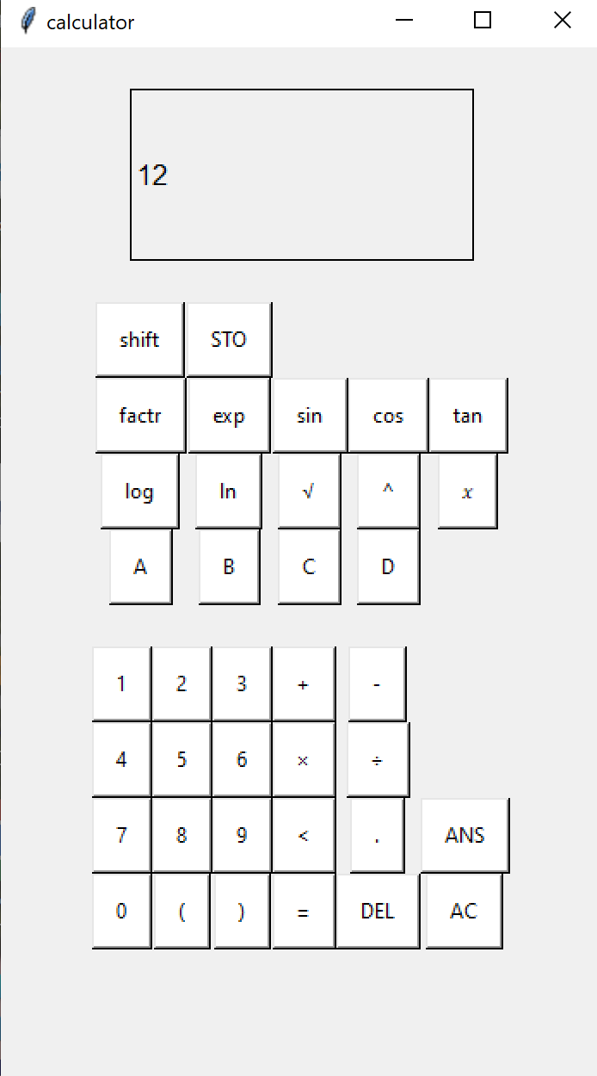
1c | 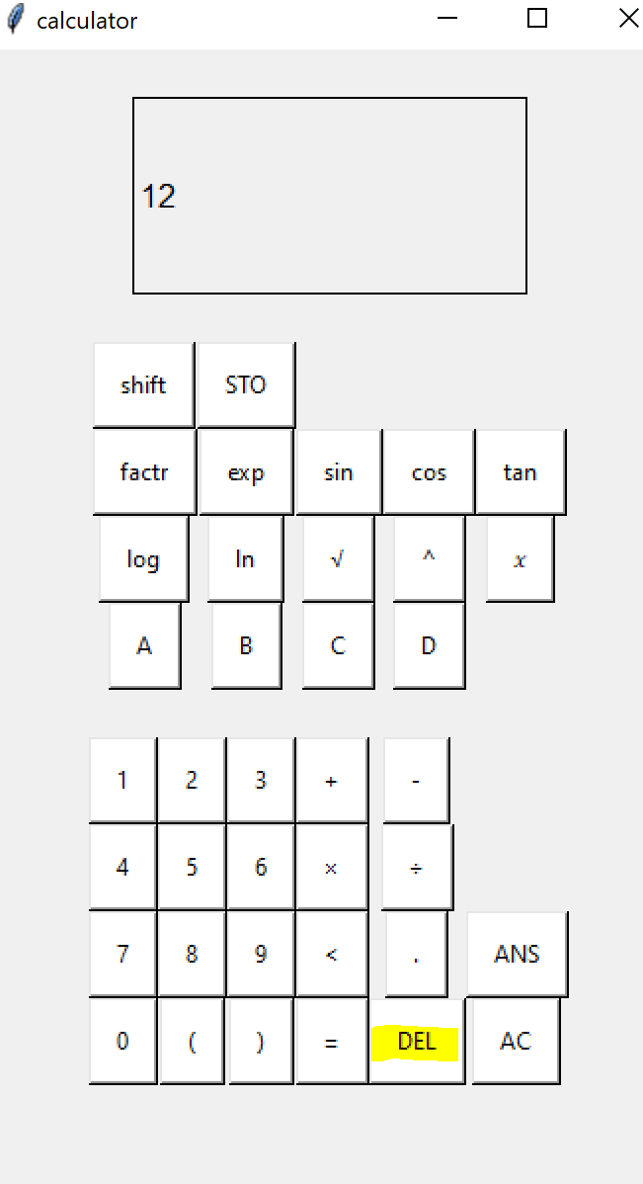 | 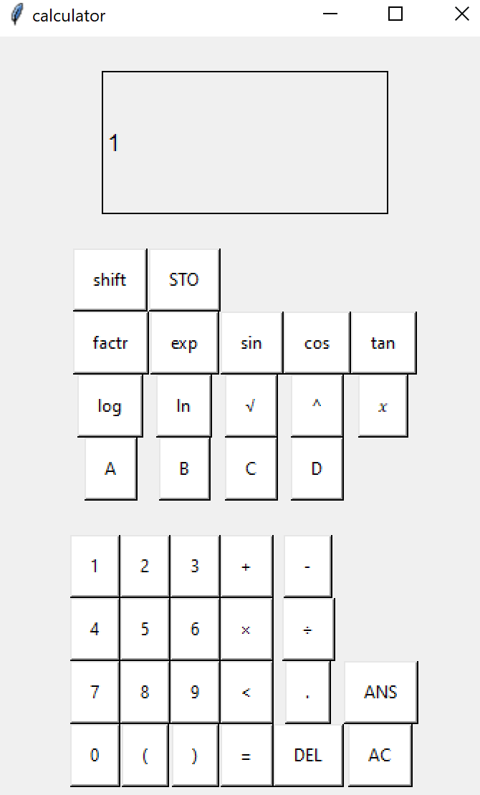
 | 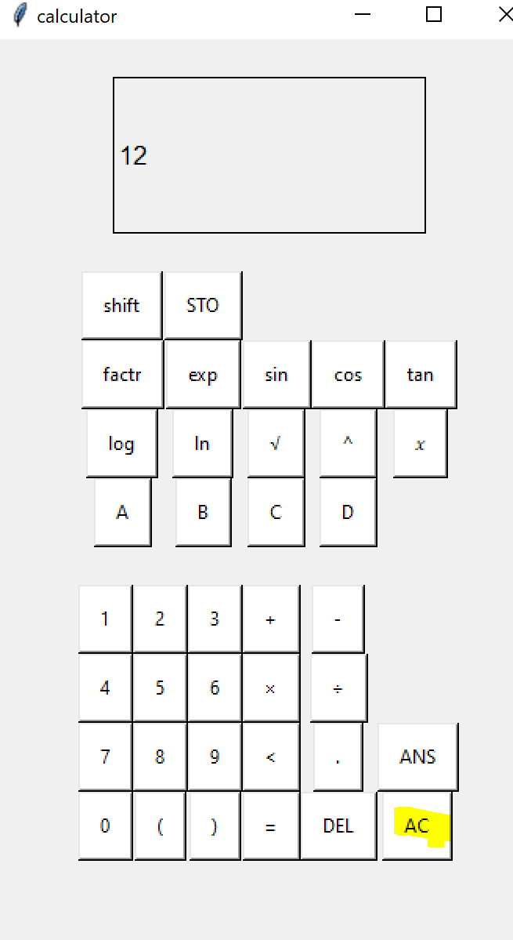 | 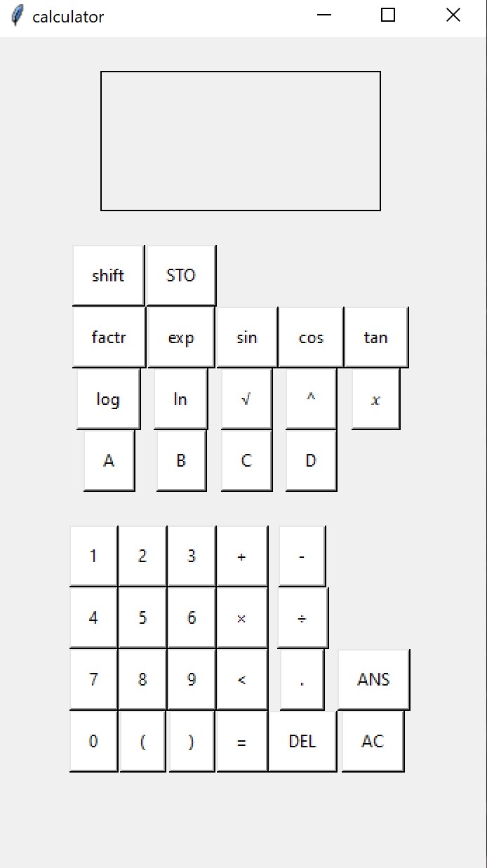
2a | 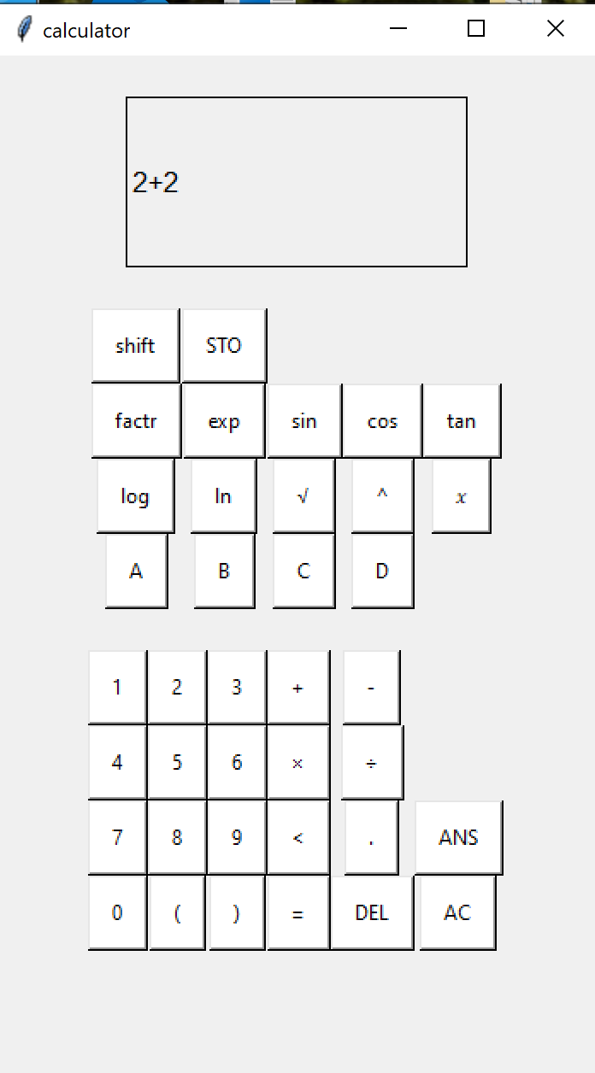 | 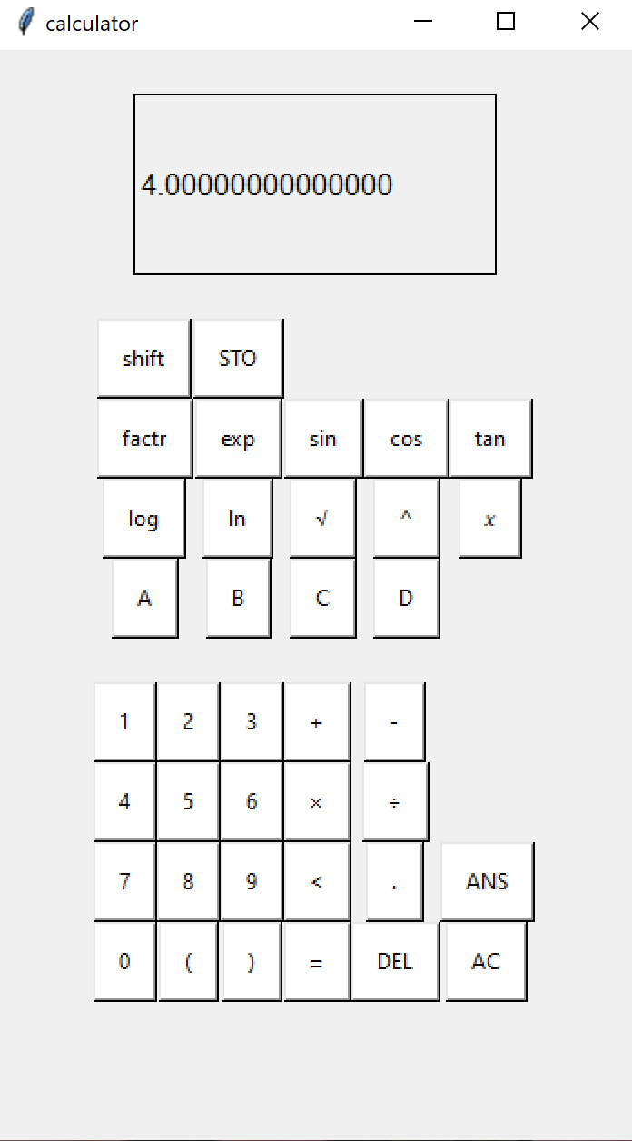
3a | 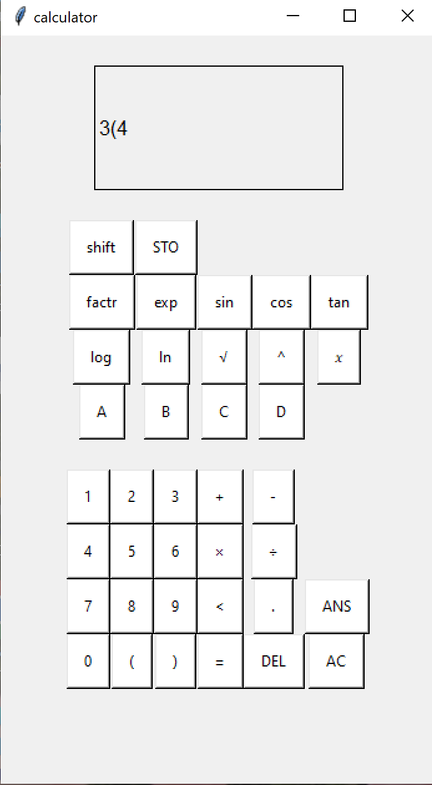 | 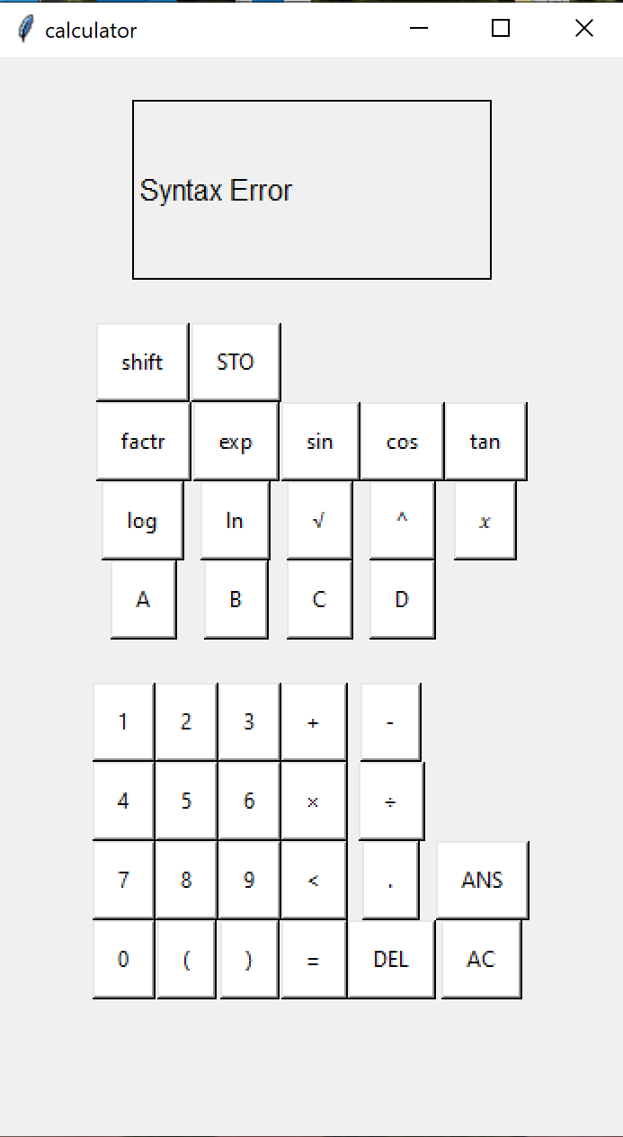
3b | 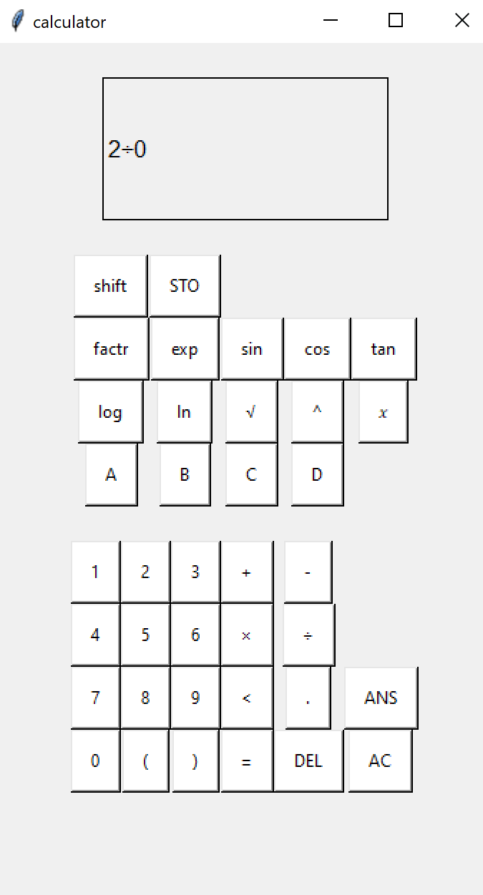 | 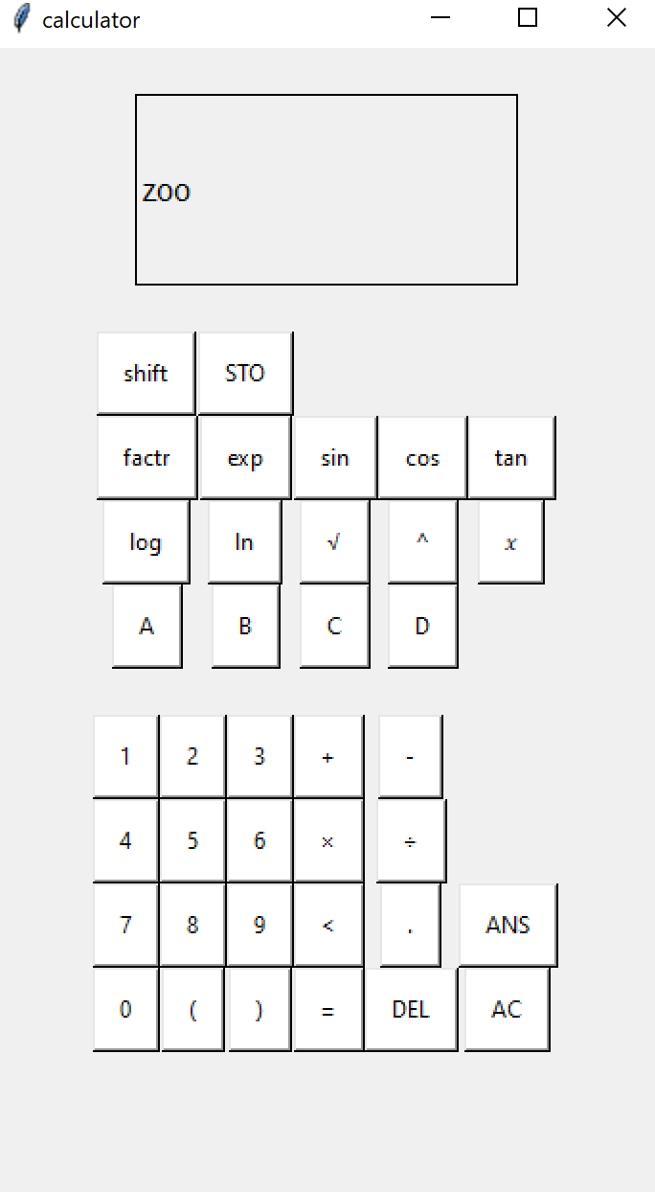 | I identified that I needed to re- write this error message previously however I have not done so.
3c | 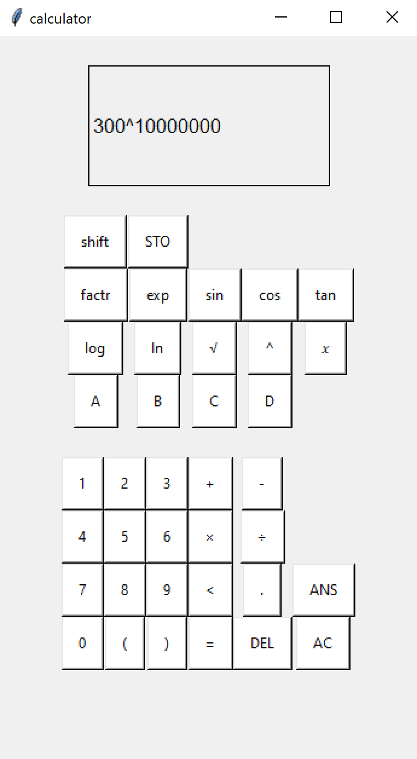 | 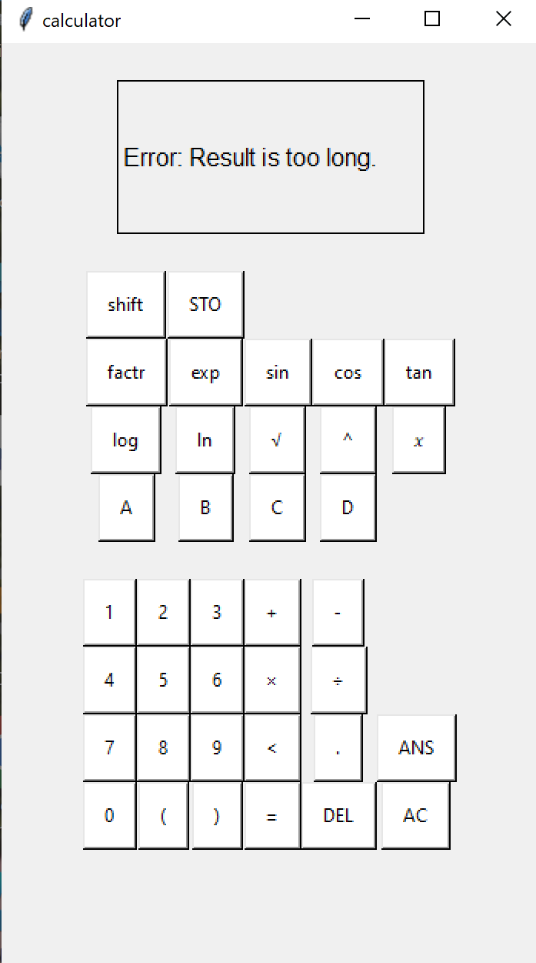 | The app pauses for 3 seconds before displaying the message. This suggests it needs more preventative measures.
3d | 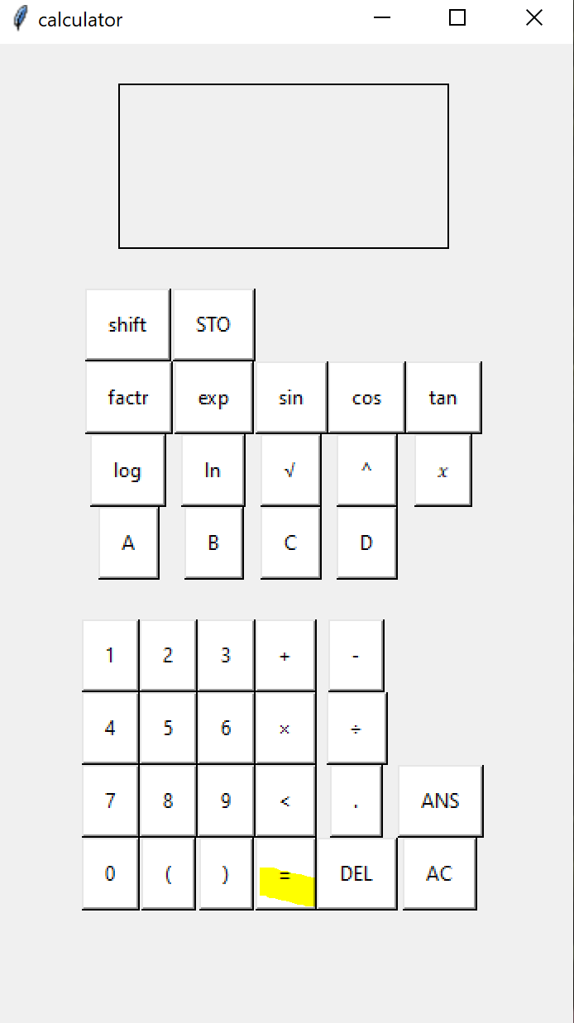 | 
4a | 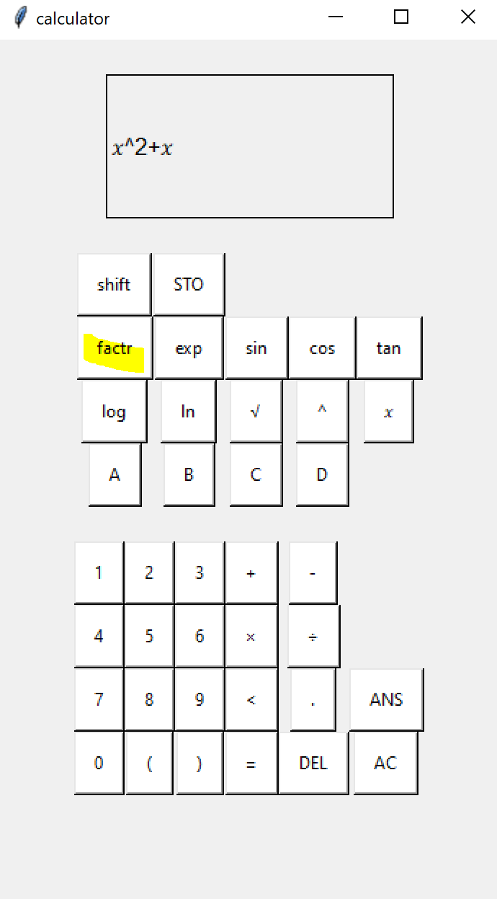 | 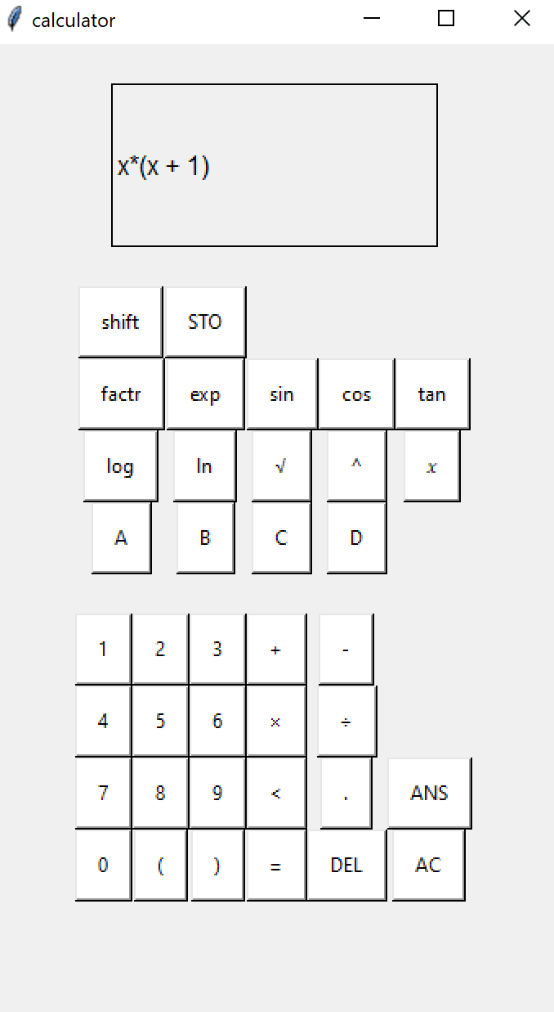
4b | 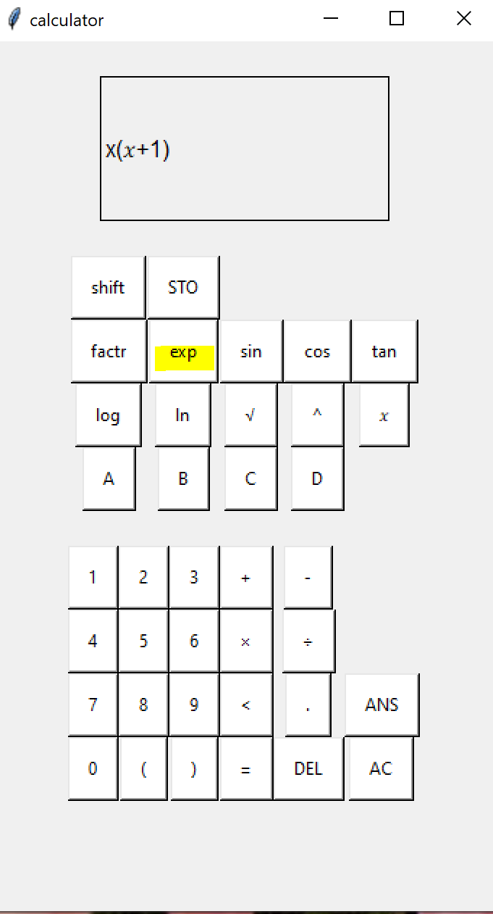 | 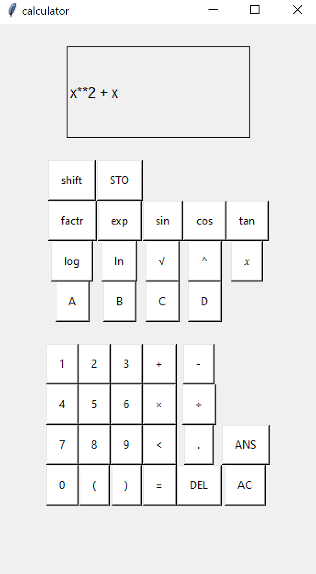
4c | 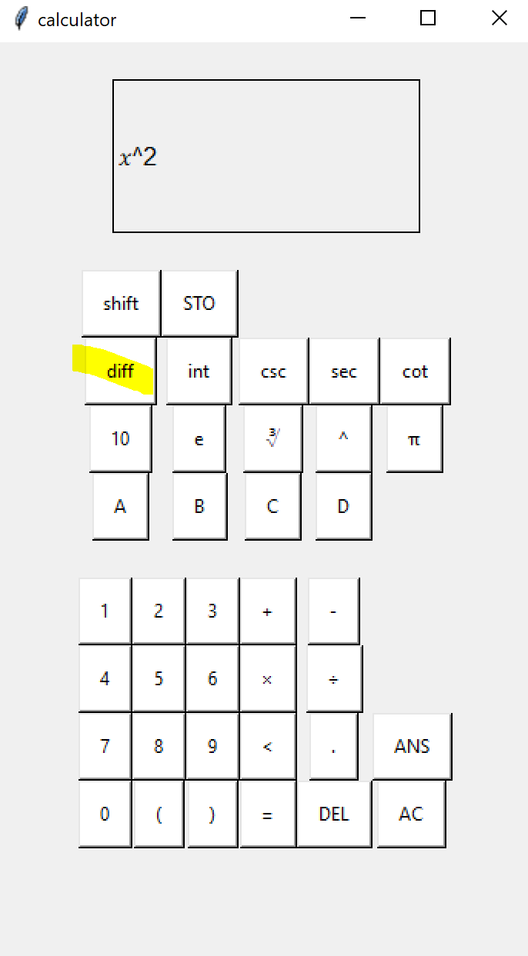 | 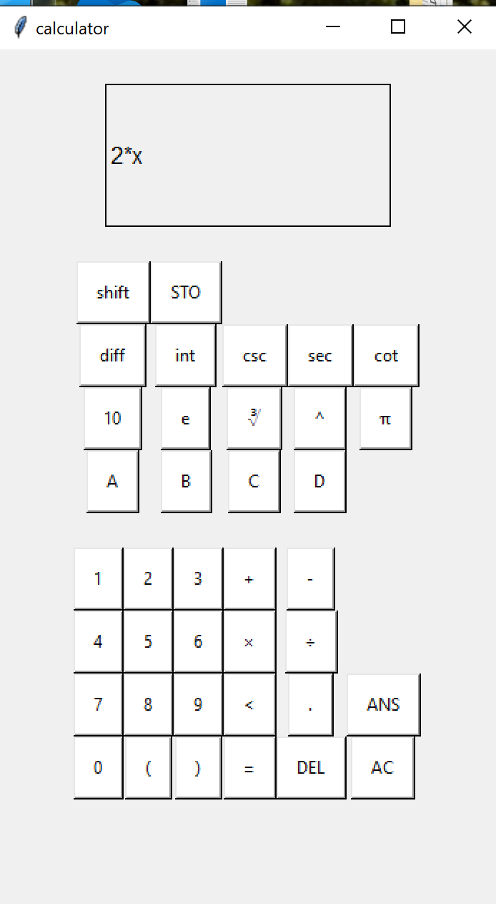
5a | 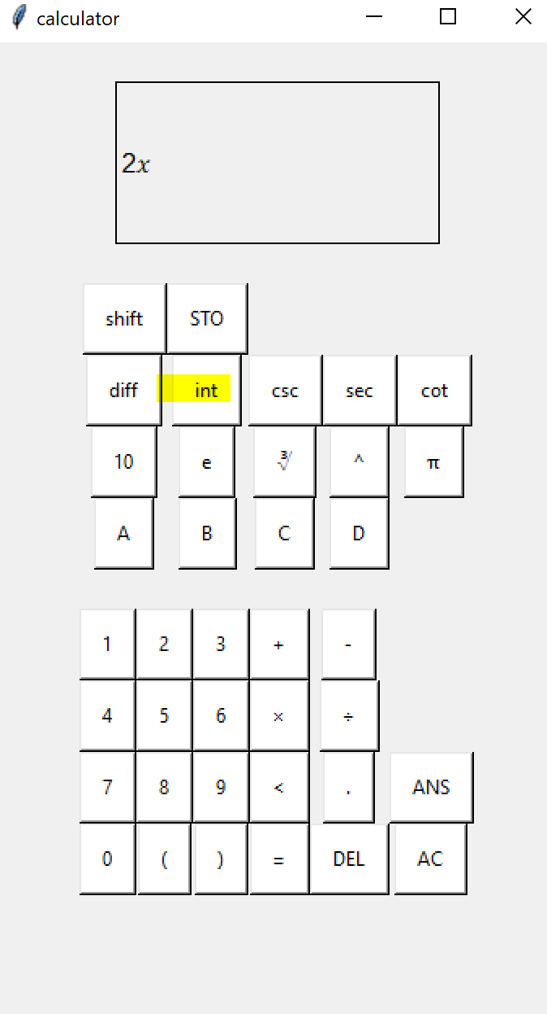 | 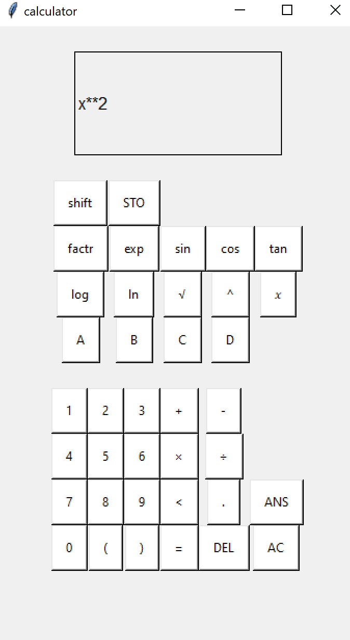 | This is fine but it could also be amended so “ + c” is added to the end. This would not work as an expression but it would help the user not to forget something else could be added.
6b | 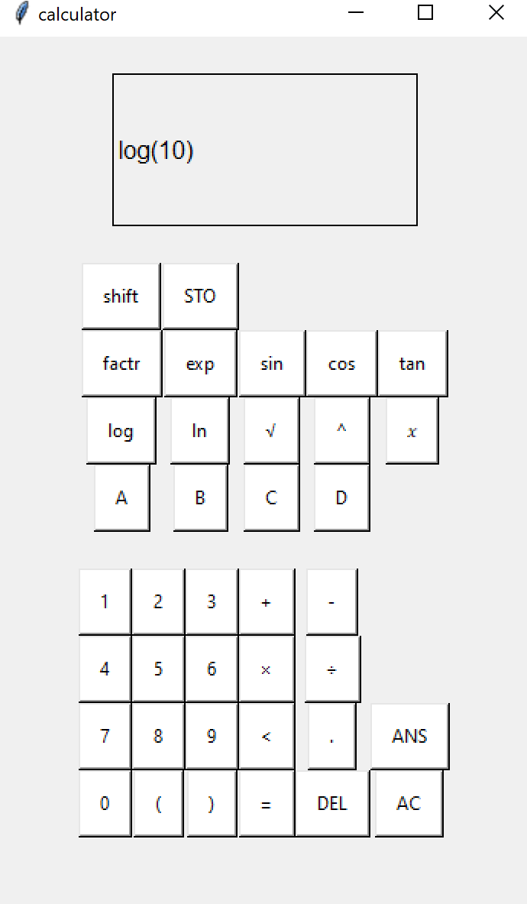 | 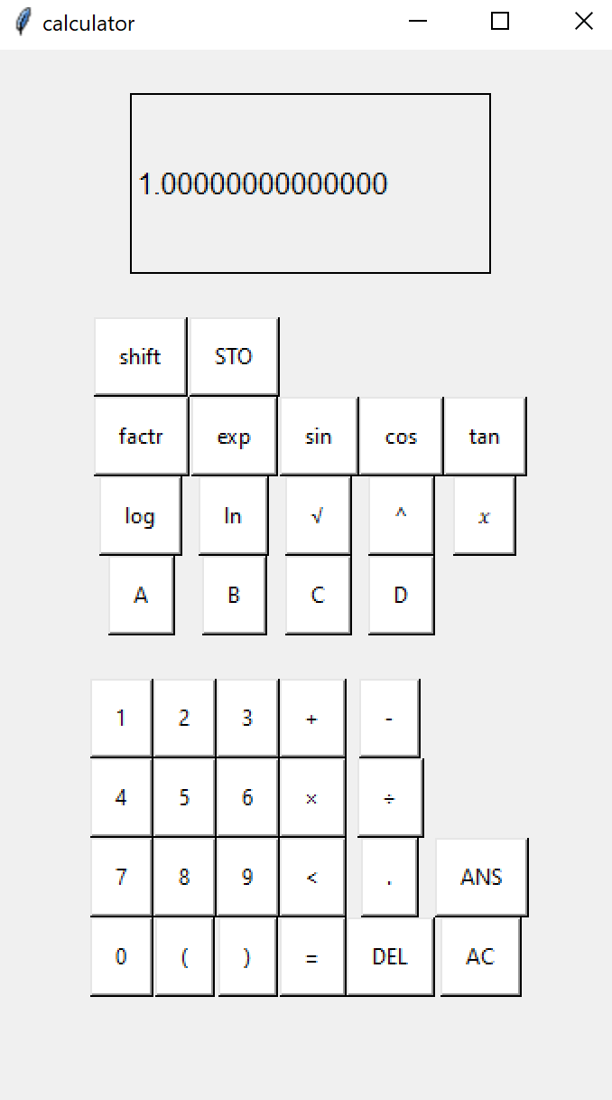 | The automatic opening bracket has made functions such as log much faster to type.
7a |  |  | I didn’t end up adding an nCr statistical function.
8a | (typed in 3 then = before this)  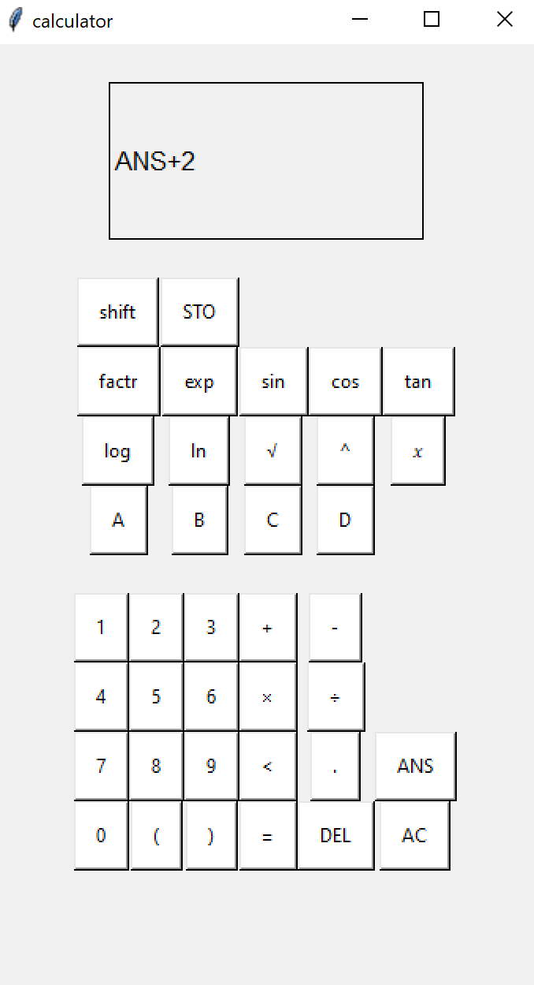 | 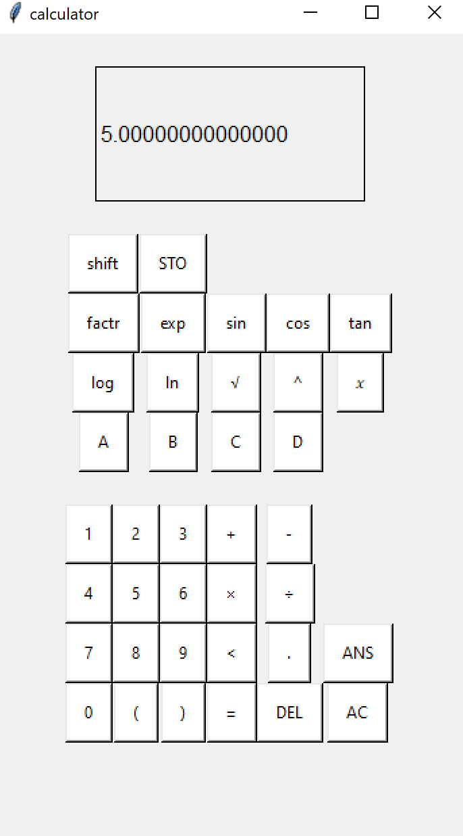
9a | 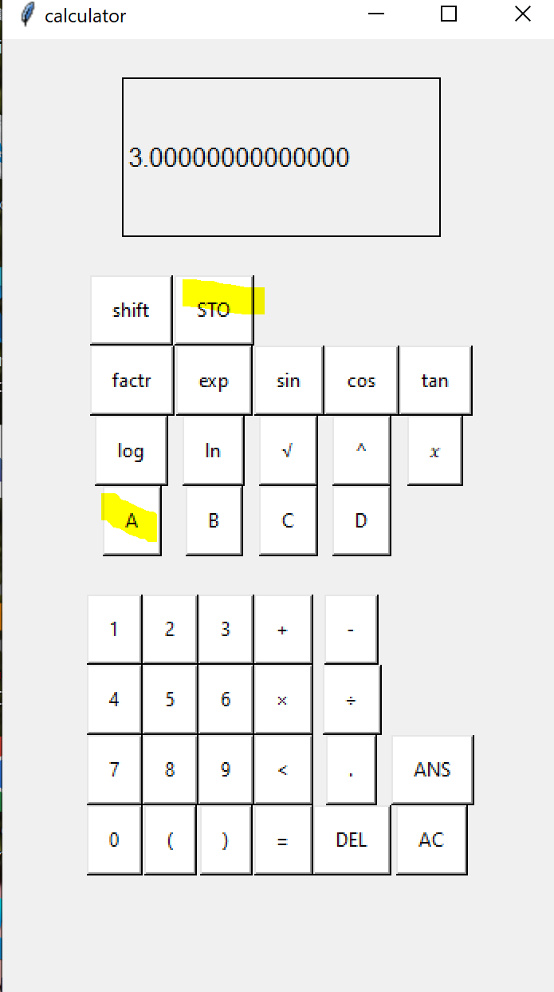  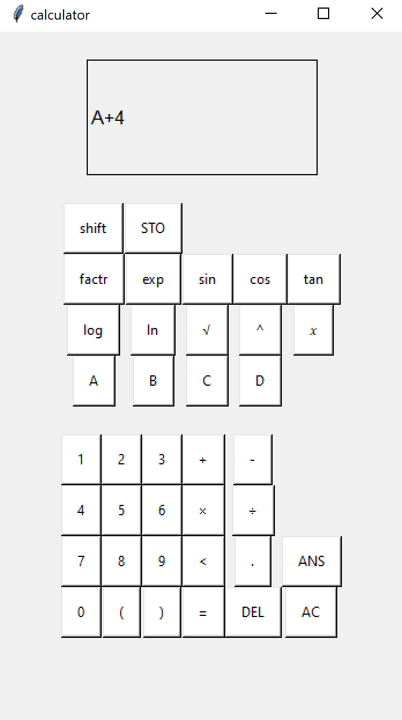 | 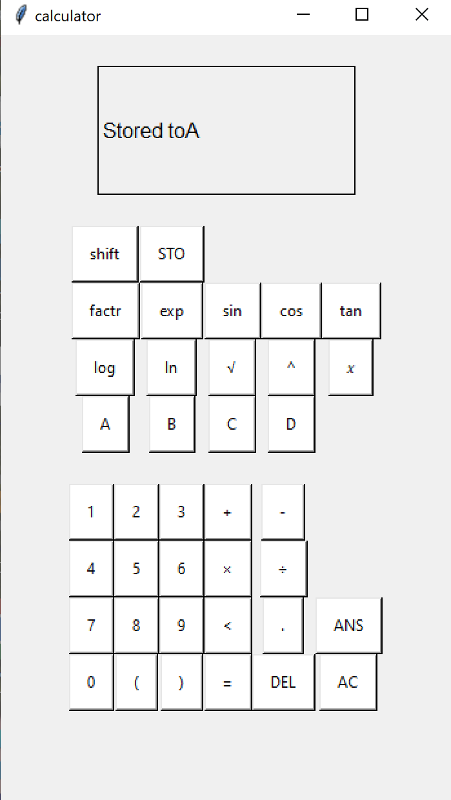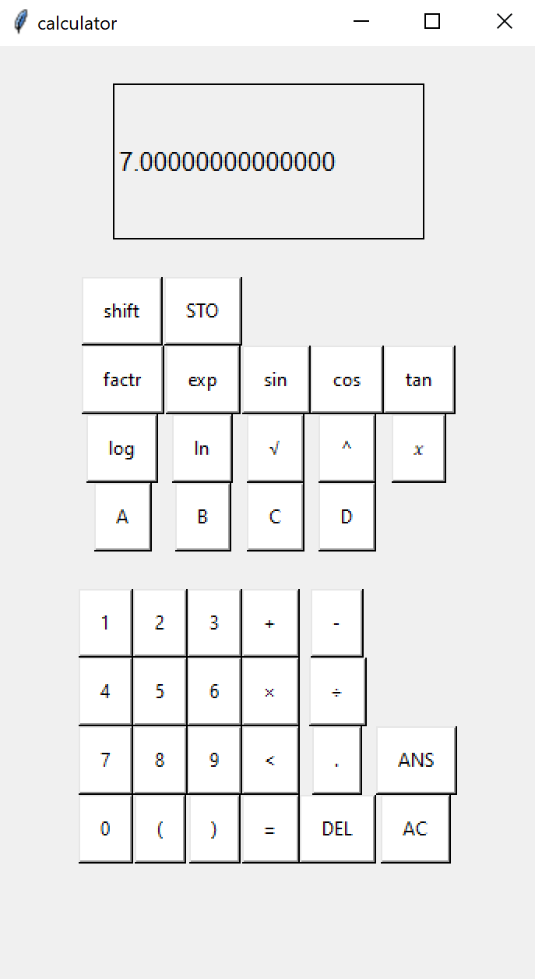 | A space could be added between to and the variable name.
9b | ^ having set the variable to 3 as above, the program was closed and then re – opened.  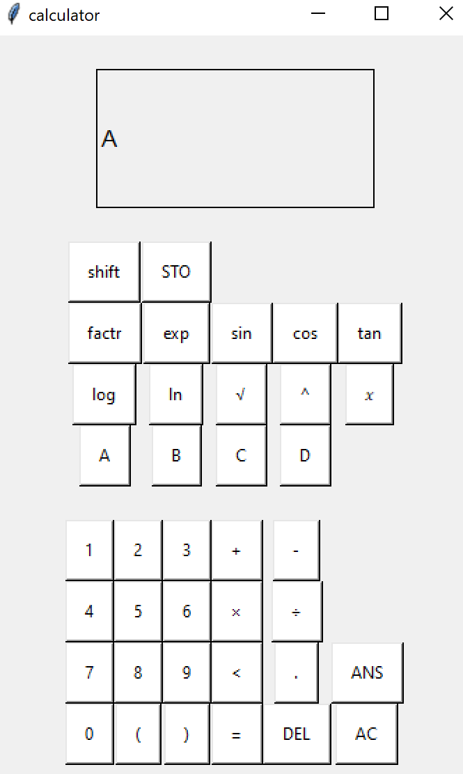 | 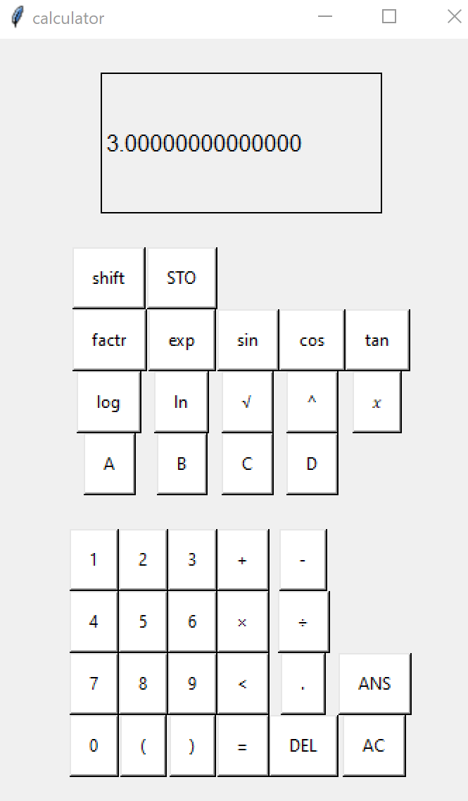

Overview of testing
The following table analyses the coverage of project requirements met through the developments of prototypes
Requirement | Prototype 1 | Prototype 2 | Final
Type Buttons
Enter valid expression
Error messages |  | More specific messages added | Still suffers from zoo error message
Algebraic functions
Trigonometry |  |  | Made easier to type
Logarithms |  |  | Made easier to type
Statistics
Store results |  | Added ANS | Added variables
 | 2 in full, 2 partially met | 5 in full, 2 partially met | 6 met in full, 1 partially met, 1 not met

Robustness
User error | outcome | Robustness
Incorrect syntax | “Syntax Error” message | 100
Incorrect logic | “zoo” message | 100
Input too big | Length of input is checked and if it is too long it is not processed and a specific message appears | 100
Output too big to fit on screen/ too big to process | “result is too large” error message but the program still can slow down | 50
User presses equals or another function while the screen is blank | Nothing happens | 100
User saves something that shouldn’t be saved as a variable | It is saved and if used it will cause an error but the program wont crash. | 20

Overall : 78% robustness.
Chance of program crashing is 0%
However there is a chance of bugs occurring. Also, unfortunately, there is one error message which is hard to understand. The “zoo” error message appears when a zero error occurs. For this reason the error messages requirement is only partially achieved.
User Testing
A range of 10 individuals with varying degrees of mathematics tested this app on both a laptop and a phone.
In terms of the stakeholder profiles:
Education: 2 GCSE students and 1 Primary school teacher tested the app.
A level: 4 Stem Students (who use mathematics) and 3 non- stem Students tested the app.
Business: 1 business owner tested the app.
Notes based on the user’s feedback was added in red.
User 1: Sumayyah Bhula Politics Student, 17
“wow. That’s so good.” “Why are these not the same size, it annoys me. Also why is there a weird gap there?” “you should make it pink.”
# A colourful and more polished GUI might appeal more to users
User 2: Urvi Odedra Maths Student, 17
“An improvement would be if you could choose a different base for logarithms. It’s very practical I can just type. I like that it doesn’t erase the result because it makes it easier to carry on calculations.”
Urvi was the first person to try and use the mathematical functions such as factorising which she was impressed by.
“I love that this is a laptop app. Like you can even play valorant on it. You could be doing your maths homework at the same time. An improvement would be – if it had a brain and could do my 5 a day for me.”
# suggests to add bases to logarithms
# advantages of a virtual calculator includes multi – tasking!
User 3: Honey Rymell Computer Science Student, 18
Honey tried to use the ANS button as an equals button.
“I could get down with this. It has a lot of features my calculator doesn’t have. You can do like sin on a touch screen and my mobile calculator can’t do that.”
I also asked honey based on the previous user’s feedback if she would rather the screen went blank.
“i would rather it did that, just to speed things up. When im tip- tapping on my keyboard, I want to go lightning speed but apart from that , its great.”
# placement of ANS button may not be user friendly
# screen auto- clear would be a good feature
User 4: Diya Gurung Biology Student, 18
Diya used the calculator for her homework. She Liked it, but also suggested it be made pink. She also made use of the shift and store functions.
User 5: Kaitlyn Ofori-atta English Student, 18
“It’s very fast at typing, wow. It’s a good calculator I would say, it just obviously when you generate an answer- like when you put new letters in I feel like it should delete itself . The previous answer before. Other than that I think it functions really well.”
User 6: Priya Bahia ,Baker 17
“You should make it brown.”
Priya also tried to use the ANS button as an equals button.
“I would use this calculator so I can calculate my finances and net income. And you know weighing stuff out. Like, in a bakery you can get your calculator dirty. So a non physical one would be great because you can just have it on your phone. And other calculators are really expensive. It’s easy to navigate, buttons are nice and big”
User 7: Aleona Loskutova , Engineering Student 17
“I really enjoy that there’s an ans button there, its really helpful. I would say that it has a good layout, I can read it clearly. The shift button makes it ten times better. I love that you can actually store numbers because sometimes you need multiple calculations so that’s really cool .”
She tested a lot of big numbers on the calculator and exponents. None of them were too big to the point an error appeared
“Id say this is a pretty good calculator. Of course not all the functions are set up but most – the ones that are most used are there, so good job.”
# functions and features added are relevant to a student
User 8: Bethan Parsons , GCSE Student 15
Bethan also tried to use the ANS button as an equals button.
“I like how fast it is, it types very fast. The AC button is great. I wish it showed which buttons would shift to what , for the shift feature, that would be cool. The fast typing and the touch screen I like. I like that it saves your answer and you can re- use it.
I wish it showed the calculations and the answer on the same screen. That way I can see if I typed it wrong, that’s what I like about my calculator. But yeah, jolly nice.”
# improvements suggested : adding labels to indicate what buttons shift to, displaying both the answer and input side by side
User 9: Rachel Trehy, Primary School Teacher, 47
“I think it could be improved if you had a space between the buttons, maybe some colour to differentiate the buttons. As an educator it would be brilliant to have a scientific calculator app that I could share with the students. Calculators are definitely an expensive resource.”
User 10: Kaiden Ofori – Atta, GCSE Student 16
“This is cool, it does a lot of stuff. I don’t know what diff is. I lost my calculator for school . Send me it, send me it”

The most common things suggested were for the GUI to be more colourful and for the Answer display to clear itself.
Multiple users also tried to use the ANS button as an equals button which suggests it’s placement should be altered in future versions.

Evaluation

The Degree of success in meeting original objectives

Due to time restrictions, there was one requirement I was unable to complete as well as one that was only partially met. The final testing was most thorough to ensure there was proof of all the requirements that have been met.
Success Criteria
The following table summarises the requirements of the program as well as their criteria. It has been copied from the project analysis section. All of the screenshots of the relevant test results are listed here from the original test on pages 82-92.

Requirement | Success Criteria | Relevant test results | Achieved
Type number or symbol buttons | When hovered over, the button turns a different shade  The button being pressed causes the character to appear on the virtual screen  DEL and AC buttons also work properly | 1a  1b | Yes
Enter a valid expression | Output an answer to the expression  Quick output , under 5 seconds  The output is correct  The output is in exact form | 2a  3c. | Yes
Enter an invalid expression | An error message appears  The message specifies which type of error has occured | 3a  3b  3c  3d | Partially
Algebraic functions | The calculator is able to process simple algebraic expressions  The software is able to use at least 3 algebraic functions such as integration and differentiation | 4a  4b  4c  4d | Yes
Trigonometric Functions | The calculator can use at least 3 trigonometric functions | 5a | Yes
Logarithms | The calculator can process expressions using log, ln, and e | 6a | Yes
Statistical Functions | The software can use at least 3 statistical functions such as the combination formula | None | No
Store results | The Software stores the last answer  It can be retrieved using the “ANS” button  This works as a value in expressions with a correct output | 8a | Yes
Store Variables | A variable can be edited by the user using only the GUI  The values of variables can be retrieved and used in expressions | 9a | Yes

Those of the criteria that have been met were given final testing as proof of function. This will be used as evidence when deciding if criteria have been met.
The final testing in reference to the success criteria:

- Typing
Test | Outcome | Proof
1a: Hover over button | Success | the buttons on the keyboard change to a blue colour so the user can see them more easily.
1b: Typing | Success | the button being pressed causes the character to appear on the virtual screen.
1c-DEL | success | the DEL button is fully functional
1d- AC | success | The AC button is fully functional

Overall, this criteria has been fully met as can be seen through the tests. Typing is fast and there are no buttons on the keyboard that have an issue.

- Enter a valid expression
Test | Outcome | Proof
2a: Valid expression | Success | The output is correct, valid and in exact form.
3c: Exremely large number | Success | The longest the app takes to respond when an error occurs is 3 seconds.

Therefore this criteria has been fully met. Tests 4a, 4b, 4c, 4d, 5a and 6a also show evidence of valid expressions giving correct outputs to prove the accuracy of different functions.

- Enter an Invalid Expression
Test | Outcome | Proof
3a: Invalid Syntax | Success | An error message appears  Specifying the error
3b: Invalid logic | Partial success | The wrong error message appears
3c: Extremely large number | Success | An error message appears  Specifying the error
3d: Blank input | Success | An error message appears  Specifying the error

Because of the outcome of the test 3b, this success criteria was only partially met. The criteria requires. The message specifies which type of error has occurred. However, the error message in 3b is one that was provided by the SymPy library and should have been altered. Therefore, the criteria was not met to it’s fullest potential.

Algebraic functions
Test | Outcome | Proof
4a: Factorise | Success | The calculator can use factorisation
4b: Expand | Success | Can use expansion
4c: Differentiate | Success | Can use differentiation
4d: Integrate | Success | Can use integration

This success criteria requires at least 3 algebraic functions and luckily the app was able to implement four. Their accuracy can be seen in tests 4a, b, c and d on pages 87-88 Therefore it has been fully met.

- Trigonometry
Test 5a (successful) shows that the calculator can successfully interpret and receive trigonometric functions. As well as this, the success criteria was also exceeded as 6 trigonometric functions have been added. Therefore the criteria was met.
- Logarithms
Test 6a (successful) show that the calculator can successfully interpret and receive logarithmic functions. The calculator has the functions log() ln() , e and also a “^10” button for using in logarithmic expressions. Therefore the criteria was met.
- Store Results
The test 8a/b (successful) shows that the ans button stays up to date with the last calculated result and can be used as part of an expression. Therefore, all of the given criteria has been met.
- Store variables

Test | Outcome | Proof
9a- Set + Use Variables in an expression | Success | A variable can be edited by the user using only the GUI  The values of variables can be retrieved and used in expressions
9b- Load variables from storage | Success | The app remembers what variables were inputted last time, even when the software is closed and re- opened at a later date.

While it was not originally specified for variables to be stored in memory, both of these tests show that the variable feature of the app is fully functional and it can be edited with only the GUI. Therefore, the store variables criteria has been fully achieved.

Limitations

3)Invalid expressions
In the face of an error, the program does not crash and does display an error message. However the issues that still linger with this requirement can be seen on page 86.
Although exception handling and specific error messages were implemented thoroughly, The zero error message I intended to be displayed does not function as intended. Instead what is displayed is an error message which is presumably part of the SymPy library. As well as this, The preventative measures for large inputs crashing the computer have room to be made more efficient as can be seen in test 3c.

7) Statistical functions
it was originally planned for the calculator to have more functions, specifically to have a statistical function which was discussed in the design and analysis sections. However this requirement was not met simply due to time constraints.

The main problem which I was faced with when developing this project was how to prioritize different aspects of the project especially since a calculator has the capacity for many features. The information gathered from user testing indicates which requirements were fundamental to the system itself. For example, despite having added algebraic features I neglected to add a decimal point button until the third iteration of my project. In order to prioritise the most important features these were some ideas that were left out:
- Statistical functions
- Boolean expressions
- An S/D function.
- The shift button changing colour when shift is on, as I drew it in the design section.
Maintenance
For the future development of the software, maintenance will be required to correct these limitations as well as extend desired features.
The software was written with maintenance in mind and this is reflected in it’s modular nature as well as easy to understand variables and comments throughout explaining how the algorithms work. For example, the create_button() function is named after it’s use. It also has two comments to explain what the function does as well as a feature to be inherited by all buttons. The button is accordingly named “button” .
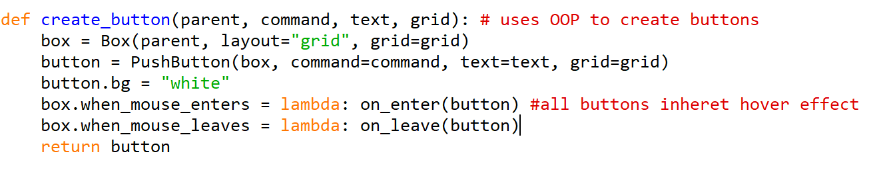
Future maintenance could be disrupted if either of the libraries which this app has made use of have issues in the future. If a different developer needs to download GUIzero and it is no longer available then the whole program will need to be re- written to an extent to be functional.
However the use of libraries also has a positive side as the libraries are used with maintainability in mind. GUIzero is much simpler to understand than other options such as Tkinter, meaning another programmer or my future self could more easily interpret the code and pick up from where it was left off.
Modules such as replace_chars() and perform_operation() were also re- written during the final iteration to become more maintainable.
Now the function does not grow in length when new characters are added as it traverses a 2D list using an iterative for loop and if statement rather than a long line of if statements.
This means that if during the future new buttons or characters are added the 2D array only needs to be edited and the function stays the same size.
Similarly the perform_operation() function being rewritten prevents repeated code and means if a change is made it only needs to be rewritten once rather than in multiple areas of the program.

Usability
While discussing usability, I will also reference the user testing feedback which was recorded on pages 93-95 .

Simple layout
The layout was intended to be simple and minimalistic. Though it Is not as polished as some other solutions that are available, it is clear enough to read and navigate.
The requirement of labelled buttons with commonly recognised mathematical symbols has also been achieved. This is clear as users had no problem using the functions without instruction or explanation.
Original plan
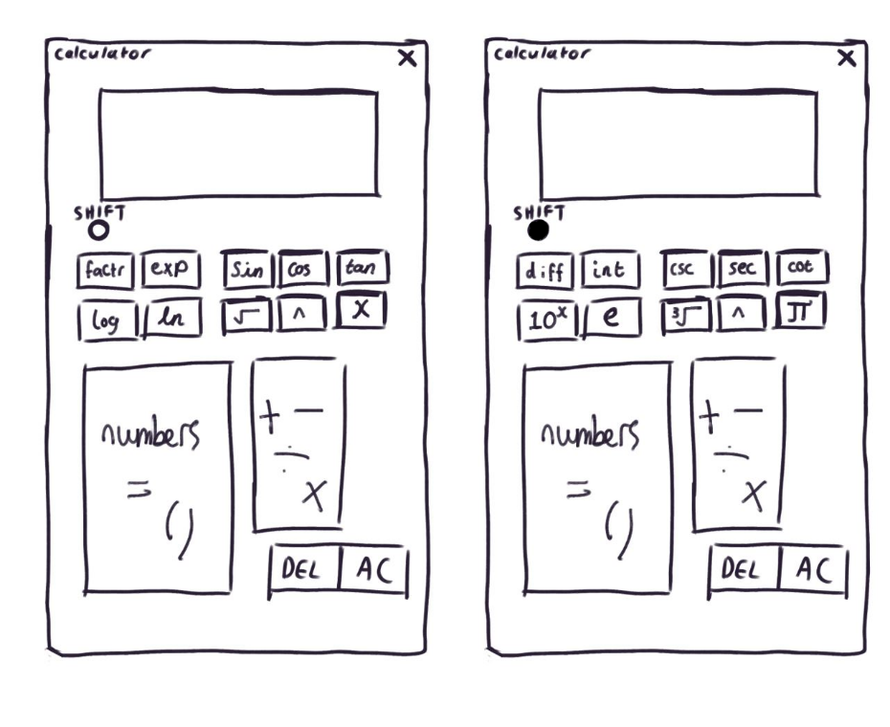

Outcome
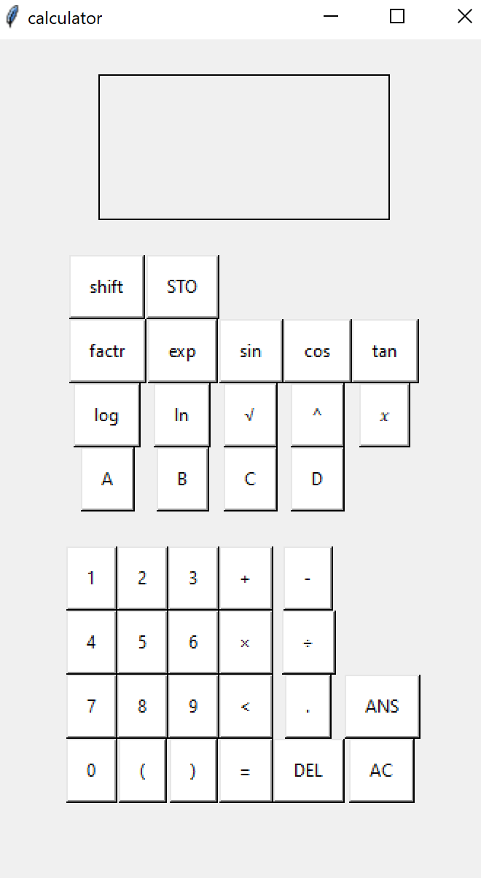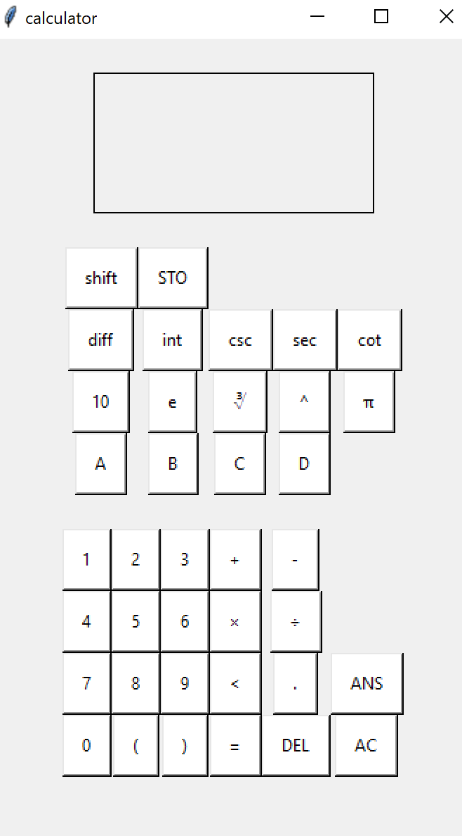 | The general layout has stayed true to the original design, though the buttons are much more boxy than intended.  This was because a grid was used to create the buttons so they are all to scale with each other. If the grids were broken down for different rows (eg. The 3rd row of buttons which has less wide buttons) then it could look more appealing.

Notably, some comments on the layout given by users:
2 students, 1 buisness owner and 1 educator each mentioned colour being added to the design. This suggests that it would appeal to most demographics to give options to change colours or differentiate the buttons on the calculator, which was specifically mentioned by User 9 who is an educator. This kind of design can be found in all sorts of devices used for primary education, such as keyboards when children are first learning to type. I also noticed that most other solutions I viewed during my research had this feature to some extent. Therefore it would be a priority to implement this in some way in the future.
Users 3, 6 and 8 also tried to use the ANS button as an equals button which drew to my attention that the layout I chose for the equals button is not the conventional layout for calculators. This could be amended easily by swapping it with another button.
Users were happy with the simplicity and size of the buttons.
Display screen to keep track of input
The display screen meets the intended requirements of tracking user input as it displays their input when they type it. It also displays all answers in exact form as intended for more universal use. While the criteria has been met, it could be expanded upon by adding an S/D button so that the user can choose if they want to see answers in exact or standard form. This could be achieved by removing the command sp.N(expr,subs(x,0)) and instead leaving the command expr.subs(x,0) .
User feedback indicates that keeping the input on the screen at the same time as the output would also be helpful to users wanting to check for their own mistakes. This would mean changing the screen to possibly contain multiple text boxes or formatting the string screen_value so it includes both.
Input methods through mouse. Trackpad, touch screen, stylus
As specified, the app can be interacted with and used to its full extent using a trackpad, mouse, touch screen, and a stylus as well as a keyboard. I have downloaded the calculator onto my phone to allow users to try it on both a phone and a laptop. Allowing a range of options for user input makes the calculator more accessible. It can be made portable when put on a light- weight device. It can also be pulled up quickly on a computer while multi- tasking.
Overall all of the usability requirements have been met, but there are also clear next steps to be taken to improve it further.

Next steps
The final evaluation has revealed the following improvements that could be made:
Change | Comment | Difficulty | Impact
nCr statistical function | This would require a function to be written using the combination formula. | Moderate | Moderate
Amend error message  As well as faster preventative measures | Write an algorithm to catch the error before it takes place and display a message, over writing other actions | Moderate | Low
Add an S/D button | This can be done easily by switching the command from  sp.N(expr,subs(x,0)) to expr.subs(x,0) . | Low | High
Change background of different sections of buttons | Change the bg attribute of certain buttons according to a colour scheme | Low | High
Add a Boolean feature using < > | Have the user type in an expression such as  A < 3  And the calculator responds with True or False. | High | Moderate
Add algebra with inequalities | User types in something such as  X^2 – x > 12 and the calculator responds with  X < -3 or X > 4 showing the possible answers . | High | Low
Add “functions” the user can write and re- write | These would be stored similarly to variables. This feature is found in a few scientific calculators but it would be more complex to program. | High | Moderate
Generating graphs | This would allow the user to type in equations and view the graphs. This could also include parametric equations. It would be difficult to program as currently the screen is only a small text box and might result in an extra window opening. | High | High
Add labels to shift buttons so you can see what they shift to | At this point the text might not be small enough to fit on the button. It might be better to actually draw the appearance of the button and use it as an image instead. This would require the images to be saved in the same file as the calculator. | Low | High
Display both input and output side by side | This could be achieved via string formatting or by adding an extra text box. The main challenge would be re writing a lot of code to accommodate this change. | High | High
Have outputs disappear once completed | This would be relatively easy, it could be achieved perhaps using a variable to indicate what the last action was. And automatically erase the screen depending on that action | Moderate | High
Add options to change colours | This would also be easy but If too many unnecessary features are added the GUI will no longer be minimalistic. Perhaps there could be a settings window that is opened when pressing a small button. Or , when the user clicks the background it could change colour, making it a fun feature. | Low | Moderate

Finally, here is how I would prioritise these changes based on their difficulty / how long they would take as well as the impact they will have on usability and functionality:
 | High impact | Moderate/ Low impact
Low difficulty | - S/D button  - Alter button backgrounds  - Add labels to shift buttons | - Change colour option
Moderate/High difficulty | - Generating Graphs  - Display input and output together  - Have outputs disappear when completed | - nCr statistics function  - Amend error message  - Add Boolean feature  - Add inequalities  - “function” user can write

Firstly the low difficulty, high impact changes will be completed as this will deliver the best results to users in the shortest time possible. In the next iteration these features will be added:

- S/D button to change answers between standard and exact definition
- Button colours change to differentiate them from each other and make the GUI look more appealing
- Add labels to buttons by using pictures that give further information on what they do while still maintaining a simple GUI

Following that, the more difficult or slow tasks that will still bring a lot of value to the user should be completed. Even if they take a long time they should be prioritised for the user experience and the lower impact changes can be considered extra things to add in the future.

Oxford Languages
M.Kowalkiewicz, Medium
https://docs.sympy.org/latest/tutorials/intro-tutorial/simplification.html
https://study.com/learn/lesson/combination-formula-calculate.html
https://www.acko.com/calculators/
https://www.casio.com/intl/scientific-calculators/software-apps/emulator-for-windows/
https://www.thestudentroom.co.uk/showthread.php?t=7304955

